# Name: Hadani Soniya Arunbhai

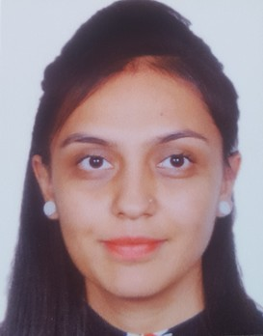

**Address:** 201, Rushbahraj apartment,

Near ambica society,

Maninagar, Ahmdebadad-380008

**E****-mail:**sonuhadani@gmail.com

**College:** Gandhinagar Institute of Technology, Gandhinagar

**Contact No.: -** +91-9909506847



**CAREER OBJECTIVE**

To excel in my field through hard work, research, skills, and perseverance, to serve my parents & my country with best of my abilities and to ensure a highly profitable career, seeking for a challenging job and healthy work environment where I can utilize my skills, experience and knowledge efficiently for organizational goal.

# ACADEMIC QUALIFICATIONS

|  |  |  |  |  |
| --- | --- | --- | --- | --- |
| **DEGREE** | **INSTITUTE** | **UNIVERSITY/ BOARD** | **PERCENTAGE** | **YEAR** |
| **B.E** | Gandhinagar Institute of Technology | Gujarat  Technological University | 8.32 CGPA | 2018 |
| **HSC** | Divine Buds Higher Secondary School | Gujarat Board | 50% | 2014 |
| **SSC** | Divine Buds High School | Gujarat Board | 83.2% | 2012 |



**TECHNICAL SKILLS**

* Good knowledge of Programming languages like C, C++, Java and Android. .
* Web Technologies HTML, FrontPage, CSS.
* Good knowledge of Data Structures, DataBase Management System ,Computer Networks, Operating System ,Theory Of Computation.
* Application making in Android Studio with all type of functions associated with it.



**PERSONAL SKILLS**

* Hard Working, Dedicated to Work & having Leadership Qualities.
* Good Communication and Presentation Skills.
* Good Learner & having a decent grasping abilities.
* Good Planning , Time Management and Analysis skill.
* Winner at inter school level in Sports and Cultural events.



**DECLARATION**

I am keen to continue my career and prepared to work and act smart to achieve my organization objectives and I hereby declare that the information furnished above is true to the best of my knowledge.



