**RESUME**

**JIGNASHA VANIYA.** 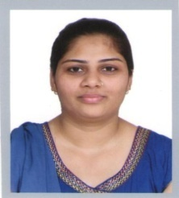

**+91-9586179488**

[**Jvania7@gmail.com**](mailto:Jvania7@gmail.com)

**Career Objective:**

* Employment with a view to enhance my skills and gain valued experience to keep abreast with change in the field .Actively participates and perform tasks allotted to me to meet management’s Goals.
* To work in a Development field and to make the best use of knowledge that I have .

**Work Experience:**

* In Titan Company Ltd on post RSO joining 3 Years @ Months.

**Educational Qualification :**

* Have completed 12th in commerce stream.
* Diploma in Fashion Designing for 3 years.
* Have completed T.Y.B.com in March 2013.
* Have completed P.G.D.C.A from ECIT.

**Personal Details:**

**Address:** D/7, Krishna bungalows,

Opp.Motera village,

Sabarmati,

Ahemdabad.

**Date of Birth:** 5th july 1985

**Marital status:** Unmarried

**Strengths:** Initiative nature,always-Positive attitude,Effective communication skill, optimist,hard working

**Languages**

**known:** English,Hindi,Gujarati.

I hare by declare that all the information given above is correct according to the best of my knowledge and belief .

**Your faithfully**

**Jignasha Vaniya**