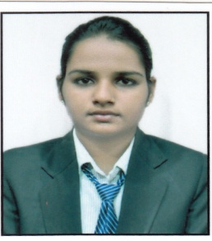

**NAMRATA GAJANAN CHOUDHARY**

[**E-mail: namratachoudhary1495@gmail.com**](mailto:E-mail:%20%20namratachoudhary1495@gmail.com)

**Contact: (09860088669, 08380973081)**

**Address:** Plot no-12A,Senapati nagar,B/H dighori ghat,

Near Shiv and hanuman mandir ,umred road,

Nagpur-440009

**CAREER OBJECTIVE:**

To work with a reputed organization which would offer me a healthy work culture, an atmosphere that enhances my professional skills and offers a challenging work environment and excellent growth prospects*.*

**ACADEMIC DETAILS:**

|  |  |  |  |  |  |
| --- | --- | --- | --- | --- | --- |
| **Year** | **Degree/**  **Certificate** | **University/**  **Board** | **College/**  **Institution** | **Percentage/CGPA** | **Remark** |
| 2013-2017 | B.E  (ETC) | RTMNU* | S.B.J.I.T.M.R*** | 65.54%(Overall)  63.72%(degree) | FIRST CLASS |
| 2013 | H.S.C | M.S.Board** | Sarvashree Junior College, Nagpur | 63.00% | PASS |
| 2011 | S.S.C | C.B.S.E | Kendriya vidyalaya, Ajni, Nagpur | CGPA-8.4 | PASS |

NOTE: R.TM.N.U*-Rashtrasant Tukdoji Maharaj Nagpur University

M.S.Board**-Maharashtra State board

S.B.J.I.T.M.R***- S.B.Jain institute of technology, Management and Research, Nagpur

**PROJECT:**

**TITLE: “S.B. Jain Smart notifier android app” (Major Project)**

**Guide:Prof. Mohd.Naushad**

**Duration:** 10 months

**Description:** In this we are going to make an android application for our department. this will surely reduce the work of assistant or clerk to take the notice to each and every class. So this app will going to reduce the chaos and all the notices regarding forums, exams,competition etc will be delivered to the student, staff (even absent student and staff)directly through this app.

**TITLE: “Door knob bell”**

**Guide: Prof. Mohd. Naushad**

**Duration:** 3 months

Description: The door alarm system is an electronic device that can be used as a security device. It is an electronic watch dog, because when installed to a door, and somebody touches the door, it sounds an alarm. It is relatively simple in both its operation and analysis. One particular feature of this project circuit (the door alarm system) is its versatility.

**TITLE : “Automatic Car parking System using IR sensor”**

**Guide: Prof. Vijay Matta**

**Duration:** 6 months

**Description:** An automatic car parking system is an system which is used while driving the car in reverse direction. In simple words, while taking the car in reverse manner earlier driver has to look out of window whether the car is touching any obstacle. But using this the problem can be overcome. In this we have used sensors to detect the obstacle within the distance of 100cm from car.

**INTERNSHIP & TRAINING**

Guide: Mr. Sandeep Bawankar

* Training on: “**CLOUD COMPUTING**”
* Period: 45days
* Topics covered: OS installation, server 2012, CCNA, cloud computing
* Learning from the project: OS installation, server 2012, CCNA, cloud computing

**Co-CURRICULAR ACTIVITIES:**

* Participated in aptitude test conducted by St. Vincent pallotti college of engineering
* Participated in Gate exam (basic test)conducted by St. Vincent pallotti college of engineering
* Participated in quiz competition conducted by IEEE
* Participated in LAN Gaming, Googler, Blind-C Competition organized at Datta Meghe Institute of Engineering, Technology & Research

**EXTRA CURRICULAR ACTIVITIES:**

* Worked as a “**Decoration Head**” under College dept. forum FEETA for the session 2015-2016.
* Captain of IIIrd Year girls cricket team.
* Participated in Poster making competition organized by Datta Meghe institute of engineering, technology and research.
* Selected as the “**Campus Ambassador 2016-2017”** of S.B.J.I.T.M.R by IIT Kanpur.

**COMPUTER PROFICIENCY:**

* Languages:- C,C++
* Operating system: Windows-07,10,professional
* Basic knowledge of MS-office.
* Basic knowledge of Matlab and Pspice software

**LANGUAGE PROFICIENCY:**

* English, Hindi and Marathi.

**PERSONAL PROFILE:**

Father’s name: Mr. GAJANAN NATTHUJI CHOUDHARY

Mother’s name: Mrs. VEENA GAJANAN CHOUDHARY

D.O.B: 14/08/1995

Hobbies and interest: Drawing cartoons, watching TV, internet surfing, listening music.

Qualities: Leadership, team player, empathetic, soft spoken, adaptability, self confidence

Blood Group: A+

Nationality: INDIAN

Marital status: SINGLE

**REFERENCES:**

References will be furnished if required.

**DECLARATION:**

I hereby declare that all the above information is true to the best of my knowledge and belief.

PLACE:-Nagpur

DATE:- 29/06/2017

____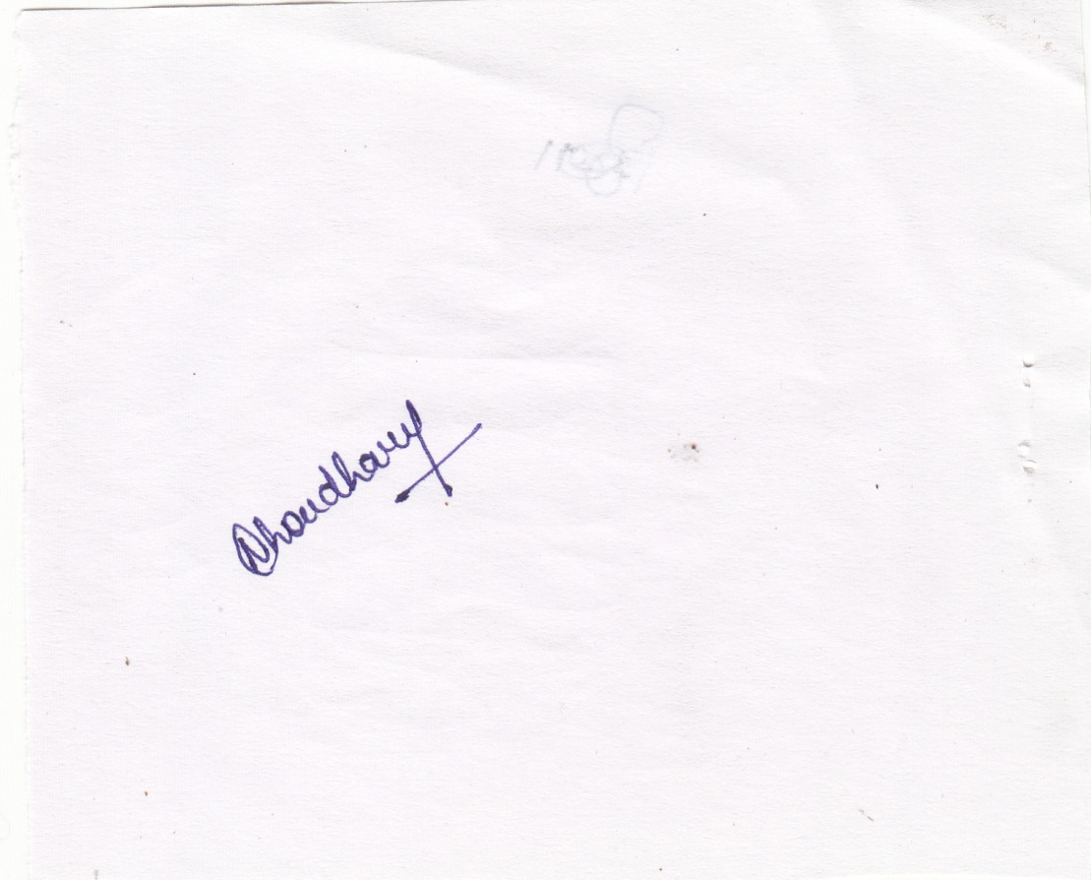_________ **NAMRATA GAJANAN CHOUDHARY**