**CURRICULUM VITAE**

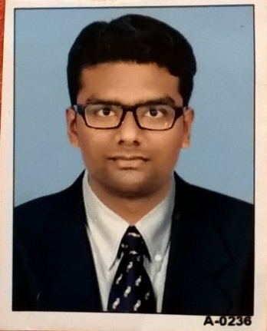

Ashish B. Pandya

B.E. Mechanical

D.E. Mechanical

**Address**: 403, Deepkamal Appt.

Postal Society, Joshipura,

Junagadh: 362001

**Contact No**: 7698925439

**Email:** [ashishpandya753@gmail.com](mailto:ashishpandya753@gmail.com)

**Objective**

* To choose the work I am interested in which I can perform at my level best.
* To deliver my duties very sincerely and regularly in the interest of organization.
* To grow in all means with time on my efforts.

**Experience**

Work as Production & Maintenance Engineer in Production Department in Sureliya Wire Cut Pvt. Ltd. since May 2016 to December 2016

Work as Mechanical engineer in maintenance department in Milan textiles,surat.

Since January 2017 to be continued.

Salary :

My salary is 3.0 lacs CTC

**Job Profile:**

▪ CNC & VMC Machine

▪ To Handle & Control CNC Process

▪ To Handle & Control VMC Process.

▪ To Prepare Maintenance Chart Of CNC & VMC Machine

• To prepare maintenance chart of the machine like preventive, breakdown

Maintenance.

**Academic**

|  |  |  |  |  |
| --- | --- | --- | --- | --- |
| Course | Institute | University | CGPA/Percentage | Year of Passing |
| B.E. Mechanical | Dr. Subhash Tech. Campus, Junagadh | Gujarat Technological University | 7.74 | 2016 |
| D.E. Mechanical | Balaji Institute Of Engg. & Technology, Junagadh | Gujarat Technological University | 8.25 | 2013 |
| S.S.C. | New Best English School, Junagadh | Gujarat State Education Board | 70.77 % | 2010 |

**Academic Projects**

1. Bachelor of Engineering: Design And Development Of Reduce The Heat Loss In Refrigeration System.
2. Diploma Engineering: Design and Development of Multi-Blade & Motor Power Operated Hacksaw Machine.

**Industrial Training**

1. Organization: Austin Engineering, Junagadh

Time Period: One month

Subject: Manufacturing

1. Organization: Creative Casting Pvt. Ltd. Junagadh

Time Period: One month

Subject: Manufacturing & Foundry

**Key Skills:-**

* Problem Solver
* Team Player
* Analyzer
* Man & Time Management

**Personal Details**

Name: Ashish B. Pandya

Date of Birth: August 16, 1995

Blood Group: O –ve

Marital Status: Unmarried

Father’s Name: Bhupeshbhai Pandya

Father’s Occupation: Driver in Pvt. Company

Strengths: Dedication, Adaptation, Self Confidence

Languages known: English, Hindi, Gujarati

**Declation** I hereby declare that the above mentioned information is true to the best of my knowledge.

Ashish Pandya