**Resume**

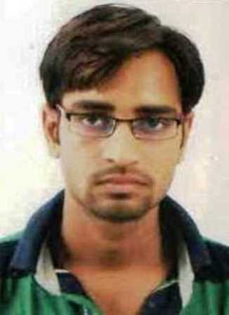

**Ashish Patel**

**22th November, 1991**

**Mobile: 9537950020**

**Email:** [patelashish555@gmail.com](mailto:patelashish555@gmail.com)

Chemical,

Vishwakarma Govt. Engg. College,

Chandkheda, Gandhinagar.

**Career Objective:**

To work in a challenging and professional environment, which helps me in developing my skills and where I can implement my knowledge for the benefit of the organization?

**Academics:**

**Bachelor of ChemicalEngineering from Vishwakarma Govt. Engineering College**

**Gujarat Technological University (2009-2013)**

|  |  |  |  |  |
| --- | --- | --- | --- | --- |
| **SEM** | 5th | 6th | 7th | 8th |
| **SPI** | 7.13 | 7.43 | 7.53 | 7.67 |

**Cumulative Grade Point Average (CGPA): 7.44**

|  |  |  |  |  |
| --- | --- | --- | --- | --- |
| **Course** | **School** | **Board** | **Year Of Passing** | **Percentage** |
| HSC | S.P Surendranagar | GSHSEB | 2009 | 73.60 |
| SSC | S.V Gandhinagar | GSHSEB | 2007 | 82.46 |

**Projects Undertaken:**

|  |  |
| --- | --- |
| SEMESTER | PROJECT NAME |
| ­7th | Reduction of concentration of so2in production of cpcc (cyclopropyle carbonic chloride) |
| 8th | To be continuous above project |

**Area of interest:**

* Petrochemical
* Distillation Process
* Heat & Mass transfer operation
* Pollution & Safety section

**Technical Skill:**

* Theory knowledge about distillation column, heat exchanger
* Well understanding of chemical reaction
* Good technical and practical knowledge

**Extracurricular Activities:**

* I had attended seminar of “advance in catalysis and catalysts “at Nirma University.
* Participated in games in school and collage time.
* **Recently working in finepac structures Pvt. Ltd.**
* Finepac company have doing to manufacture and design of distillation column and their internal parts like packing, liquid distributor & collector and etc.
* They have also provided consultancy work about distillation column for establishes new plant.
* In this company, my designation is techno-commercial engineer and my role as a technical and marketing engineer.

**Personal details:**

* Date of birth : 22thNovember, 1991
* Address : At : Nana goraiya , Ta : Patdi , Dist : Surendranagar , Pin Code : 382765
* Language proficiency : Gujarati, Hindi, English
* Mother language : Gujarati
* Nationality : Indian

**Hobbies and Interests:**

* Reading News Papers
* Playing and watching cricket.
* Watching News, discovery and national geography channel also
* Travelling and visiting new place
* Understanding new technologies.

**Strength:**

* Ability to adjust in any circumstances.
* Cooperative and Helpful.
* Learning from experience.
* Positive approach.

**Declaration:**

I hereby declare that the above mentioned information is true to the best of my known.

Place: Ahmedabad ASHISH PATEL