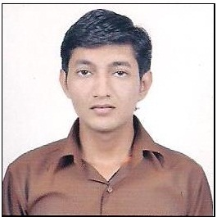***BHAVIN PATEL***

A/169, Tejndra Vihar Society, Part-1, Opp. Ambica School,

Virat Nagar Road, Nikol, Ahmedabad -382350

Mobile No.:- +919033666328

Email: patelbhavin9714@gmail.com

Career OBJECTIVE:

To present myself at the best & I can prove my full potential, dedication and intellect to make the organization reach at the apex of source, and to make my carrier glitter.

Educational Qualification:

I am Bachelor of Electrical & Electronics Engineering from Gujarat Technological University (GTU) with CGPA @ 6.90 (65.55%) in year 2012.

I had completed H.S.C. from G.H.S.E.B. Gandhinagar with 60% in year 2008 and S.S.C. from G.S.E.B. Gandhinagar with 77% in year 2006.

Training Program:

**I had attended training program of PLC programming, And Software & programming in Bosch Rexroth PLC.**

INDUSTRIAL EXPERIENCE (02 years & 06 months):

**SCREENOTEX ENGINEERING PVT LTD**

**Service Engineer From 1st October, 2012 to 28th FEB 2015**

**Job Responsibilities:**

I am presently looking after complete automation engineering work of PLC, HMI, vendor support, service and training. To resolve technical problems related to PLC, HMI & Automation equipment’s. Erection and start-up of equipment’s/Machine. Provide online as well as on-site technical support & necessary training to Vendors. Preparation of Daily Internal Report & documentation related to technical.

All type of panel knowledge like **PMCC,MCC,HT,LT,APFC,AMF,DOL,STAR DELTA,SOFT STARTER PANEL**

Technical Skills:

* Automation and control system development, System Integration, field Installation, Start up and Support. I have sound knowledge in resolving unusual and complex automation system problems.
* PLC Programming: basic knowledge about AB PLC, SLC 500, Controllogix, Micrologix, Softlogix, Siemens.
* HMI/SCADA Configuration: AB Panal, RS View32, Wonderware.
* Industrial Network and Communication: Ethernet TCP/IP, RS232
* Basic knowledge of Microsoft Word, Excel, Power Point
* Laborious and logical approach for the given task & Good communication skills.

personal DETAILS:

Date of Birth : 24th October, 1990

Sex : Male

Languages known : English, Hindi & Gujarati.

Nationality : Indian.

Marital Status : Single.

I hereby declare that the above furnished information is true to the best of my Knowledge and belief.

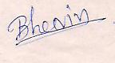

***BHAVIN PATEL***