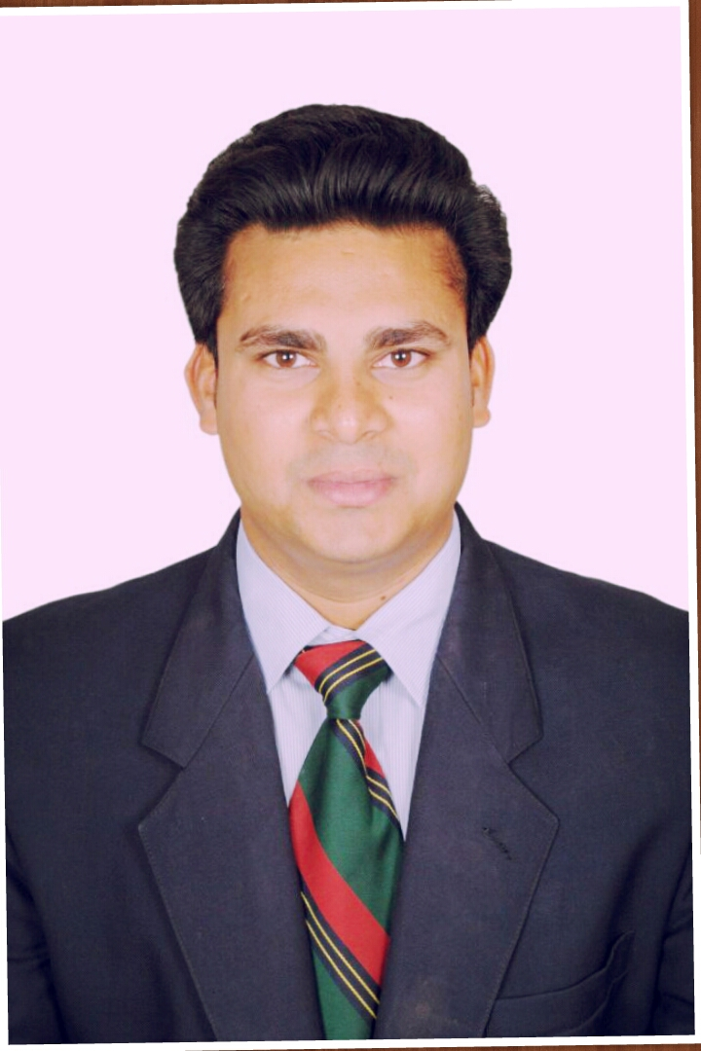 ALOKSINGH RAJPUT
Cell: + 8160095410, 9724808795 Email: alok.rajput175@gmail.com

Career Objective:

To enhance my career in Top Management` in your prestigious organization in continuation to my present job responsibility. Also, to incorporate my present job knowledge in the new work place in order to learn and adapt more technical inputs in similar fields.
Core Competence – Having a strong operational background, a proven track record of meeting budget’s & team oriented personality, I am a self starter with thorough understanding of P & L statements, budgets, cost control, inventory, marketing strategy, system & computer oriented.

MY FORTE

The Operational Perspective
- Developing and implementing procedures, control systems for hygiene, maintaining hygiene and quality standards
- Leading efforts for streamlining processes and generating cost savings in operations.
- Co-ordinate with staff for upkeep of all kind of standards

The Management Perspective
- Forecasting Food & Beverage budgets and responsible for sales, costs and inventory control
- Co-ordinate with operating staff for upkeep of equipment in perfect working order
- Organize appropriate training on Food knowledge, Service Excellence and Teamwork to restaurant and support service staff.

The Marketing &PR Perspective
- Ensuring high quality services, resulting in customer delight and optimum resource utilization for maximum service quality.
- Ensuring maximum customer satisfaction by closely interacting with potential clients & understand their requirements and customizing the product and services accordingly.
- Instrumental in drawing out marketing and PR plans in coordination with Sales team.

The Training & Development Perspective

- Conducting training sessions to F&B team for smooth flow of operations.
- Handling operational functions like pre-shifts staff briefings, creating the duty roster, shift management.
- Organizing and conducting practical and theoretical training programs, to enhance skills and motivational levels.

Education Qualification:
- Bachelor Of Science From Mathura Vrindavan University with First Class.

Professional Experience:

- I Have 10 Year Experience in Hospitality industry.

- CURRENTY WORKING AT THE YELLOW CHILI RESTAURENT WITH SANJEEV KAPOOR As A RESTAURENT MANAGER IN FOOD B BEVERAGE.

The Job – An Overview
- Report to Director Operation and Vice President.
- Implement SOP as per resorts requirement.
- Managing the F&B critical path for pre-opening.
- Design Food festival & promotion calendar for the year.
- Coordinate with Corporate Training Manager for training needs of new implementation.
- I Have worked 9 Months as a Assistant Food & Beverage Manager in Highway food Mall Limbi
- I Have worked 2 years at Hotel Kohinoor plaza in Ahmadabad, As a F & B Manager.
- Manages the F & B overall and looks after the hotels F & B day to day needs.
- Holds meetings with potential clients, P R Agency, Media for F & B.
- Holds Departmental meetings to help my team to know better about the revenues achieved, Promotions, knowing their difficulties in operations, listening to their thoughts & ideas & yes if required implementing the same.
- Hands on operations to know more with the team, builds up team work & motivational level for the team.
- Aggressive marketing campaign for the F & B outlets as well as for banqueting.
- Tie up with various Corporate / Credit Cards etc for F & B Promotions.
- Set up Standard Operating Procedures for F & B.
- Core banqueting experience has helped in Creative set ups with small theme as add on to the corporate benefits & good exposure to the hotel.
- Budgets & forecasted revenue for the hotel for the coming year was penned down for the team to work towards it.
- Personally, has taken interest in training & grooming the F & B team, for understanding the figures, up selling, & to present oneself in front of the house.
- Banqueting booking procedures penned down, with targets to achieve.

HAVMOR RESTAURANT

- I Have worked 4 year & 6 Month As a Restaurant & Operation Manager

- Proactive hospitality and suggestive selling.
- Enforcement of regular training to all executives and associates for implementation of standards of the organization.
- Maintaining pars as established for crockery, cutlery, linen and glassware.
- Assisting in all quarterly inventories.
- Developing and maintaining teamwork among the staff and looking into their involvement in operations.
- Conducting and overlooking briefing.
- Planning of restaurant manpower and rostering.
- Personally, took more interest in increasing the number of covers during weekends and generated more revenue for the outlet.
- Add on live counters for weekend dinners.

- I Have worked 2 years at Hotel west western in Bangalore, As a Restaurant Manager.

- Responsible for overall functioning, effective manpower planning, proper handling, store and effective control of all service equipments and accessories in order to achieve a smooth operation.
- Ensuring compliance with service standards according to guidelines established by the organization.
- Maintaining good public relation with the clientele.
- Recommending changes in the menus and service standards based on customer feedback and perceived need.
- Ensuring cost effectiveness of resources under control to achieve optimum profitability.
- Rendering training and updating staff so that a professional work environment is maintained.

- I Have worked 1.6 month in papa john’s As a team member

Job Profile Specification
- Displays emotional maturity and sensitivity in dealing with others.
- Operates with integrity and objectivity at all times
- Organized and demonstrates good planning skills
- Proactive to address and resolve issues.
- Ability to work in a fast-paced work environment

STRENGTHS:

- Selling abilities, adaptability and adjustability, creative and innovative, initializing for responsibilities.

HOBBIES:
- Listening music, traveling .

I hereby declare that the information given is true to the best of my knowledge.

AlokSingh Rajput

