Neha Tomar
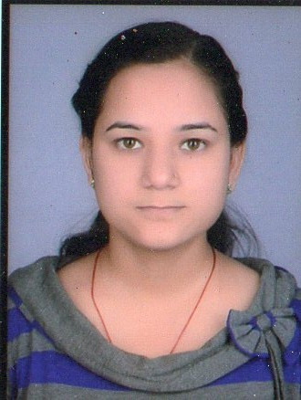
B-10, Gandhi Colony
Near Tulika Convent School
Morena (M.P.)-476001
Mob: 8269414497
Email- nehatomar61@gmail.com

Career Objective:-

To apply my skills to gain deep exposure in various business environments and to establish myself as a capable manager. I am a team leader with excellent management, technical, communication and presentation skills.

Experience:-

10 months experience as a Customer care executive in IIFL Morena.

11 months experience as a agent in Reliance Life Insurance Morena.

Educational Qualification:-

Level of Study | School / College | University | Performance
- M.B.A. (H.R.)  - 2011-2013 | - Prestige Institute of Management,  - Gwalior | - Jiwaji University, Gwalior | - Tot=64%
- B.Com  - 2008-2011 | - Girls College, Morena | - Jiwaji University, Gwalior | - Tot=62%
- D.C.A.  - 2009 | - Victor Institute of Professional Studies, Morena | - Makhanlal Chaturvedi  University,  Bhopal | - Tot=57%
- 12th  - 2008 | - Tulika Convent School, Morena | - M.P. Board, Bhopal | - Tot=67%
- 10th  - 2006 | - Tulika Convent School, Morena | - M.P. Board, Bhopal | - Tot=69%

Trainings:-

45 Days training in ING Vyasya, Gwalior, under Sanjeev Mehra

Strengths:-

Always willing to take new challenges, ability to learn new things quickly & a good team player.

Hobbies:-

Internet Surfing, Reading Books, Listening Songs.

Personal Profile:-

Name : Neha Tomar
Father’s Name : Mr. Ram Avtar Tomar
Date of Birth : 27th May 1990
Sex : Female
Martial Status : Married
Languages Known : English and Hindi
City : Morena (M.P.)

Place- Morena Neha Tomar

