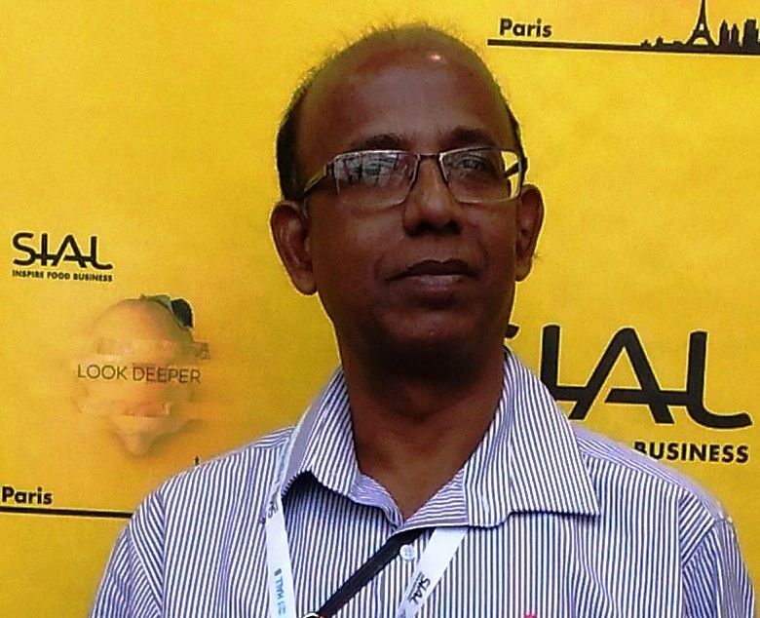
SAMIR KANTI BISWAS , B.E.(MECH.), M.I.E & Chartered Eng.
Date of Birth :13.01.64. Flat no.: S-3, Block-B, Santi Nibas Apts., 42/1,Netaji
Subhas Road, near FCI godown,Kolkata-700 132. 9432898737, 8013581658 .
E-MAIL : skbkol[at]hotmail[dot]com, bsamirkol[at]gmail[dot]com

Job Objective
B.E (NIT) & Chartered engr., 29+ Yrs. expert of smart work in Shop floor management, Project management, International Business Development & representation of co. in International Fairs and Plant operation & maintenance management. (Agro & FMCG, Steel & Power, Cement, Chemical & Fertilisers )., I would like to establish myself in a job that offers satisfaction through continuous knowledge acquisition and where achievement gets its due reward. Possessing good Communication skills and Leadership qualities, excellent Group culture, ability of Smart work and Zeal to learn the things, P & L responsibility of business by Analytical & problem resolving skill .

Experience
28+ Years Plant Operations & Construction in Process Industries & International Business Development (Agro & FMCG, Steel & Power, Cement, Chemical & Fert.), HOLDING 10 YEARS US VISA (B1/B2).

Key Skill
Excellent negotiating skills, telle marketing, enthusiasm, strong interpersonal skills, good grasping power, International Business Development, P&L, Shop Floor Management, Project work, Administration, Production process, Preventive, Predictive & Breakdown maint., taking responsibility as a SBU Head.

Primary Skills
Expert in Shop Floor Management, Project work, Administration, Production process, Preventive, Predictive & Breakdown maint., International Business Development , Effective team work & Safety, Energy saving & House keeping, Reduction of production wastage, Scrap disposal,Valuation of plant & machineries, Controlling of indents , Purchase & Work orders, Materials management, Inventory control, Important Liasoning work etc., Auditing of Quality control related affairs, Passing of bills, Cost effective targeted production, Preparation of plant budget, Training of engineers & skilled workers, Solving critical problems of plant, Negotiations with Financial Institutions, vendors, contractors, outside parties, Statutory Compliances with Govt. Authorities, etc.etc.

Strong Decision maker, ‘have to do’ attitude, Analytical & problem resolving skill, Strong International tie ups with renowned buyers and representation of the company to the Global platform, Corporate communication, Business planning , it’s development & Finance, P&L responsibility of the Company businesses.

Secondary Skills
Hands on experience in the Operation of Process plant machineries, all type of programming, computer operation etc. Having a practice to be involved in any problem for finding out a solution, etc.etc.

Achievements
- In business tie up with Europe, Japan ,Thailand ,USA ,Australia ,Middle East , Africa etc etc. like Walmart, ALDI, Family Dollar, 99p Stores, MOI Australia, Basso, Olio Goccia & Monini Italy, Bridgewell, Gemsa, Bakels and many others. Business turn over 55 million USD.
- Previous food business turnover was of Rs.45 crores in USA ,Canada , Russia, Europe, UK, Middle east, Australia. Obtained a single record P.O of USD 1.6 million from ALDI ( USA Super chain store ). My other prestigious customers were Wall-mart, 99p Stores, Family Dollar, Mikado, Dollarama, Field Harvest, TRI-S Food, United Food, Spirosky, Vitaland, Lorado, Pomona, HoReCa, La Casita, Feldthusen, TL Food, Codipex, La Colombe, Wunsche, Zakuson Inc. Three Threes Condiments Pty Ltd,
- Successfully set up 2 nos Modern Food Processing Units ( 100% export oriented ) from conception ,design etc. to total business development of Rs. 60 crore turn over at Karnataka.
- Expanded Present Group Business (approx.160 crores) in domestic & International Market .
- I have successfully Erected, Commissioned & stabled 3 nos. 350 & 2 nos.100 TPD SIDS (Integrated Steel Plants),2X8 MW Power Plants, 200TPD Coal Washery etc. etc. and successfully implemented Operation & Maint. Management in those areas.
- I had successfully implemented dust free char unloading, increased 01MW electricity production by using dust puffing from kilns, arrested and rectified red hot kiln shell by damaged casting in SIDS (integrated steel plants) (SAVING OF APPROX. RS.6 CRORES).
- I had successfully implemented my project “Reduction of Down Time” in Slag Dryer and Cement Mills at Cement Industry of Birla Corporation Ltd. (SAVINGS OF APPROX. RS. 1.5 CRORES).
- I had successfully improved the quality of granulated slag at the Cement unit of Birla Corp. Ltd.(WASTAGE REDUCED FROM 30% TO 10%).
- I was the head of quality control group “Viswakarma” at the Cement unit of Birla Corporation Ltd. Page 1 of 2

- I had successfully repaired one mixer shaft of SSP plant of Fert. Unit within 18 hrs.which needs 5-6 days for the replacement ( savings of Rs. 1 crore )
- I had successfully stabled Pulverized mills of SSP plants at Fertiliser Unit etc. etc.
- I had replaced one Scrubbing fan at SSP plant of Fert. Unit on line without stopping production.
- I had successfully erected & commissioned a new Pet Bottle line& expanded one Glass bottle line of an authorised bottler of COCA COLA COMPANY- USA.

- Education : B.E (Mechanical) from NIT/REC, Durgapur in 1987 in 1st. class.

Other Qualification(s) / Certification(s) : M.I.E. & Chartered Engineer.

- Awards : Certificate of merit and national prize.

Practical Training : D.V.C.,D.T.P.S., Durgapur, from 10.06.86 to 10.07.86.

Summary of Skills and Experience :

1. From November ’15 to present, CEO / President of Mandal Group of Cos. & looking after these cos. for International Business along with the Plant Operations & P&L. Taking active part of total group business & to outbreak as one of the largest producer & exporter of India

2. From August ’15 to August ’17 , President of Hemraj Group of Industries & looking after this co. for International Business along with the Plant Operations & P&L. Taking active part to revamp the total group business & to outbreak as one of the largest producer & exporter of India
Hemraj Group of Industries is a professionally managed, largest manufacturer, supplier and exporter of Physically Refined Rice Bran Oil, Crude Rice Bran Oil, De-Oiled Rice Bran Extraction and Rice of various varieties, in Agro Business of Eastern India . This group has 3 factories in W.B.

3. From March ’07 to August ’15 , G.M-Group Operations & International Business of S K Mall group (Agro & FMCG, Steel & Power, Plastic Extrusion & Import – Export ) and looking after Plants operations, Projects execution, Group Administration, Coordination among units, Business setup & development, Fund management , Corporate Liasoning, International Business & representation of co. in International Fairs etc.

Joined this co as G.M.(Operation)- Unit In-Charge of Sunil Ispat & Power Ltd.( S K Mall group ). I was in the leading role for the completion of SID (350TPD) by end Dec.’08 and started it’s production from Jan’09.

4. From May ’05 to February’07 , DGM (MAINT,WORKS & PURCHASE) of Ind Synergy Ltd .,having Sponge Iron Divn. of 3 lac ton per annum ,SMS of 2 lac ton per annum, Power Plant of 39MW, Coal Washery of 200TPH, Rolling Mill. I was in the leading role of 2X350TPD SID & 2x8MW Power plant, 200TPD Coal Washery project. and successfully implemented Operation & Maint. Management in those areas..

5. From Feb’04 to May’05, H.O.D- MECHANICAL of Salasar Sponge & Power Ltd., having 2X100TPD SID,12MW Power plant. I was responsible for the uninterrupted Production of the Plant. Also I was successfully completed the project of 2X 100TPD Kiln, RMHS and its Auxiliaries, for integrated SID and successfully implemented Operation & Maint. Management in those areas .

6. From Oct’02 to Jan’04, Plant Manager of an authorised bottler (BBPL) of COCA COLA COMPANY- USA, having 600 & 400 BPM RGB & 200 BPM Pet line and responsible for plant Admin. & Operation. I have hands on experience in various equipments of RGB & PET LINE. AND LATEST SBO PET BLOWING MACHINE. I was successfully expanded one glass bottle and one new Pet bottle line.

7. From July ’99 to October ’02 , I was Chief Engineer of Jayshree Chemicals & Fertilisers of B.K Birla Group. I had an overall responsibility of Mechanical, Electrical, Civil, Heavy Earthmoving, Weigh Bridge etc. departments of 2 nos. of Units over there. Also I had to look after shop floor management & a lot of administrative job, auditing of ISO related papers, negotiations with the Contractors, passing of bills etc., to solve critical problems of plant, to develope new planning’s & ideas to improve the efficiency of the plant & quality of the products.

8. From June, ’98 to July,’99, I was Valuer, Surveyor and Loss Assessor, Investigator, Consultant Engineer of General Insurance Corporation and Hindustan Lever Limited and “Works Executive” (Unit Head) of a Machine components manufacturing unit at Calcutta for Railways, Defense etc. My responsibility was to look after Administration and Techno-commercial affairs of unit.

9. From March,’88 to May, ’98 , I was engaged in Durgapur Cement Works of M P Birla Group, having capacity of 09 lac ton per annum. After completion of training and by showing my good performance in this industry, I was promoted upped Dy. Manager.

I had to look after operation and maintenance as well as breakdown works at different sections Also I had to look after Shop Floor Management, Plant administrative work, Planning for uninterrupted production as well as new ideas to improve the efficiency and quality of the plant.

10. From June ’87 to January ’88 and January ’94 to December ’95 , I was engaged with a Private Construction Co. as Tech. Consultant (Part Time) mainly for thermal insulation works in Durgapur Steel Plant, Durgapur Thermal Power Station, W.B.S.E.D.C.L, D.V.C. etc. S.K.Biswas. Page 2 of 2

