CURRICULUM VITAE 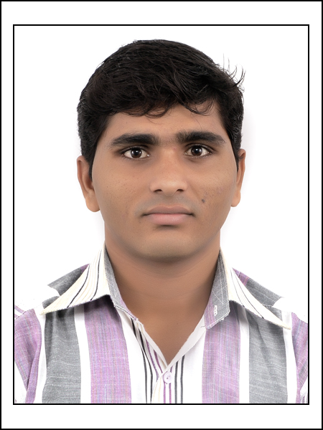

DHAPA GANESHBHAI BABUBHAI

Address: - TO: - Kalsar Email:- ganeshdhapa1990@gmail.com
TA: - Mahuva ganeshdhapa59@gmail.com
Dist.: - Bhavnagar
Pin no; - 364290 Contact: - (M) +91 9722207422
Gujrat Contact: - (H) +91 9898834066

CAREER OBJECTIVE:-

Seeking a challenging role to pursue my career & being an individual with good communication skills, commitment for work & flexibility. I believe in performing quality work in whatever field I work in. In zeal to explore new challenges & opportunities & hone my analytical & interpersonal skills & grow professionally through experience & my own individual efforts& ultimately foresee a position where I am able to oversee all major function of the division of an organization.

MAJOR STRENGTH:-

- Positive attitude, Dedication, Determination

- Being a team player & my interpersonal skills make me people’s man

- I have developed commitment towards my work & my ability to take initiative has helped me take up & complete successfully various curricular & non-curricular projects

- Hard work & being firm on principles
ACADEMIC CREDENTIALS:-

- I have completed B.E-TEXTILE TECHNOLOGY ENGG. IN affiliated to Gujarat technological university with 6.02 % CGPA (cumulative grade point average) and 5.68 CPI (current performance index) in year 2013 L.D.COLLEGE OF ENGINEERING .AHMEDABAD.

- I have completed HSC with 57.40% from GSHEB board in year 2009. KAMANI FORWARD HIGH SCHOOL , AMRELI.

- I have completed SSC with 71.38% from GSEB board in year 2007. V.L.MAGUKIYA MADHYMIK SALA MALVAV

CAREER HIGHLIGHTS:-

Present Status: - Working as a Manager Manufacturing ( E2) in Arvind Mills Ltd. Since 10/11/2014 at SHIRTING WEAVING PREPARATORY-SIZING (COTTON)

- Worked with Sr. Manager Manufacturing (E1) at Aarvee denim export .Pvt.ltd (Vijay fam) Ahmedabad division ( 6 Month)

- Worked with sizing production supervisor Dharmshil industrial Pvt. Ltd. ( 6 Month)

- Worked with spinning unit in auto Coro supervisor (open end spinning) Aarvee denim export .Pvt. ltd (Vijay fam) Ahmedabad division ( 6 Month) .

TECHNICAL KNOWLEDGE:-

- Worked with various types of m/cs.

- Sizing M/C : Sucker Muller, U-kil, Karl Mayer Jupiter ,Tsudakoma,
- Sec. Wpg. : Tsudakoma, Vamatex .
- Direct Wpg. : Tsudakoma.

JOB RESPONSIBILITIES/AREA OF EXPERTISE:-

PROFESSIONAL SKILLS:-

- Hands on experience of all shop floor activity & managerial skill

- Daily Production scheduling and provide plans for shop floor.

- Execution plan as per the availability of the man, m/c & material

- Knowledge of documentation as per regulating requirement

- Maintenance of discipline on shop floor & optimum use of man power & resources

- Process Development

- Train subordinates for quality improvement

WHAT I’M CONFIDENT & BRING ALONG:-

- Good People’s person

- Quality & Proactive approach oriented

- sustain the pressure & focus on action - results

- Ability to lead & manage team

- Effective hand-on industry experience

- Intimate understanding of the industrial environment

- Continuous Improvement focus

- Ability to develop ideas into workable plans

- Possess strong analytical & communication skill

- Excellent planning skill, interpersonal skill & people management capabilities

HOUSEKEEPING:-

- Ensuring overall division cleanliness by effective managing the housekeeping function

- Interpreting document such as safety rules operation

ACADEMIC VISIT & TRAINING:-

- I have visited ANKUR TEXTILE MILL AHEMDABAD & ASHIMA TEXTILE MILL AHMEMDABA.

- I have worked in project of AARVEE DENIM EXPORT .NAROL AHMEMDABAD.

- I have training MAFATLAL DENIM .LTD.PVT. NAVSHARIY.

EXTRA ACTIVITIES:-

- Participated in the VOLUNTEER in technical event in February 2012 at LDCE

- Participated in ROBOTICS in the TEONOX - 2012 LDCE,AIT,VGEC and I-FEST-2011 (Nirma university)

- Participated in as cricket cup in our college.

- Participated in as cricket cup in my company ARVIND LTD.PVT.

PERSONAL INFORMATION :-

SELF:- D.O.B. HEIGHT WT.

DAHPA GANESH BABUBHAI 05TH Sept 1990 5’ 8” 70KG

Marital Status: Married

Father: DHAPA BABUBHAI BIJAL BHAI he is a Farmer
Mother: DHAPA DEVUBEN BABUBHAI sheis a Housewife

PRESENT ADDRESS : - PERMANENT ADDRESS :-

DHAPA GANESH BABUBHAI DHAPA GANESH BABUBHAI
9 Foram park society TO: - KALASHAR
R.C politechnic Rod TA: - MAHUVA
Near Indian petrol pump DIST: - BHAVNAGA
Chandlodiya PIN NO: - 364290
Ahmadabad

Proficiency in Language : English, Hindi, Gujarati
Hobbies : Designing ,learning new,
Sports : Chess & crick
E-mail : ganeshdhapa1990@gmail.co
Contact No. : (M) +91 9722207422 / +91 9898834066
Current CTC : Rs. 2.85 Lacs p.a.

DECLARATION :-

I hereby declare that the information given above is true & best of my knowledge & belief.

Signature:- 

PLACE:- AHMADABAD YOU’RE FAITHFULLY
GANESH B DHAPA

