CURRICULUM VITAE

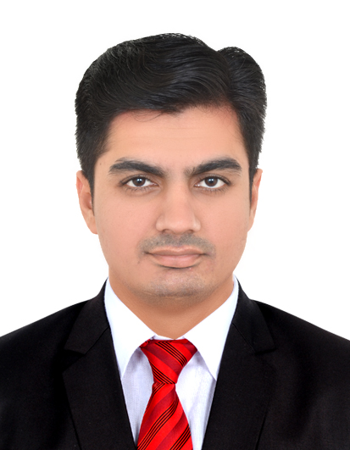
Dhruvin Bhavsar

Address : 301 Zainal Stars II,
Hamariya Street,
Near Musalla Round About,
Bur Dubai, Dubai.
Phone : (M) +971 5 2258 2569
Email ID : active.dhruvin@gmail.com

Career Objective:

To Work In A Managerial Capacity Where My Skills And Knowledge Will Be Utilized To The Maximum, Enabling Me To Grow With The Organization Growth, Thus Leading Me To A Successful Career.

Job Profile:

- Harshad Trading Co. LLC.
Deira Dubai, U.A.E.

Position: Branch Account In charge Sep 2014 To Continue...........

Duties :
- Directing All Operational Aspects Including Customer Service, Human Resources, Administration And Sales In Accordance
- Receive Payment By Cash, Check, Credit Cards and Vouchers.
- Issue Receipts, Refunds, Credits, Or Change Due To Customers
- Count Money In Cash Drawers At The Beginning Of Shifts To Ensure That Amounts Are Correct And That There Is Adequate Change
- Internal Branch Stock Transfer
- Petty Cash

- Tata Active Automobiles.
Sarkhej, Ahmedabad.

Position: Account Assistant Aug 2012 To Sep 2014

Duties :
- Issue Receipts, Refunds, Credits, Or Change Due To Customers
- Receive Payment By Cash, Check, Credit Cards and Vouchers.
- Maintaining A Customer Database Investigating Customer's Needs And Advising Appropriate Insurance
- Managing Databases And Filing
- Bank Reconciliation
- Providing Support To Our Managers And Employees, Assisting In Daily Office Needs And Managing Our Company's General Administrative Activities
- Claims (Event, Additional Support, Corporate, Demo)

- Shivam Computer Academy.
Meghaninagar, Ahmedabad.

Position: Branch Incharge April 2009 To May 2012

Duties :
- Directing All Operational Aspects Including Distribution, Customer Service, Human Resources, Administration
- Providing Training, Coaching, Development And Motivation

Key Skills:

- Confident And Hardworking.
- Loyal And Honest To All Work.
- Trying To Get Deep knowledge In Particular Field To Understand The Exact Concept.
- A Self-Motivated And Understanding.
- Problem Solving, Strong In Concepts, Go-Getter, Positivity, Passionate
- Quick Learner And Ability To Learn New Concepts
- Interpersonal Communication, Adaptable, Attentive

Education Qualifications:

- SSC From Guj. Board With 50.14 % In March 2006.
- HSC From Guj. Board With 52.86 % In March 2008.
- B.COM From Guj. University With Pass Class In Oct 2013.

Additional Qualification

- I Have Completed My PROFESSIONAL ACCOUNTING (Tally 9) Course From Future-star Consultancy With A Grade In July 2014.
- I Have Completed My CIRTIFICATE COURSE IN COMPUTER APPLICATION” (Microsoft Office, Internet & E-Mail) Course From NIC Education With “A+” Grade In Sep 2008.

Other Details

- Date Of Birth : July 25, 1991
- Gender : Male
- Marital Status : Married
- Nationality : Indian
- Languages Known : English, Hindi & Gujarati.
- Passport No : U4495204

Declaration

All The Information Mentioned In The Resume Are Correct To The Best Of My Knowledge And Believe

Dhruvin Bhavsar

