Curriculum Vitae

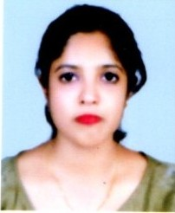
Gitima Rajkhowa
H No-100, Bagharbari
Panjabari, Shiva Mandir Path
Guwahati-781037
Ph. No- +919538320807
Email: gitimarajkhowa@gmail.com

Objective | : | To pursue long-term career in hospitality industry and enabling company objectives of growth, customer satisfaction and service industry by applying skill and knowledge.
Educational Qualification | : | - Xth from SEBA in the year 2006  - XII from AHSEC in the year 2008  - 3 yrs Degree Course in Hotel Management From IHM, Guwahati in 2011
Professional qualification | : | - 3 yrs Degree Course in Hotel Management From IHM, Guwahati in 2011
Industrial exposure | : | Completed 20 weeks of Industrial Training from  Hotel Brahmaputra Ashok,  Guwahati  Completed 4 weeks vocational Training from Hotel Brahmaputra Ashok,Guwahati
Experience | : | - Worked as House Keeping Associate in Ista Bangalore 24/06/11 to 31/01/12  - Ista Ahmadabad at 01/02/12 to 17/01/13 as House Keeping Associate .  - The Oberoi Bangalore 28/01/2013 to 31/1/2017.  - Trident Cochin from 1/2/2017 to 31/08/2018 Got transfer as housekeeping supervisor.  - Joined as House Keeping Executive at Courtyard by Marriott & Fairfield by Marriott, Bangalore Outer Ring Road from 3rd Sept’2018- 30th Octomber2019.  - Joined JIS Foundation Guwahati on 1st February2020 as hospitality traineer .
Core of interest | : | HOUSE KEEPING
Hobbies | : | Listening music, Dancing.
personal traits | : | Father’s Name | - | Mr. Motiram Rajkhowa
 |  | Date of birth | - | 06th March 1990
 |  | Sex | - | Female
 |  | Marital Status | - | Unmarried
 |  | Language Known | - | English, Hindi, Assamese
pARMANANT ADDRESS |  | House No.100, Bagharbari, Shiv Mandir Path,  P.O. Panjabari, Dist. Kamrup (Assam)  Guwahati - 781037
Correspondence address | : | House No.100, Bagharbari, Shiv Mandir Path,  P.O. Panjabari, Dist. Kamrup (Assam)  Guwahati - 781037
I do hereby declare that all the above information’s are true to the best of my knowledge.
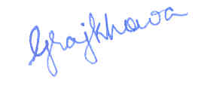
Date:
Place: Guwahati (GITIMA RAJKHOWA)

