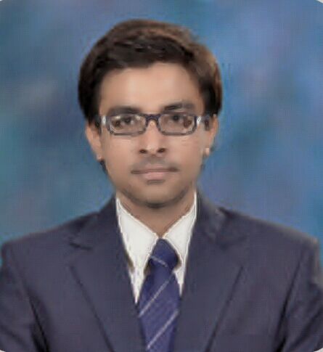

NIKUL P. PRAJAPATI.
EMAIL :Nikulpprajapati92@gmail.com
MOBILE No: +91 8460693944.

CARRIER Objective:

To open up the career with a challenging job where Values, Vision and Knowledge can
Be learned. Keeping the knowledge update and having the personality improved with the
Richness of experience.

Educational Qualification:

Examination | University/Institute | Year | Class
MBA(Finance) | Ganpat University | April-2014 | Second Class
B.com | Mumbai University | March-2012 | First Class
H.S.C. | Maharashtra State Board | February-2009 | First Class
S.S.C. | Maharashtra State Board | March-2007 | First Class

TECHNICAL QUALIFICATION

- Well versed with concepts of Basic Computer, Internet Application
- Tally 9.1.

PROJECT STUDY

- In MBA 3rd semester we have done MRP-1 (Management Research Project) on
“Wrist Watch Industries in India.”

- In MBA 4th semester we have done MRP-2 (Management Research Project) on
“An Inventory Turnover and its impact on Financial performance of two different Indian Industries.”

- SUMMER INTERSHIP PROJECT (SIP)
I have done SIP in Aroma Pumps Pvt. Ltd. at Palanpur

Project Title | “Financial Analysis”
Company | Aroma Pumps Pvt. Ltd.
Duration | 9thMay 2013 to 23rd June 2013

PERSONAL SKILL

- Creative, Always like to do & Learn New Things.
- Believe in Perseverance & like to work in Team.
- Outstanding ability in Rendering Service and Respecting Authority.
- Positive Attitude, Flexibility in nature, Decision Making Abilities.
- Excellent Communication skill teamed with ability to develop an admirable rapport with employees and peers.
- Ability to maintain a calm composure, and with efficiency in fast-paced pressure environment.

LANGUAGES KNOWN

- English, Hindi, Gujarati.

HOBBIES

- Travelling, Listening Music, Dancing.

PERSONAL DETAIL

Date of Birth: 21stApril 1992.
Nationality: Indian
Marital Status: Single
Permanent Address: At post-Ganeshpura, Ta-Siddhapur, Dist-Patan,
North Gujarat. Pin-384151.

I hereby declare that the above given details are true to the best of my knowledge and belief.

NIKUL P. PRAJAPATI

