Resume 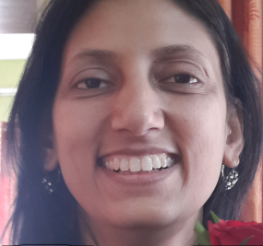
Name: Nidhi Mishra
DOB: 8th February,1970
Address: A-404 ,Sarjan Towers Memnagar , Ahmedabad-52
Contact: mittumini@yahoo.co.in
Mob: 7046334191

Educational background:
M.A.- English Literature- 1993- University of Lucknow.
B.ed –IGNOU- 2008
Intermediate-1988- Loreto Convent, Lucknow.
ICSE- 1986-St. Agnes’ Loreto Day School, Lucknow.
Professional background:
Have been working with Zydus School for Excellence, Vejalpur Ahmedabad since 2004.(13+ years)
Current CTC- 5.5 lakhs p.a
I have previously taught at St. Fidelis Senior Secondary School , Lucknow and Modern School Lucknow)
Professional achievements:

- The teaching and result in the senior secondary classes- (ICSE and ISC)
- I have worked in various capacities viz. H.O.D, mentor and coordinator.
- As HOD for English , have chalked out ways for the improved teaching- learning in the subject.
- Have helped to initiate and mentor new team members into the school system.
- I was Head of Exam Department when it was established and was in its nascent stage.
- Training students for various inter school events like public speaking, creative writing, elocution , MUN and others.

Soft Skills Mantra: My strength.
It is of utmost importance that leaders in keeping with the systems and procedures have a certain empathy and sensitivity towards colleagues. Communication skill and clarity of thought in keeping with the larger vision of the organisation is what I lay a lot of emphasis on because it can help us tackle complex issues.
Keeping this mantra in mind I have executed my primary duty, that of a teacher and have taken up the other duties with utmost passion. I feel I have the natural ability to mentor, counsel and lead and I think I would do justice to any position that I take up.
Hobbies:
Travelling ,music and cooking are a few things that I enjoy during leisure time

