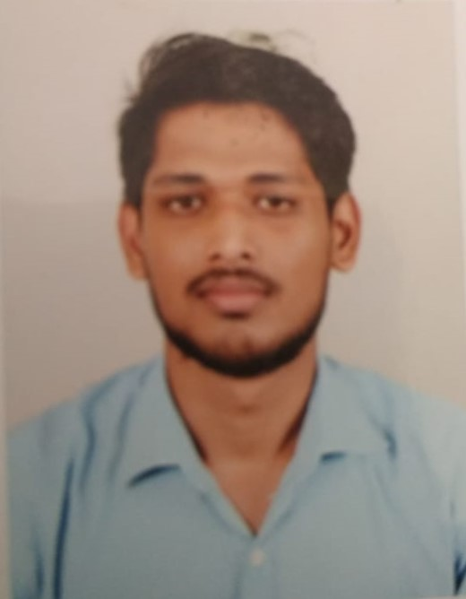
Rajeev Sharma
sharmarajeev1200@gmail.com
+91 903-331-3573

Objective:
To become associated with a company where I can utilize my skill and gain experience while enhancing the company’s productivity and reputation.

Professional Skills:

Skills: Internet literate, MS Word, MS Excel, MS PowerPoint
Languages: English, Hindi, Gujarati

Education:

Degree | Institute/School | Board/University | Passing Year | CGPA/%
MBA | L.J Institute of Management Studies | G.T.U | 2020 | 72.9%
B.Com | J.G college of commerce | Gujarat University | 2015-2017 | 53.8%
HSC | Aditya Birla higher secondary School | GSEB | 2015 | 75.00%
SSC | Aditya Birla higher secondary School | GSEB | 2013 | 80.00%

Projects:

Havmor PVT LTD (Internship)
Top Distributor and their behaviour.

Health Awareness Week:
“To create awareness among people regarding vehicle pollution and P.U.C is Norms”

Social Cause:
“To create awareness among people regarding Girls education”

Archetype Week:
“Made a business model of Nashta Vala”

Experience:
Vedantu Sep 2019 - Present
Business Development Executive
Working as a BDE in order to grow and increase sales and network of Company.

EPOS GURU Jul 2017 – Aug 2018
Business Sales Associate

Tech Mahindra
Customer Care Executive Dec 2016- Dec 2017

Co-Curricular / Extra Curricular Activities
- Visited Radio City.
- Participated in health awareness week.
- Participated in different event and sports
- Adventure Event:- Coordinator in Business bazigar, sports & Decoration

Personal Details:
Address: D-205 Radhe vandan apartment, Kaneti road, Sanand, Ahmedabad.
Date of Birth: 26-12-1995
Gender: Male
Nationality: Indian
Marital Status: Single.
Hobbies: Travelling, Socializing, and Networking.

