CURRICULUM VITAE
RAJESH SHARMA 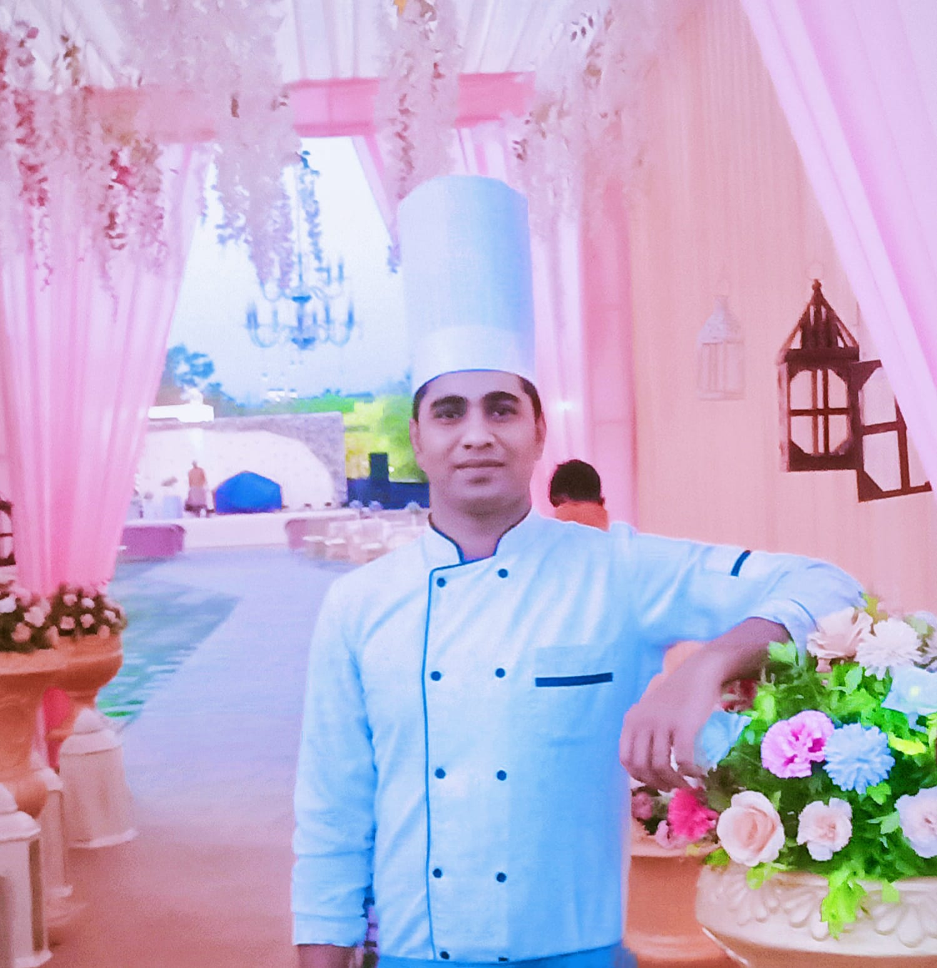

Objective
Looking forward to join a company for job which puts my knowledge and skills to their height of excellence in a competitive working environment.
.

Professional Experience

- Worked with Lemon Tree Premier, The Atrium Ahmedabad from 27/05/ 2017 to date 31/08/ 2018 a Apprentice in Food Production Department. 
- worked with Lemon Tree Premier The Atrium Ahemedabad from 01/09/2018 to 28/06/2019 as a Commi 3 in Food Production Department

- Worked with citrus hotel karwar Karnataka from 28/06/2019 to 22/04/2020 date as a commi 2 in production department



- Worked with Palm velley svasti hotel & resort udaipur Rajasthan from 16/11/2020 to till date as a commi 1 in food & production department

- Working with lemon tree premier Dwarka gujrat from 17/09/2021to till date

Job Description
• Assist in the preparation & service of all food according to the hotel recipe.
•Ensure the cleanliness & maintenance of all area, utensils & equipment.
•Follow all safety & sanitation policy when handling food & beverage.
• Assist the CDP to plan & prepare quality service for the food & beverage.
• Assist to measure the Ingredients & Spices.

Academic Qualification

- Intermediate From U.P Board.
- Secondary Examination from UP Board

Best Award

- Appericiation latter at palm valley savasti Hotel & Resort Udaipur Rajsthan
- Appericiation latter at Lemon Tree Premier Dwarka Gujrat

Information Technology Background

- Knowledge of MS-Office, Internet, Protel Software

Area of Interest

- Food Production.

Key Strengths

- Honest
- Problem Solving
- Goal Oriented
- Positive Attitude

Language Proficiency

- Voice: Hindi , English ,Bhojpuri

Hobbies

- Listening Music.
- Chatting with friends.

Personal Particular

Date of Birth : 15th July 1999
Father’s Name : Mr. Ambika Sharma
Nationality : Indian
Status : Single
Gender : Male
Marital Status : Single
Blood Group : B⁺
Email id : sharmarajesh277124@gmail.com
Contact No. :+917376958498, +919662640930
Passport no T 1809440
Address : Rajesh Sharma,
At:-Usasa Pur, Dist:-Ballia
Uttar Pradesh 277124

Declaration

I am hereby declaring that all the details furnished above are true to the best of my knowledge.

Place: BALLIA
Date: Rajesh Sharma

