RESUME
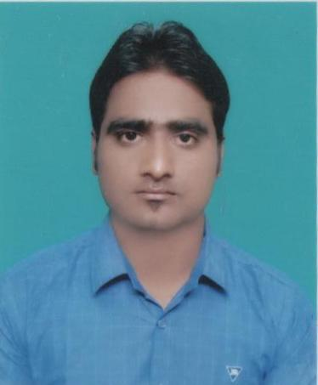  AMAR TIWARI  MOBILE NUMBER  07020067676, 09451566192  EMAIL ID  amartiwari88@gmail.com  DATE OF BIRTH  15.06.1994  PAN NO:  AREPT9939J  Notice Period – 1 Month  Current Annual CTC – 3.2 lakh  Total Experience- 3 Year  CONTACT DETAILS  Bhagwati Vatica Opp.Punam Party Plot Kanjari Road  Halol,  Halol-389350  Gujarat,  PERMANENT  CONTACT DETAILS  Vill& Post –Mubarakpur Daiyadeeh, Dist-Ambedkar nagar, Pin No-224122 Uttar Pradesh  PERSONAL DATA  Name : Amar Tiwari  DOB : 15.06.1994  Father name : Swami Nath  Tiwari  Gender : Male  Mother tongue : Hindi  Nationality : Indian  Marital Status : Single  Hobbies : Listening Music, Travelling new places.  LINGUISTIC ABILITY  Hindi : Speak, Read, Write  English : Speak, Read, Write | OBJECTIVE:-  To pursue a career in the field of Engineering /Manufacturing which provides a challenging work environment and allows me to utilize my knowledge to contribute in the growth of organization.  I am a person with strong analytical skills and am very friendly with my co-workers and peers. I also like to take on challenging tasks at work. I also strive to maximize customer satisfaction.  EXPERIENCE  - I have 2 year 6 Months Experience as a Production Engineer in “GABRIEL INDIA Ltd” from 10.06.2015 to 31.12.2017.  Company profile:-  Gabriel India Ltd., is Member of Anand Group, located in Hosur which has got IATF16949 , QS9000 ISO9000 , ISO 9002 , ISO 14001 & OHSAS18001 dedicated to manufacture Ride control products (shock Absorbers, Rear & Front Fork) & Suspension system for Two wheelers and Three wheelers. Major customers of the company are TVS, HONDA, and SUZUKI & YAMAHA.  - Currently I am working in ENDURANCE TECHNOLOGY Ltd as a Production Engineer From 01.01.2018  Company Profile  Endurance Technology is one of India's leading automotive component manufacturing companies, located in Halol which has got IATF16949 ,QS 9000 , ISO 14001 & OHSAS18001 dedicated to manufacture Ride control products (shock Absorbers, Rear & Front Fork) & Suspension system for Two wheelers and Three wheelers. Major customers of the company are TVS, HONDA, and SUZUKI & YAMAHA.  Responsibilities as a Production Engineer in Endurance Technology Ltd :-  - Attending daily production meeting And Production Planning.  - Manpower Handling and give on Job training.  - Maintaining line wise hourly production reports.  - Update all reports in SAP system.  - Materials follow up for line feeding.  - Weekly meeting for Quality concern, special precautions, any customer complaint, visit/audits.  - Verifying in process inspection report (I PI R).  - Poke yoke verification.  - Implementing 5s activity in shop floor.  - Calculating OEE and updating.  - To ensure the smooth flow of materials to next customer.  - Maintaining line QRQC.  - Motivating the team to achieve daily and weekly production targets.  - Having discussion with team on daily basis to reduce the in process rejections.  - Maintain and improvements through KAIZEN  Kaizen:-  - Change Grinding Wheel against of costly Grinding Wheel.  - Grinding filter paper changed for Grinding machine.  Technical Expertise:-  - 5s  - KAIZEN  - 7QC TOOLS  - TPM  - POKA YOKE  - 16 MAJOR LOSSES  - TPS  - OEE  - PPM  - QRQC  Achievements & Awards:-  - Achieved 100% On Time Delivery.  - Achieved Zero Customer PPM for continuously 6months.  - Achieved zero Accidents in shop floor.  - Award of Best Operating Engineer.  - Award of maximum suggestions.  Educational Qualifications:-  - Diploma. In Mechanical Engineering passed out in 2015 With 69.3% From Hewett Polytechnic Lucknow.  - H.S.C With 51% from B N INTER COLLEGE AKBARPUR AMBEDKAR NAGAR  - 12th with 69.3% from B N INTER COLLEGE AKBARPUR AMBEDKAR NAGAR  Strengths:-  - Positive thinking & attitude.  - Ever ready to work under deadlines  Keywords:-  - Supervisor  - Declaration:-  I hereby declare that the above side particulars are true to the best of my knowledge.  Yours sincerely,  Amar Tiwari

