CURRICULUM VITAE

 Address:- B-1/22 Saffrony Apartment
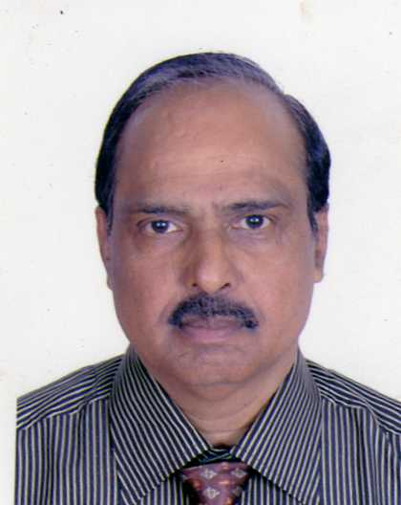
Opp: Sarkari Tube Well
Bopal, Ahmedabad-380058
 Mob: +91 9558014733
 gopisreedharan@gmail.com

GOPI SREEDHARAN
IMO NO. 8980645489

“Post applied for “Personal Assistant to CEO”.

Career Objective
Seeking a successful career in a growth oriented organization, which fully utilizes my zeal and commitment towards my work and gives me a competitive atmosphere to check my enthusiasm and results in my self development. Willing to work as a key player in challenging, dynamic and creative environment.

Special skills
- Excellent Team Building and Leadership Skills
- Excellent Coordination and Planning Skills.

Educational Qualifications
- B.A. with Indira Gandhi National Open University.
- SSLC from Secretary Board of Public Examination Kerala.
- Typewriting & Stenography with a speed of 100 w.p.m. in shorthand & 50 w.p.m. in typewriting with Azad Hind School of Commerce, Pathanapuram, Kerala

Computer Skills
MSOffice / Word/ Excel, PowerPoint, etc.

Languages known | Read | Write | Speak
English [US, UK] | √ | √ | √
Hindi | √ | √ | √
Gujarati | √ | √ | √
Malayalam | √ | √ | √
Tamil |  |  | √

1. Experience

Currently I am working as PA to MD & Chairman with M/s Multi Mantech International Pvt. Ltd., Ahmedabad, India since 10/03/2011.

2 Experience
Secretary with Suvadh Contracting L.L.C. a Dolphin Group of Companies Dubai, U.A.E. from 10.12.2007 to 10/12/2010.

Job Profile - Handling construction related communications, taking down dictations, doing independent correspondence, preparing Invoice, variations, updating variation summary, sending Fax messages, attending meeting and making minutes of meeting and circulating the same to all concerned, preparing weekly report, monthly report, collecting critical issues of all sites and submitting the same to the management to resolve the issues, attending telephone, coordination with concerned departments, organizing meetings, keeping records etc, etc. During the above period my services were utilized in Suvadh Metal Structure Manufacturing LLC, RAS AL KHAIMAH for 3 months.

3. Experience
Secretary Reporting to Executive Director with Cadila Pharmaceuticals Ltd., Ahmedabad, India from 21.11.1996 to 07.12.2007.

Job Profile - Looking after administrative activities of R&D, F&D, Supply Chain, Distribution & Logistics function. Taking down dictations of letters, fax messages, minutes of meeting, project report, operating computer, well versed with word processing, spreadsheets, presentation packages, PowerPoint, (MSOffice), fax, internet, arranging tickets, hotel accommodation for Boss, fixing appointment, coordination with concerned departments, organizing meetings, keeping records etc, etc.

4. Experience
Personal Assistant with Mantech Consultant from 15.02.1996 to 20.11.1996.

Job Profile – Secretarial

5. Experience
Personal Secretary to Chairman with Prarthana Construction from 16.08.1994 to 08.02.1996

Job Profile – Secretarial & Administration

6. Experience

Secretary to GM with Sterling Catering Service Doha - Qatar from 24.01.1993 to 01.05.1993

Job Profile – Secretarial & Administration

7. Experience
Steno Secretary with Inductotherm [India] Ltd. Ahmedabad, India, from 17.04.1986 to 16.01.1993.

Job Profile – Secretarial & Administration.

8. Experience
Personal Assistant with Calico Mills Ltd. From 16.10.1984 to 15.02.1986.

Job Profile – Secretarial & Administration.

9. Experience
Steno Secretary with Gujarat Government Irrigation Department from 28.04.1978 to 14.03.1983.

Job Profile – Secretarial & Administration.

Playing Hobbies
Traveling, watching TV, Internet surfing, etc

Current Salary : INR. 25,000/- per month

Expected Salary: Negotiable

Joining time required: Two months

Current Location : Ahmedabad

Strength

- Intelligent Hard Work
- Good communication skill
- Perseverance
- Honesty, sincerity

Weakness
- High level of ambition
- Expectation of perfection –
- and order tendency to help everybody
- Attachment to wife & children
- Transparencies

Achievements

- During the service with Dolphin, Dubai I learnt about construction related activities in Gulf that was one of the achievements.
- During my stay in Dubai I got an opportunity to visit the World tallest Building Burj Khalifa that was a wonderful achievement in my life.
- During the above mentioned period I had visited Jumairah & Fujairah Beaches along with my colleagues, and we took a bath over there.
- I have also visited Cornich Park Abu Dhabi.
- During my service in Cadila, Medical Department with Doctors, I learnt medical terminology, prepared lot of presentation slides, Prepared Therapeutic Index and attended various products launch meetings, etc.
- In Cadila Supply Chain, Distribution and Logistics, F&D, R&D Department enabled me to attend teleconference, Video conference along with my Boss and prepared the conference minutes of meeting and circulated the same to the Global players. A lot of things had to be taken care of and day-to-day there is a scope of learning something new due to launch of new products with the changing needs and requirements of the customer.

Personal Profile

Name : GOPI

Father’s Name : Late Shri Sreedharan

Date of Birth : 19/04/1952

Marital Status : Married having one son & one daughter

Permanent Address : B-1/22, Saffrony Apartment, Opp: Govt. Tube Well,
Bopal, Ahmedabad-380053, India

Passport No : K-1966248

Phone No. : Mob: +91 9558014733

E-mail : gopisreedharan@gmail.com

Declaration

I hereby declare that particulars given herein above are true and complete to the best of my knowledge and belief.

Place: Ahmedabad (GOPI SREEDHARAN)

