DESAI FULESH NAGJIBHAI 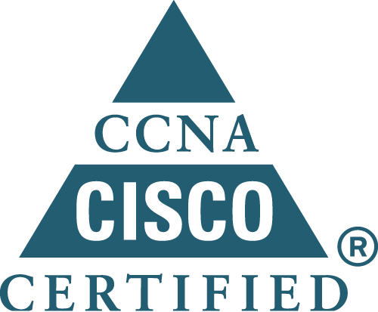
Mob no:9408233152 E-mail:fulesh.desai@gmail.com

Present add: 59/789, Prakashdip Appt’s, Behind Vyas Vadi,New Vadaj, Ahmedabad. Gujarat, India.
Professional objective:

- I seek a career in an organization that provides motivation, Ambience, upward mobility and exposure to innovative technology & procedures I seek a position in accordance with my technical education to utilize my skills and Abilities as a network/ hardware engineer

Result Summary:

Course | University |  | Passing year |  | Percentage
12th Science | G.S.E.B |  | 2001 |  | 46 %
10th Science | G.S.E.B |  | 1999 |  | 69%
DIPLOMA IN COMPUTER ENGINEER. | T.E.B.E | 2006 |  | 55.96%

Projects & Experience:

- Participated in the Project of “bank” by using “VB, Oracle” language
- 6 Months Vocational Training in Compex Technology, Ahmedabad
- 6 Months Experiance as computer hardware Engg in Compex Technology, Ahmedabad
4. PC Net Technology Pvt. Ltd, Ahmedabad (01/03/2005 to 30/11/2007)

- Times of India At Ahmedabad (AMC)
- Larsen & Toubro At Ahmedabad (AMC)
- Zenith Spinners At Ahmedabad & Dholka (AMC)
- Johnson Engineering & Moulding Co‎ At Ahmedabad & Viramgam (AMC)
- Hester Pharmaceuticals Limited At Ahmedabad & Sanatej (AMC)
- Lubi Group Of Industries At Ahmedabad (AMC)
- ACE At Ahmedabad (AMC)
- Italliya Ceramic At Ahmedabad (AMC)
- Hudco At Ahmedabad At Ahmedabad (AMC)
- Acme Intl Liited‎ At Ahmedabad (AMC)
- CMIE At Ahmedabad (AMC)
- SHILP GRAVURES LTD At Ahmedabad (AMC)
- SHREE HANS ALLOYS LIMITED At Ahmedabad & Dholka (AMC)
- Nirma Institute At Ahmedabad (AMC)
- Daga Global Chemicals Ltd At Ahmedabad (AMC)
- Tmvt Industries Pvt Ltd At Ahmedabad (AMC)

Work experience at PC Net Technology Pvt. Ltd

- Infrastructure Analysis/Design: - LAN set up & administration, small-scale network design, implementation, integration and commissioning, Microsoft outlook and outlook express.
- Operating Systems:- Windows 9x, Microsoft windows ME/XP/2000,, and Microsoft windows 2000/2003 server.
- Hardware:- Server, PC, NIC, Modem, Hub, Switch & Router
- To monitor whole network like creating domain, updating antivirus, print server, internet configuration, installation of printers and other IT equipments, maintain Outlook,data backup, intranet site development.
- Done work As Ahmedabad all site In charge.

- I have worked as Desktop support And Networking Engg. In Chem E Tech at Ahmedabad
- I Have 2 years Experience In Call Center As Customer Care Executive.
- I am Recently Join At Kaizan It Servises As Cutomer Support Executive.

Professional certificates:

- CCNA (Cisco Certified Network Associate) Done with 936/1000
- Network Implements
- Configure, verify and troubleshoot a switch with VLANs and interswitch communication.
- Implement and IP addressing scheme and IP services to meet network requirement.
- Configure, verify and troubleshoot basic router operation and routing on Cisco devices.
- Explain and select the appropriate administrative tasks required for a WLAN.
- Identify security threats to a network and describe general methods to mitigate those thre.
- Implement, verify, and troubleshoot NAT and ACLs in a medium-size enterprise branch office.
- Implement and verify WAN links.

Personal Information:
- Name : Fulesh Desai
- Father’s Name : Nagjibhai Desai
- Sex : Male
- Marital Status : married.
- Nationality : Indian.
- Languages Known : English, Hindi, Gujarati
- Hobbies : Playing Cricket,Reading books
- Mobile no : 9408233152 , 9998650575

Information mentioned above is true to the best of my knowledge
Fulesh desai

