CURRICULAM VITAE
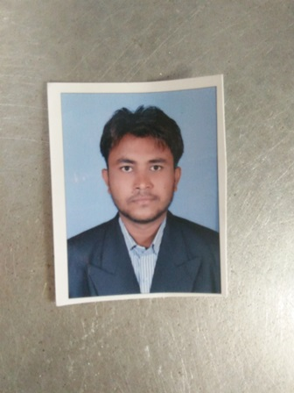
VINOD. B. MAKWANA
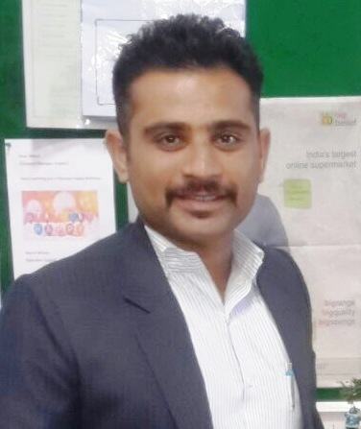
Email Id: - saxenavicky1986@gmail.com
Mob-9714464479 / 7984497935

BRIEF OVERVIEW
A dynamic professional with more than 6 years of experience in the areas of housekeeping, Filed work and Marketing, Corporate Client building, Inventory Management, Visual Merchandising, Customer Service, Cash Management & Team Management. Deftness in handling overall functioning of back office Operations. Excellent interpersonal, communication & organizational skills with proven abilities in team management, customer relationship management & effective crisis & warehouse management.

PVR ltd 19th JAN, 2018 TO PRESENT
In India, PVR cinemas, is the largest and the most premium film entertainment company and is listed as India's Most Trusted and Most Attractive brand consecutively for three years since 2013 in the Category of Entertainment and Display. The journey from a single screen to 704 screens has been stupendous. As we continue to grow, we strive to excel in the minds of our patrons by bringing the latest technology, the most sought after content, world class ambience and scrumptious F&B services. We are a consumer company; our dedicated team at PVR takes immense pride in providing the complete user experience.

Working as a HK - OPRECTION Executive (19th JAN 2018)
- I am best training and smooth guideline for housekeeping
- Good management and soft skill
- Every type situation handle and smooth work
- Good service for company
- Proper documentation.
- Maintain weekly wise training all tips.
- Responsible for inventory management and identifying the products categories.
- Weekly and monthly stock audit and maintain the base level of stock.
- Analysing requirements of goods and reporting to C.G.M. AM for regularly.
- Managing and handling store operation and stock inward & outward.
- Ensured Store maintenance, general administration & safety producer.
- Handling GRN & COGS Activity on daily basis on VISTA.

Previous Work Experience:-

- 2 year ( 2013 to 2014 ) AHMEDABAD ASHARWA CICIL HOSPITAL AS SANITARY INSPECTOR
- 1 YEAR (2015) DISHMAN PHARMACEUTICALS CHEMICAL PVT. LTD AS HOUSEKEEPING EXECUTIVE
- 2 YEAR (2016 TO 2017) INTAS CORPORATE OFFCE AHMEDABAD AS HK – EXECUTIVE
- CURRANT (2018) PVR CINEMAS LTD HK – OPRECTION EXECUTIVE
Qualification | Institution / University | Year of Passing | Percentage
B.COM | Gujarat University | 2016 | PASS
S I ( SANITARY INSPECTOR ) DIPLOMA | MUMBAI UNI | 2013 | PASS

Technical and Soft Skills
- Knowledge about MS Office, Tally, Microsoft Power Point, Microsoft Excel.
PERSONAL DOSSIER_____________________________________________________________
Contact Address : 448 / R D COLONY, OPP, BAPUNAGAR CITY GOLD CINEMAS,ANIL STARCH
ROAD,SARASPUR, Ahmedabad - 380018
Date of Birth : 06 JUN 1996
Languages Known : English, Hindi & Gujarati.
REFERENCES____________________________________________________________________
Available on request

DATE:
AHMEDABAD MAKWANA VINOD

