Curriculum Vitae

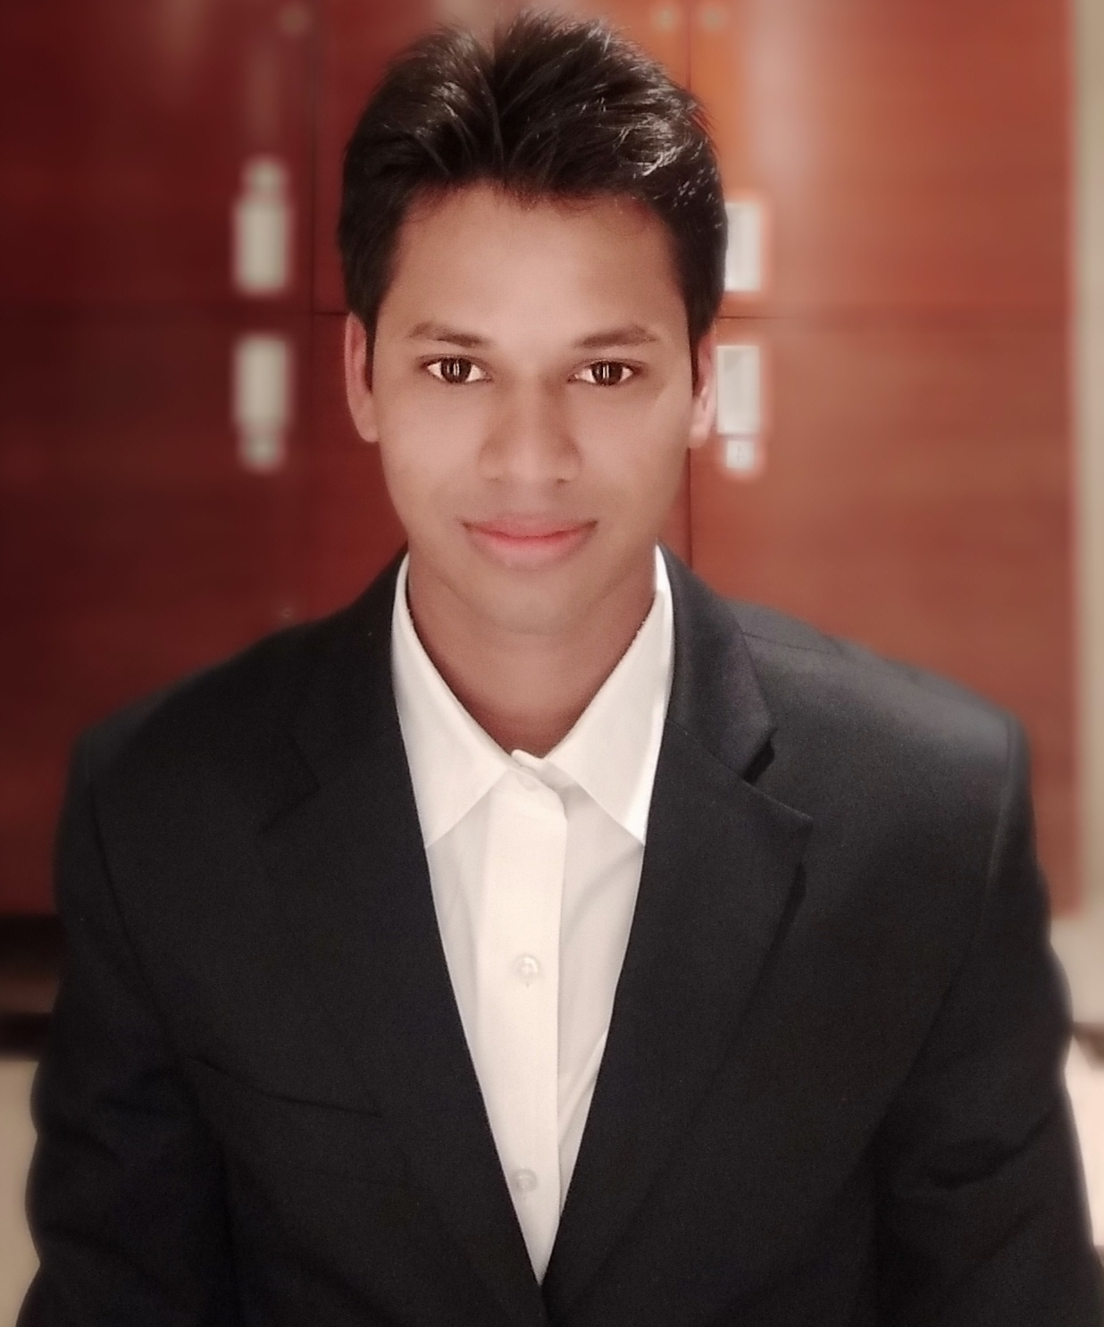

Sandeep Kumar
Vill. Rastamau post. Mangrouli
Dist. Amethi State. Uttar Pradesh
Pin code (227816)
Sandeepsaroj01011997@gmail.com +919838652322

Job Objective:

Seeking a position as Laundry Attendant & valet in highly reputed and professional organization.

Summary of Qualifications:
Profound knowledge of administering a laundry setup.
Ability to exert physical effort in moving bundles of linen into and out of equipment.
Remarkable knowledge of setting proper drying for different types of linen.
Excellent ability to remain alert while operating laundry equipment.
Ability to lift bundles of linen weighing up to 75 lbs.
Strong physical ability to stand and walk for extended periods of time.
Ability to perform assigned duties with attention to detail, speed, and accuracy.
Ability to endure working in area of high temperatures with lint accumulations.
Ability to prioritize and organize work.
Excellent verbal and written communication skills.

Work Experience:

Operated washing and drying equipment, loading and unloading laundry from machines.
Administered cleaning agents to laundry according to product specifications.
Monitored feeder information on washers, ensured all drums are full.
Ensured to set the proper drying and cooling times for different types of linen.
Managed to clean up machines and surrounding areas.
Ensured to comply with attendance rules and be available to work on a regular basis.
Identityfication garments of guest laundry & uniform.
Micros operating and bill posting of guest laundry.
Inventery of room linen and uniform.
Handling guest request and problems and providing good satisfaction to guest.

Educational Qualification:

Completed B.A from Awadh University Uttar Pradesh From 2015 to 2018.

Professional Experience:

I Have Worked in CROWN PLAZA AHMEDABAD CITY CENTRE from 15 September 2017 to 04 January 2019 contrect base as a laundry attendant.

I Have Worked in RENAISSANCE MARRIOTT HOTEL IN AHMEDABAD since three month completed as a laundry attendant.

I Have Worked in COURTYARD BY MARRIOTT HOTEL IN AHMEDABAD as a laundry attendant from 08 April 2019 to 10 August 2020 date.

I Have Worked in CROWN PLAZA AHAMDABAD CITY CENTER as a laundry attendant from 11 February 2021 to 10 January 2022 date.

I am working in CADILA PHARMACEUTICAL LIMITED COMPANY as a laundry attendant from 07 February 2022 to till date.

Skills :-. : Laundry valet.
: Working Experiences with MICROS.
: Ability to work in all shift.

Achievement: : 01Time awarded as
"ASSOCIATE OF THE MONTH"
Courtyard by Marriott
ahamedabad

Personal Details:

Name : Sandeep Kumar

Date of Birth : 1st Jan 1997

Father Name : Ram Yash

Mother Name : Shyama Devi

Gender : Male

Blood Group : A +ve

Marital Status : married

Nationality : Indian

Languages : English, Hindi.

Hobbies:

- Playing Cricket
- Writing

INTEREST:

Looking forward of getting an opportunity to be part of your esteemed organization ..

Date :

Place : (Sandeep Kumar)

