CURRICULUM VITAE
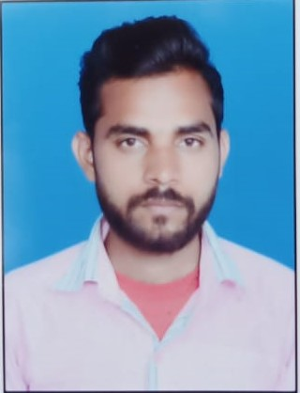
ypos:0.203472in; frame-width:1.587500in; frame-height:2.073611in; xpos:4.201389in; frame-type:image

kaushik vankar
Mechanical Operater,
AT.PO. AMBALIYARA SIDDHARTHNAGAR
TA.BAYAD
DIST.ARAVALLI 383325

Carrier Objective:

To work in a challenging environment that provides generous opportunities for learning. In the field of manufacturing/maintenance/quality.

Personal attributes:

Calm and determined under pressure, Effective problem solver, Tactful and patient communicator, Customer focused, Success motivated, Health and Safety awareness.

Personal Profiles:

Name | KAUSHIK VANKAR
Date of Birth | 18-12-1994
E-mail | kaushiksoneri7474@gmail.com
Contact No | +918401501091 (M)
Gender | Male
Caste | Hindu
Marital Status | married
Hobbies | Playing Cricket
Languages Known | English, Hindi, Gujarati
Goal | To develop new products using current tools & technologies which can be sold in entire world & helps to reach Indian economy as well as company and make myself on top.
Strength | Discipline, Ability to learn new and more skills, leadership, hardworking and self-confidence, having discipline is the ability to gain control by obedience

Educational Qualification:

Qualification | Year of Passing | Board | Percentage
H.S.C | March-2012 | GSHEB | 62.14%
IGTR | 2013 | DEHLI | 82.00%
I.T.I(FITER) | July-20116 | NCVT | 72.00%

Field of Interest

- Mechanical Maintenance
- Quality Control/Quality Assurance
- Production

Computer Literacy:

- M.S. Office.

Work experience:

1) ORGANISATION
▪ Company Name : AAKASH OIL FIELD AND SERVICES PVT. LTD.
▪ Designation : UNSKILLED OPERATOR
▪ Duration : May 2015 to till date.

Declaration:

I hereby declare that the information furnished above is true to the best of my knowledge. More for the mentioning can be overridden once we have personal interaction with each other. I shall not disappoint you is for sure. Looking forward your response.

YOURS SINCERELY,

VANKAR KAUSHIK

