CURRICULUM VITAE

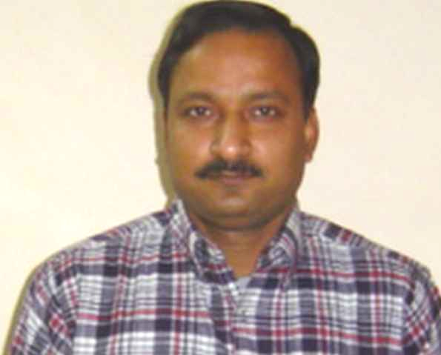
ASHWINI KUMAR SINGH

House No. 5/442 , MRN
Mathura Refinery Nagar
Mathura (U.P) – 281006
Mob No . 09456287908
E-mail – ashwini_singh18@rediffmail.com
ashwini.singh65@yahoo.in

Father’s Name : : Late : Ram Pal Singh

Date Of Birth : : 18.07.1965

Academic Qualification

Qualification : : Graduation from Agra University , Agra
with Second Division in the year 1987

Professional Qualification : : M.B.A with First Division in the year 1990

Membership : : Graduate Member Of All India
Management Association – New Delhi

:Member Of National Institute Of Personnel Management – Kolkata.

Certificate : Welfare Officers Oral Examination
(Ministry of Labour & Planning) Bihar Govt.
Professional Training : :Six weeks training in P&A Department at
Indian Oil Corporation Ltd.
( Barauni Refinery) under MBA Curriculam

Objective :

To pursue my career in a challenging area as and to gain excellence and expertise in my work field.

Total Work Experience : : Twenty Two Years

Present Employment :

Gujarat State Petronet Ltd. : Sr. Manager (Administration)
Gandhinagar ( Gujarat )
Working Since December 2012 to till date &
Presently assigned with all work related to
Administration at Gandhinagar (Gujarat )

Previous Employment :

Fernas Construction India : Dy. General Manager (HR/Administration)
Pvt Ltd, Gurgaon ( Haryana ) From March 2012 to November 2012 & was
assigned with OPaL (Petrochemical)Project at
Dahej ( Gujarat ) – 09 Months.

Kazstroy Service Infrastructure India Pvt Ltd – Sr. Manager ( HR/Admin ) – From March Gurgaon ( Haryana ) 2009 to March 2012 – 03 Yrs

Adani Mundra SEZ Infrastructure Pvt Ltd. (Adani Group )- Manager (HR/Administration) Mundra ( Gujarat ) From September 2007 to March 2009 – 1.5 Yrs

Punj Lloyd Ltd, New Delhi – Dy Manager ( HR/Admin ) -From Oct.1994 to Sep 2007) -12 Yrs Gurgaon ( Haryana ) at H.O & various Projects of EPC, ICC, Telecom, etc.

Greenfield Auto Pvt Ltd - Administrative Officer -From Aug1990 to Oct 1994- 4.5 Yrs
Gorakhpur ( U.P )

Job Responsibilities :

To implement company’s HR policies & ensure employee Welfare benefits as per company norms.

Induction and Joining Formalities , Personnel / HRD Management & Related Policies from time to time , Recruitment -Selection of Workmen and Staff , Wages & Salary Administration Benefits & Maintenance of Personnel Records.

Manpower Succession Plan:

Prepare & review Employee benefit plan, compensation policies as per the local conditions and management guidelines .

Maintenance and to keep track with Performance Appraisal of Staff. Taking care of daily & monthly,MIS, Budgeting reports.
Interaction with client representatives & comply instruction.

To monitor mobilization & demobilization of identified Manpowers, implementation of company policies , system & procedures.

Dealing and processing of Confirmation , Regularization , resignations , separation of employees Relieving and Termination of Employees. Dealing with Bonus , Gratuity and Other Statutory Acts applicable to company.

Preparing Full & final settlements of all employees / workers, conducting Exit Interview report.

Training & Development :

Identifying training needs for skill improvement, higher responsibility, and meet future requirements. Employee counselling and welfare.

Inter Department / Site Correspondence regarding Personnel Matters & Grievances of Employees.

Co-ordination and in consultation with HOD, we generate & arrange an adequate manpower which enable us to create a stress free working environment.

Functions Related with Administration :
Hiring of Accomodation , Office Premises , Guest Hoses , & ensuring their upkeep & housekeeping.

Time Office Management – To administer Leave Controlling & Monitoring of Attendence , Absenteesm and Late Attendence, overtime reports etc.

Monitioring & Looking after Labour Welfare.

Operation & Maintenance of Office , Canteen , Mess, Guest Houses , Hotel Arrangements,

Ensuring timely catering , fooding , mess arrangement for guests / employees

Explore possibility of furniture , capital assets of company from other sites before ordering fresh purchase.

Management of Transport & Department Vehicles

Planning, sourcing and maintenance of company vehicle transportation.

Arranging & providing Hired Vehicles Transportation , Observation of Billing of Vehicles etc.
Arranging Travel arrangements -Ticket Booking for the employees as per eligibility.

Arranging operation & maintenance of Office Establishment ie Communication , broadband services , Computers , Printers, Printing & Stationaries , Photocopier etc.

Arranging logistics for site office , client meetings , Annual Functions etc at site.

Liaison Works :

To maintain cordial relation with client , District Administration & Local Police.

Liasioning with all Government & Pvt Offices like PF, ESI, Collector’s Office , Police Station, PWD , BSNL ,Electricity Deptt , Banks , Airtel etc.
Securitv Arrangements

Overall responsibility for managing Security arrangements & Maintenance of movable & immovable company's assets.

Preparing & Processing billing of the security agency.

Functions Related with IR
To ensure & maintain Statutory Compliance / cordial IR , attend to court cases.

Contract Labour Act ( R&A ) 1971 – Maintain Various Registers.
Forecasting & anticipating problems and resolving the problematic situation before they manifest Enacted Standing Order & Issued Warning Letters / Charge Sheet …..etc
Suspension / Dismissal before and after Domestic enquiry.
Handled Unions / Strike / Enacted settlements / Agreements pertaining to wage , bonus / uniform / washing allowance / loan & others relevant demands
Proceeding relating to conciliation officer - RLC / ALC , Labour Court etc.
Statutory Assignment: We have made monthly check list under Various applicable Acts and submission of the statutory Forms / Returns / Challans in time.
Contract Labour Management : Handled labour contractors & contractual work force checking regularly all relevant statutory records related to Labour office / PF & ESI Matters

W.C Policy- Processing & ensuring settlement of benefit under GPAIP claims / W.C Policy.

SHE – (Safety , Health & Environment

Planning & implementing safety standards ISO 14001
Managing HSE plan at site – Occupational Health , Hygenic Condition.

Identifying unsafe act & working conditions at site.

Projects Completed :

A. Punj Lloyd Ltd :

Corporate Office – Nehru Place , New Delhi : From 1994 to 1998

I.O.C. L - EPC Project - SRU& HCU at Mathura Refinery – 1998 to 2001

IRCON - Noida to Greater Noida Express way Road Project – 2001 to 2002

MTNL – Trenching & Laying of OFC in New Delhi / NCR – 2002 to 2003

DMRC (Delhi Metro Rail Corp.Project) – Section Moti Nagar to Tilak Nagar – 2003 to 2005

NHAI Project – Four Lane Road Project from Kota to Chittorgarh of NH-76 – 2005 to 2007

B. Adani Mundra SEZ Infrastructure Pvt Ltd - ADANI GROUP :

Construction of Mass Housing Project at Samudra Township - Mundra – 2007 to 2009

C. Kazstroy Service Infrastructure India Pvt Ltd :

HMEL – Laying of Crude Oil 30” dia pipeline from Mundra to Bhatinda ( MBPL-Part B ) March 2009 to April 2011

ONGC – Worked for UKON-PGP-ONGC pipeline project since April 2011 to March 2012.

D. Fernas Construction India Pvt Ltd : Dy. General Manager (HR/Admin )
From March 2012 to November 2012 & was
Assigned with OPaL ( Petrochemical ) at Dahej

Independently handled all functions related to HR , IR & Administration Deptt & successfully accomplished for 1500 workforce.

Benefits ( In Present Employment)

EPF , Gratuity, Medical Reimbursement, Fuel & Maintenance Reimbursement , Conveyance Allowance , Encashment of Leave , LTA , Fooding Allowance , Superannuation etc.

Additional Information

Marital Status : Married

Blood Group : B +

Religion: Hindu

Language Known : English , Hindi

Passport No : H – 2359934 ( Valid upto 22.01.2019 )

Driving Lic. No : RJ-06/DLC/06/34794 , DOI-28.09.06.
Valid upto- 17.07.2015

Current Salary: INR. 13.69618 PA. ( CTC )

Expected Salary : Negotiable

Place : Mathura (U.P)

Date : 15.01.2013. ASHWINI KUMAR SINGH

References :

- Mr. A.P.Choudhri
Director ( Retd )
Indian Oil Corporation Ltd (R&P Dvn)
Scope Complex , Lodi Road , New Delhi

- Mr. C.K.Tiwari
DGM- Barauni Refinery
Indian Oil Corporation Ltd
Begusarai (Bihar) – 851114.

