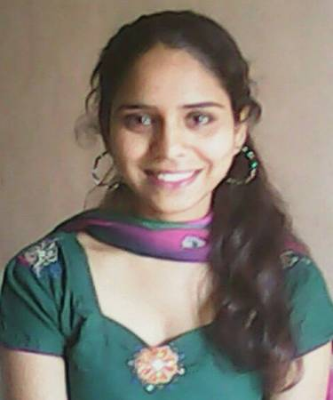

DIPTI SHARMA

CONTACT ADDRESS
diptisharma8562@gmail.com D-107 Savvy Strata nr. LJ college
6359151776, 9669625489 Opp. YMCA club, Makarba, Ahmedabad

Experience

- Worked in Cross Road Clothing Pvt. Ltd. for a period of 6 months
- 1 year experience as a Production Merchandiser in Kumar Products Capri
- Worked as a Process coordinator in Pradeep Overseas Ltd for a period of 1.5 year
- Handled product manufacturing line, product dispatch, transportation and client communication
- Dress designing on adobe illustrator and coral draw

College Projects

- Indo western, Indian & Western Dress Designing with accessories in COROL DRAW CS 6
- Indo western, Indian & Western Dress Designing with accessories in ADOBE ILLUSTRATOR CS 4
- Sketching projects in themes like, summer vacation, college outfits, office outfits flora-fauna with back grounds
- Project report on BSL suiting industry Bhilwara, Rajasthan.
- Project presentation on coacher line

Education

Graduation - B.Sc in Fashion technology
Bhartiya Institute of fashion technology Ujjain
PUNJAB TECHNICAL UNIVERSITY JALANDHAR

Score

B.Sc. | 68 %
12th | 52 %
10th | 62 %

Achievement

- Drama execution in Annual function in 2011
- Played a successful role of program coordinator in annual college program in June 2012
- Participated in college fashion Show as designer in 2011 and 2013

Industrial Training
Successfully completed one month training in Indra Export Pvt. Ltd. manufacturing company in June 2013.

Declaration

I hereby declare that the above-mentioned information is correct up to my knowledge and I bear the responsibility for the correctness of the above-mentioned particulars.

Location: Ahmedabad DIPTI SHARMA

