CURRICULUM VIETE

SUMERA KRUNAL M 45, Jyotinagar
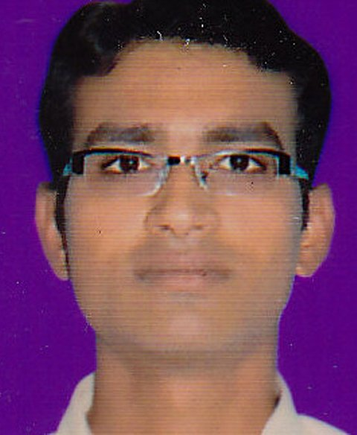
NEAR-NH 8A
AT-Chotila
DIS-Surendranagar
MN-8128830302
Email: kmsumera302@gmail.com

PERSONAL INGORMATION

FULL NAME : Sumera Krunal Mangalbhai
BIRTH DATE : 27/06/1987
SEX : Male
NATIONALITY : Indian
BIRTH PLACE : Lakhatar, Gujarat
MOTHER TONGUE: Gujarati
STATE : Gujarat

GOAL

To became a successful manager and bring about reforms within the particular industry.

STRENGTHS

A strong will-power, Hard-working, Efficient time management, an amicable person, Ability to take decision, Disciplined, Always eager to do something new
Things, Ability to work in teams as well as leader when necessary.

EDUCATION

Sr.no. | Degree | University | Year | Percentage
1 | S.S.C | GSEB | 2002 | 6357
2 | H.S.C | GHSEB | 2004 | 49.67
3 | B.Com | Saurashtra | 2008 | 64.57
4 | M.BA | GTU | 2012 | 6.57 CPI
EXPERIENCE

I have done job for one year in IL&FS PVT LTD as a Master Trainer and School coordinator.
I am also doing a job in Life Insurance Corporation of India as a Direct Sales Executive right now.

HOBBY

I like to read books. I also like to hear music, playing games, and thinking innovative.

REFERENCE

MR. Govindbhai Makwana
Primary school teacher
At Madharikhada
Ta Chotila
Dis Surendranagar
State gujarat. Pin 363520
MN 9925340760
YOURS FAITHFULLY
SUMERA K M

THANK YOU

