RESUME
NAME : NAVADIYA PARTH GORDHANBHAI
EMAIL : parthnavadiya6@gmail.com
MOBILE NO : +91-9879044535

PEARSONAL DETAILS:

PARMANENT ADDRESS:

To : Vijyanagar,
Ta : Savarkundla,
Dist : Amreli,
Pin : 364522,
Gujrat.

PRESENT ADDRESS:

10/109, Mangalmurti app,
Near Shashtrinagar,
Naranpura,
Ahmedabad,
Gujarat,

D.O.B : 14th aug 1997

Age : 21 Years.

Sex : Male.

Merital Status :

Unmarried

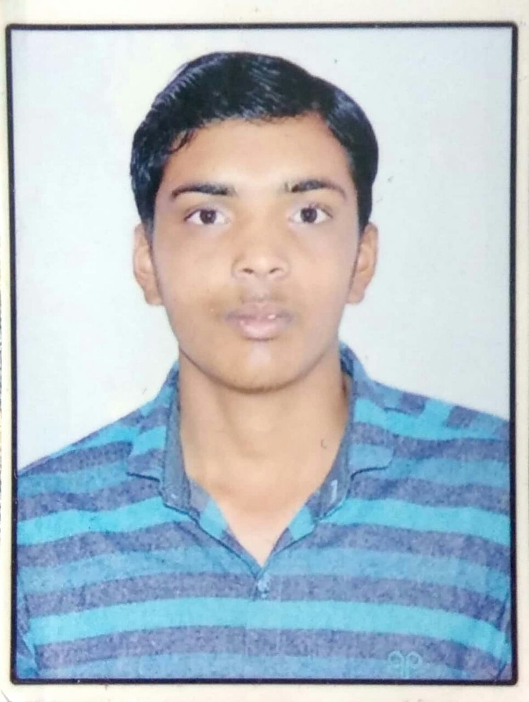
Objection :
- To work in a harmonious environment with a progressive organization that shall enable me to improve my skill sets and to achieve a career that indulges my passion for technology combined with an opportunity to apply my understandings of the same.
- Through this career I should have the opportunity to learn and to utilize the learning.

Education Qualifications :

Sr.  No. | EXAM | BOARD/UNI | YEAR OF  PASSING | RESULT  (IN %)
1 | S.S.C | G.S.E.B | 2013 | 79%
2 | H.S.C | G.H.S.E.B | 2015 | 77%
3 | B.C.A. | GUJ Uni. | 2017 | Running

Interpersonal Skills

- Good oral communication skills.

- Can work for long period.

- Multitasking ability.

Languages Known :

- English
- Hindi
- Gujarati.

Technical skills :

- Very well MS-Office.

- Basic computer and Tally.

- Adobe Photoshop 7.0.

Declaration :

- I hereby declare that the above-mentioned information is true to best
- of my knowledge

- Parth G. Navadiya

