RITESH K. MAKWANA
‘SWASTIK’, 12-A Niranjanbaug Society,
I.O.C. Road, D-Cabin, Sabarmati,
Ahmedabad-380019
Gujarat, India

OBJECTIVE
Individual wishes to use qualifications and experience in the field of banking or non banking financial services & wealth management services for brightening carrier.

DEPT. OF INTEREST
I am interested to work with the department of operations, process management relevant to finance & accounts.

LOCATION
I am able to relocate within Gujarat.

EDUCATION
Shri Swaminarayn College of Computer Science, Bhavnagar.
M.C.A. secured 44.24* % marks in 2005.
(*) One subject is remained to passed in 5th Semester.

Shri M.J. College of Commerce, Bhavnagar.
Completed B.Com. in May-2002 (secured 52.29 % marks)

Gujarat Secondary Education Board.
Completed H.S.C. in April-1999 (secured 56.17 % marks)
Completed S.S.C. in March-1997 (secured 49.29 % marks)

OTHER
Passed NCFM Commodity Module in October-2006 (secured 58.25% marks)

EXPERIENCE (9 yrs.)
1. Currently I am working as an Accountant (Finance Assistant) in Commissionerate of Health (Epidemic Branch), Gandhinagar since 15-Nov-’11.

2. I was working in SMC Global Securities Ltd., Bhavnagar as a Senior Relationship Manager from 09-July-’11 to 15-Aug-’11.

3. I have worked as a Finance Assistant in Bhavnagar Municipal Corporation (Health Department - C.P.M. Unit), Bhavnagar under National Rural Health Mission from 17-April-’08 to 18-January-’11.

4. I have worked as a Business Development Manager & Back Office Executive with the franchisee of Reliance Money Ltd., Bhavnagar from 10-December-’06 to 10-April-’08.

5. I have worked as a Dealer & Head of Department & I was also responsible for the all back office operations with the franchisee of Kotak Commodity Services Ltd., Bhavnagar from 01-October-05 to 09-December-’06.

CTC
My current CTC is Rs.2,11,944 per annum.

PERSONAL DETAILS
Father’s Name : Kishorbhai C. Makwana
DOB : 21-December-1981.
Marital Status: Married
Contacts : 9727776888, 9714625532, makritesh@yahoo.co.in
Languages : English, Hindi, Gujarati
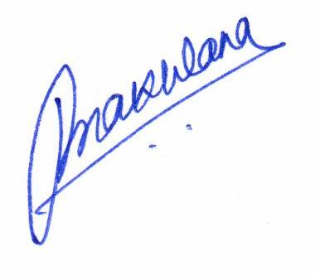
Permanent
Addreess : Vadva, Opp. Khadiya Kuva, Bhavnagar-364001.

Date : 23-March-2017
Place : Ahmedabad. Ritesh Makwana

