RESUME
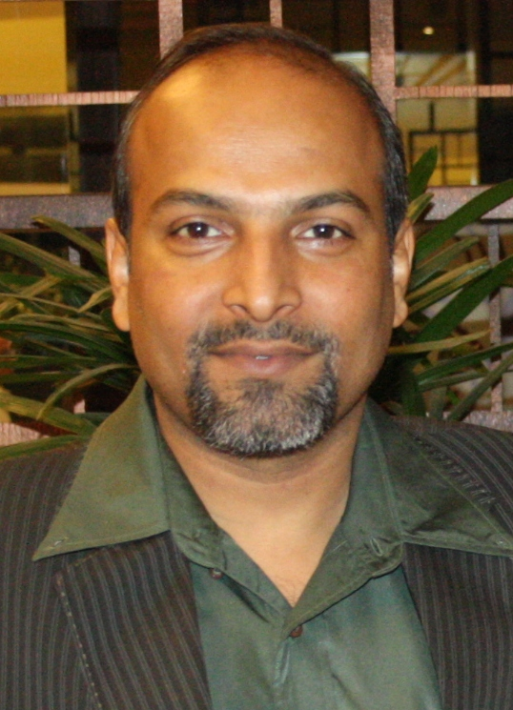

SUMIT MUKHERJEE
A-302, Mangalmurti Apartments,
Pethapur, Gandhinagar, Gujarat-382610
M: +91 94265 87503 E Mail: sumeet936@gmail.com
human resource & OPERATIONS ADMINistrator

Objective

Superior, aggressive, confident and proactive decision maker, completely driven by passion to achieve organizational goals in HR, Adm & Ops management. Team player, undeterred by obstacle in the path to progress utilizing rich experience of two decades as an Administrator in the Indian Air Force followed by decade long Manufacturing Plant level exposure. Possessing invaluable Integrity & valuable ‘Jack of All’ insight with keen attention to details, team approach to implement best practices. Highly adept to working in high pressure environment with strict deadlines & multiple deliverables. I am a proud industrial structuring expert.

Core Competency & Prowess

HR Operations
- Implementation and adherence of HR policies for manpower planning, recruitment, selection, induction, orientation, MIS & development of employees in the organization
- Heading & delegating subordinates to ensure timely execution of operations. Employee record check, internal audit with a scope of ISO/TS compliances, minimum wage adherence, LWF, POSH, Industrial Safety, etc.
- Major HR key functions like PMS (KRA/ KPI), T&D, Statutes, Grievance Handling, Employee Database Management, Welfare Activities, Payroll, Employee engagement, Liaising with Govt. agencies for compliances of Factory Inspections, GPCB, ESIC, EPF, etc.

General Administration, Security & Fire Safety
- Administrative activities vis-à-vis upkeep of equipment, AMC, transportation, housekeeping.
- Identifying and networking with cost effective & reliable vendors for judicious purchase.
- Develop / implement security policy, standards, guidelines, procedures of security.
- CCTV surveillance, motion sensors, Greyhound guard monitoring system, fire safety conformity and appliances serviceability with regular training and mock drills.

Facilities & Plant Utility Management
- Developing budget & annual plan for managing multi facility needs and upkeep of manufacturing infrastructure and in-house accommodation of workers.
- Facility Management with service providers for cost effective solutions and ensure effective & seamless operations in the field of production line, canteen, horticulture, recreation etc.
- Plant maintenance with technical utility management vis-a-vis upkeep of DG set, UPS, HVAC, Air Comp, transformers, etc, to ensure zero break down for highest production line efficiency.

Current Occupation

Dec’2022 to till date in Vasant Masala Pvt. Ltd., Ahmedabad as Group Head-HR & Admin. (Corporate & 2 Plant’s) One of India’s leading Spice manufacturing & exporting company.
Previous Employment

Apr’2021 to Nov’2022 in Match Graphics Pvt. Ltd., Ahmedabad as Plant Head-Operations, HR & Admin. India’s largest Décor Printing Co.

May’2019 to Nov’2020 and earlier from May’2011 to Jun’2017 in Pal Shellcast Pvt Ltd, Ahmedabad (A Western Auto Spares Group Company), as Group Head-HR & Admin. An ISO/ TS-16949:2009 certified company (Corporate & 4 Plants) specialized in manufacturing premium Auto Ancillaries from Foundry to Finish, for major OEMs-M&M, Greaves, Eicher, Mercedes, Volvo.

Cont’d…2/-
-2-
Achievables at Western Auto Group
- Spearhead the entire gamut of HR, Administration, Operations, Facility & Security of 3 associated group companies with workforce exceeding 2200 employees.
- Pivotal in controlling attrition level from 15% to 3% by regular counseling of employees. Standardized payroll system across the group. On course for implementing ERP system with total Network integration of all locations. ISO TS 16949 compliance adherence and that of Pollution Control and factory statutes
- Introduced KRAs/ KPIs and stringent appraisal system on a half yearly basis to bring out optimum performance out of employees with thrust area in training and discipline.
- Optimum use of work force by balancing good welfare and motivational activities keeping in view grueling work environment of furnace and machining.
- Ensured timely AMC & maintenance schedule of all key factory operations equipment for high degree of serviceability of production process.
- Entrusted with the highly critical responsibility of monitoring & overseeing across the board company purchases for instilling sense of judicious spending & cost saving.
- Efficiently handling facility management of plant, workers colony and canteen, saving in excess of Rs. 2 lacs pm. Successful implementation of Mobile & Tobacco free environment.
- Judicious scrap management endeavor earning revenue in excess of Rs 2 Cr in 4 years & instrumental in water management in foundry saving 40KL per day with recycling.

Jun’2017 to May’2019: HOF Furniture System Pvt Ltd, Ahmedabad as Head-HR & Admin (GM) (Corporate & Plant). An ISO 9001 certified premium furniture manufacturing company catering to the likes of clienteles such as PMO, the Parliament and various state Govt. and top corporate houses of India. Heading the entire gamut of HR, Admin, Facility & Security of the plant as well as corporate house. KRAs include Talent Acquisition, Performance Management System, Training & Development, Induction & Orientation Program, Compensation & Benefits, Retention Mgmt, IR Mgmt, 5S and advanced cost cutting initiatives, manpower audit/ revaluation for boosting annual turnover.

Mar'09 to Apr'11: Microgenix Specialities Pvt Ltd, Ahmedabad as Senior Manager HR, Admin & Marketing: An ISO 9001:2000 certified company manufacturing premium grade Textile Chemicals (Silicone & Enzymes). Independently managed the entire gamut of HR, Admin & Marketing whereby initiating and streamlining complete process development of a company. Additionally developed sales/ dealer network pan India along with South East Asian market.

Initial Assignment

Mar’86 to Feb'09: Indian Air Force as Manager- HR & Administration. Proven expertise & functional exposure in middle level Personnel Management, Administration & Operations in highly diverse and sensitive locations in India & abroad. Highly motivated, optimistic & goal-oriented team leader with exceptional expertise in HR (Payroll, L&D, PMS, OD), Facility Mgmt, Govt. liaison, communications, developing cordial intrapersonal relationship and maintaining high degree of operational/ combat readiness. Commended twice by Base Commander on Air Force Day of 1993 & 1996 for exemplary devotion to duty & sense of responsibility.

Education/ Courses
- MBA (HR) from Eastern Institute of Integrated Learning in Management in 2012
- Diploma in Business Management (HR & Marketing) from Symbiosis, Pune in 2008
- Industrial Safety Auditor from National Safety Council in 2015
- Security & Fire Officer Course from Lancer Institute, Pune in 2009
- Middle level Management & Leadership Course from Indian Air Force in 2002
- B.A. (Economics) from Punjab University, Chandigarh in 1986

Place: Gandhinagar, Gujarat

Date: 18th Apr 2023 Sumit Mukherjee

