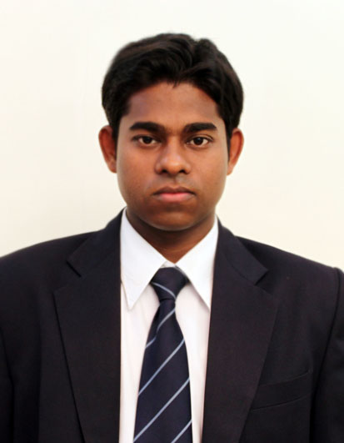
frame-col-ypos:-0.000694in; bot-style:none; xpos:5.092361in; wrap-mode:below-text; frame-type:image; ypos:-0.000694in; left-style:none; frame-height:1.719444in; top-style:none; position-to:block-above-text; frame-col-xpos:5.092361in; right-style:none; frame-width:1.368750in
frame-col-xpos:-0.125000in; wrap-mode:above-text; frame-height:0.323611in; frame-type:textbox; ypos:0.115278in; frame-col-ypos:0.115278in; frame-width:3.615278in; xpos:-0.125000in; position-to:block-above-text

Address-

No.48, 6th Main Road,

5th Cross, new Colony,

Domlur layout,

E-mail id : nath.avi89@gmail.com

M : 9035713861

CARRIER OBJECTIVE
To work in a responsible and challenging position in an organization where I can utilize and enhance my skills, knowledge and personality for the betterment of that organization and achieve the organizational goals and objectives in the area of :

- Logistics /Freight Forwarding/export import.
- Relationship Management, Client Servicing, Customer service operation in Marketing sector

ACADEMIC QUALIFICATION

Qualification | College/University/Board | CGPA/Percentage | Year
PGDM - Port Shipping Logistics Management & Marketing | AIMS Business School, Bhubaneswar | 7.5 | 2012
B.Com | Ranchi University, Ranchi | 61% | 2009
12th –Commerce | J.A.C.,Ranchi | 67% | 2006
10th | J.A.C.,Ranchi | 64% | 2004

WORK EXPERIENCE

1.6 years experience in the field of logistics Operation and warehousing at Britannia Industries Ltd.
- Coordinating supply chain operations in Ranchi, Jamshedpur, Dhanbad location.
- Handling Consignment orders, purchase orders, and customer relationship management.
- Monitoring of deliveries, primary and secondary transportation and dispatch related activities with the objective of reducing the lead time of orders.

SUMMER INTERNSHIP

Organization : Assotech-Bebl Infrastructure Ltd., Bhubaneswar.

Duration : June’11- August‘11

Functional Area: Marketing

Project : Market Research

Activities : Analyzing the market.

Survey of Real estate companies in Bhubaneswar.

Dealing with Clients.

COMPUTER SKILLS

- MS Office Automation Suite.
- HTML & SQL

INDUSTRIAL EXPOSURE

- Neelanchal Ispat Nigam Limited.
Studied Steel manufacturing process and power generation process.

- Gupta Power Infrastructure Limited.
Fabrication process of Electrical wire and cables.

- Parle Pvt. Ltd.
Production process of biscuits.

KEY STRENGTHS
- Management skills - planning, coordinating, organizing, execution, review.
- Good communication skills.
- Multi-tasking
- Team handling and motivation

HOBBIES AND INTEREST

- Watching movies, Making friends ,Cricket and internet surfing

LANGUAGES :

English, Hindi, Bengali & Oriya

PERSONAL DETAILS

FATHER’S NAME | : | Mr. Biren Nath
DATE OF BIRTH | : | 05.01.1989
SEX | : | Male
NATIONALITY | : | Indian
RELIGION | : | Hindu

DECLARATION:

I hereby declare that the information given above is true and correct to the best of my knowledge and belief.

Date:

Place: AVIJIT NATH

