Resume

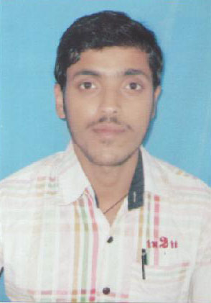
Name : KISHAN KUMAR RAWAT (Bari)
Date of Birth : 16-08-1993
Father’s Name : Sri Vinay Kumar Prasad
Address : Vill+Po- Vijaipur
P.S – Vijaipur
Dist. – Gopalganj
State - Bihar
Pin Code-841508
Mobile. No. : 9576007785
Nationality : Indian
Religion : Hindu
Language Known : Hindi & English
Marital Status : Unmarried
Sex : Male
Educational Qualification

Exam | Board | Year | Div
Matric | U.P. Board | 2010 | 2nd
I.Sc. | U.P. Board | 2012 | 2nd
B.A. | D.D.Unversity (U.P.) | Appearing

Extra Knowledge : D.C.A., D.T.P. & Typing (Eng.)

Date: .................

Place: ................ Signature

