RAKHI SHARMA 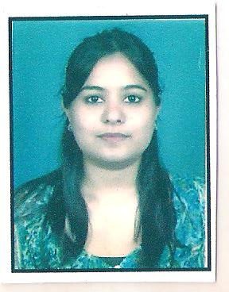
Flat-506 Block-C ,Swareet Apartments
Bakeri City Vejalpur
Mobile: +91 – 9574531309
Email: sharma.rakhi338@gmail.com

teaching professional

Profile

Dynamic graduate with more than three years of experience in teaching.
Comprehensive experience in cementing healthy relationship with the students, thereby ensuring the all round development of their personalities.

Professional Experience

- As spoken English faculty for BAFEL(British Academy for English Language),West
Patel Nagar branch,New Delhi.
- As Trained Graduate Teacher(ENGLISH) in MODERN PUBLIC SCHOOL,Shalimar Bagh New Delhi
- As Spoken English Faculty in British School Of Language New Delhi District
Centre , Janakpuri New Delhi.

Academic Credentials:
Bachelor of Education from B.R Ambedkar University Agra.
Bachelor's Degree in English Honours.(Calcutta University)
Presently working as an English teacher T.G.T in Shreyas Foundation school.
Class 12th -72%
Hariyana Vidya Mandir , C.B.S.E.(Kolkata)

Class 10th - 83%
Hariyana Vidya Mandir, C.B.S.E(Kolkata)
Qualified Central teacher eligibility test for Trained Graduate Teacher.
Presently undergoing Masters in English from IGNOU.
Personal Details
Date of Birth : 20th Aug 1984.
Languages : English and Hindi and Bengali
Permanent Address : Swareet Apartments ,Flat-506, Block –C
Bakeri City Vejalpur.

