
AVISHEK SIRCAR
Mobile: 91-8134913300
E-Mail: sircar.avishek@gmail.com
LinkedIn Id: in.linkedin.com/pub/avishek-sircar/16/a4/55a/

JOB OBJECTIVE

Techno-managerial professional, in quest of challenging assignments in Sales/ Business Development/ Team Management with an organization of high repute
Industry Preference: Marketing/IT

PROFILE SNAPSHOT

- Multi-faceted professional with over 8 years of experience in:

~ Sales & Marketing ~ Business Development ~ Pre-Sales
~ SAP End User/Super User ~ Client Relationship Management ~ Team Management

- Expert in handling all sales, marketing & business development activities, analyzing market trends and establishing healthy & prolonged business relations with the clients
- Adroit in creating business development procedures, dealership standards and sales strategies as well as service delivery plans & guidelines
- Resourceful in framing strategies for establishing greater awareness about company & its products and building brand focus in conjunction with operational requirements
- Hands-on-experience in managing Corporate Sales operations with key focus on top & bottom line profitability by ensuring optimal utilization of resources in the organization
- Expertise as an End User of SAP (SD Module) comprising of entire sales order booking process and MIS reporting
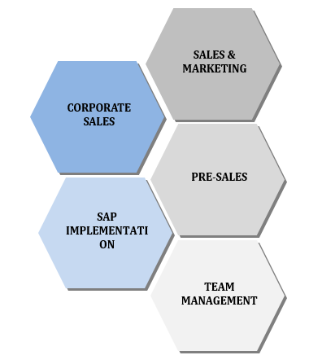
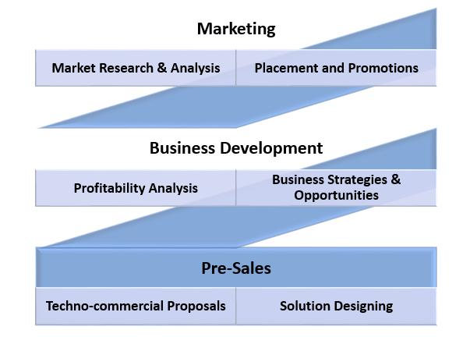
- An aspiring leader with excellent communication, analytical, interpersonal and decision making skills

CORE COMPETENCIES

Pre-Sales
- Preparing techno-commercial proposals for customers in response to regular requirements, RFPs, tenders and conducting scope/ price negotiations for planning & optimization services
- Suggesting appropriate methodology and designing high level solutions for customers after critical analysis of their business needs

Marketing
- Managing & monitoring sales & marketing operations, increasing sales growth and driving sales initiatives in order to achieve business goals
- Understanding business needs, its strategic direction and identifying initiatives that will allow a business to meet those strategic goals

Business Development
- Identifying and pursuing business opportunities and mapping requirements through market surveys
- Initiating and developing relationships with key decision makers in target organizations for business development

Branding
- Identifying and executing various branding activities, both ATL and BTL to increase brand awareness and visibility.

EMPLOYMENT DETAILS

Since Feb’16: Maruti Suzuki India Ltd., Ahmedabad as Regional Manager – Sales & Marketing
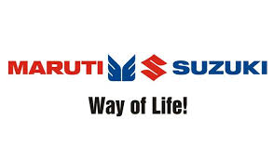
Key Result Areas:
- Business Development of new car sales through exchange.
- Responsible for building up the capabilities of the dealers for Sourcing, Refurbishing and selling of used cars in the assigned territory at dealerships.
- Instrumental in handling various key and bigger dealer groups like Kiran Motors and Kataria automobiles.
- Instrumental in designing, crafting and implementation of various MIS reports and Business Intelligence reports.
- Increased dealer True Value network for better penetration and visibility of brand as well as product

Highlights: 2016 - Present
- Increased profitability of dealers from 3Crs yearly in 2016 to 8 Crs yearly in 2018.
- Increased profit/car from Rs. 8000 to Rs. 15000 for dealership
- Accountable of achieving the following:
- 10% YOY growth on Exchange sales
- 10% YOY growth on Pre Owned car Sales
- 20% YOY growth on Certified Car sales
- Responsible for periodic designing of Price Matrix of Pre owned cars as per Market intelligence.
- Responsible for providing training to the dealer sales employees and evaluators on various aspects.
- Responsible for providing inputs and guidelines on techno-commercial analysis of used cars.
- Responsible for Refurbishment and Merchandising of used cars.
- Analysis and counter measures on warranty failures.
- Responsible for Customer relationship management

Jul’11 – Jan’16: Jindal Steel & Power Ltd., Guwahati as Deputy Manager – Sales & Marketing

Key Result Areas:
- Accountable for promoting marketing initiatives of various steel products (flat & long) to various customers in Jharkhand through relevant strategies targeted towards product penetration
- Acquiring new customers and maintaining existing ones to generate business by
  - Maintaining high Net Sales Realization
  - Providing best Pre sales and Post Sales services
  - Increased sales of Value Added Products
  - Maintaining high OTIF (on time in full)

Highlights: 2011-2014
- Instrumental in handling various key and national accounts like Tata Group comprising of TATA Steel Ltd, TATA Steel Growth Shop, TRF Ltd, and Telcon
- Pivotal role in managing entire sales process in SAP encompassing order booking starting from creating enquiries, quotations, contracts to sales orders along with various MIS reports related to sales dispatch report, order status, etc.
- Accountable of achieving the following:
- Highest NSR (Net Sales Realization) for my region across the country
- Sales figures of 50000MT each year for 3 years from 2011-2014
- Collection figures of 250Cr each year for 3 years from 2011-2014
- Increased share of value added products from 0 to 35% in 3 years
- Increased Market share of 2% to 5% in Jharkhand over three years
- Maintained 95% OTIF throughout the tenure
- Sole SAP end user for the entire Sales process within the assigned region and for 1 Stockyard for entire Stockyard Operation process
- Gained additional responsibility to cater Retail Sales of Entire North Eastern region in a new initiative taken by the company

Highlights: 2014-2015
- Handling Retail sales for entire North east region through 2 distributors
- Increased Market share from 3% to 10% in North East over one year
- Increased dealer network for better penetration of brand as well as product
- Accountable of achieving the following:
- Highest NSR (Net Sales Realization) for my region across the country in retail sales
- Sales figures of 35000MT from 2014 to 2015
- Increased Turnover of distributor from 2Crs monthly in 2014 to 100 Crs yearly in 2015.


Mar’10 – Jan’11: Ceasefire Industries Ltd., Jamshedpur as Senior Business Development Manager – Corporate Sales

Highlights:
- Instrumental in increasing the market share through share-of-wallet effort in the assigned territory from 1% to 3%
- Engaged in B2B sales while mapping and managing the entire life cycle of all Corporate Clients including HDFC, Shoppers stop, Airtel, Aditya Birla Management Corp., IDBI Bank
- Pivotal role in client acquisition and gaining the maximum market share for the business against strict competition by
  - Awareness to customers
  - Fire safety training to various companies
  - Imparting knowledge of Fire safety solutions to various Businesses

ACADEMICS

2010 MBA (Marketing & IT) from ICFAI Business School, ICFAI University, Kolkata with 7.85 CGPA
2007 B.E. (Electrical & Electronics) from AIT, Chikmagalur, VTU, Chikmagalur with 70%
2003 12th from Delhi Public School, Bokaro, CBSE Board with 71.6%
2001 10th from Delhi Public School, Bokaro, CBSE Board with 82.6%

TECHNICAL PURVIEW

Operating Systems: Windows XP/VISTA
Database: MS Access
Computer Languages: C/ C++
Softwares: MS-Office 2007, SPSS and SAP (SD Module)

INTERNSHIP

Title: Identification and analysis of Operational Procedures & Constraints of JSPL, using Market Intelligence Techniques
Organization: Vesuvius India Ltd., Kolkata
Duration: Feb’09 to May’09
Highlight: Received the Summer Internship Program Excellence Award for 2008-10 Batch

PROFESSIONAL ENHANCEMENTS

Research:
- Presented a Research Paper on Advanced Electricity Storage Technologies

Workshops:
- Attended the following workshops:
- 3 Days Workshop on “Stability and Control in Power Systems”
- 1 Day National Level Workshop on Lighting

EXTRAMURAL ENGAGEMENTS

- Attained a Junior Diploma in Instrumental Music (Guitar) from Prayag Sangeet Samiti, Allahabad in 2012

PERSONAL DETAILS

Date of Birth: 8th January, 1985
Address: C1, Mangaldeep Residency, Lal Ganesh, Guwahati, Assam
Languages Known: English, Hindi & Bengali

