Curriculum Vitae

JAYKANT KUMAR S SINGH.
Mining Engineering
Contact No. : - +918128639416
E-mail :- jaykant05505@gmail.com

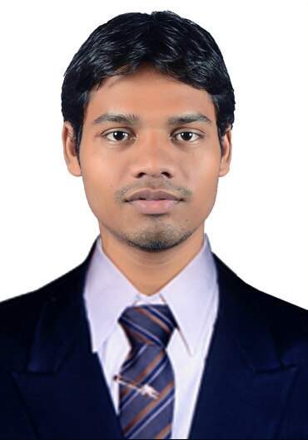
Present Address:
5-2, Rajeswari Park,CTM Char Rasta, Amraiwadi, Ahmedabad, Gujarat.. 380026.

CAREER OBJECTIVE

To be a part of fast growing company which offers continue opportunity for an excellent career
Development, and to achieve perfection in my works through hard dedication.

ACADEMIC DETAILS

Qualification | University/Board | Year | CGPA/Percentage
B.E. in Mining Engineering | GTU | 2017 | 7.77 CGPA
H.S.C | GSHSEB | 2013 | 55.08%
SSC | BSEB | 2011 | 76.6%

*CGPA ON A SCALE OF 10.

ACADEMIC PROJECT

TITLE OF PROJECT:
“HAZARD IN MINES”
Description: The main motive of this project is to identify potential hazard and risks to the people and
Property,inclusive of public health and safety considerations, Eliminating or reducing the level of risk.
‘ROLES AND RESPONSIBILITIES’
- Hazard identification and Risk analysis, ‘Duty of Care’ includes protecting of mine worker’s from both physical hazards and workplace hazards.
- Provide and maintain workplaces, plant and systems of work so that other workers are not exposed to hazards.
- Provide information about the hazards and risks.

TRAINING ATTENDED

- GMDC LTD Lignite Mine Project Rajpardi, Bharuch.
- GMDC LTD Bauxite Mine Project Gadhsisa, Kutch(Bhuj).

TECHNICAL SKILLS

- Microsoft Office (Powerpoint,Word,Excel)
- Auto CAD
- Internet Knowledge
    - Online Transactions.
    - Knowledge Brousing Web Pages.
    - Downloading and Uploading Files.

ACHIEVEMENTS

- I got a certificate of ‘FINISHINING SCHOOL PROGRAMME’ by the GOVERNMENT OF GUJARAT.

STRENGTH

- Ability to rapidly build relationship.
- Confident and Determined.
- Ability to work hard with well team.
- Time Management.
- Positive Attitude.

PERSONAL PROFILE

- Name :- Jaykant Kumar S Singh
- Date of Birth :- SEPT 30, 1996
- Nationality :- Indian
- Religion :- Hindu
- Language Known :- Hindi, English & Gujarati
- Marital Status :- Unwedded
- Interest & Hobbies :- Sports - Playing Cricket, Chess, Badminton etc.
Travelling - Exploring Exotic Cities.

DECLARATION

I hereby declare that the information given as above is true to the best of my knowledge and belief.

Place:
Date: (Signature)
Jaykant Kumar

