KUMAR ABHISEK

Qualification: B.Pharm and PGCSM from IIM-Kozhikode
Work-Experience: 105 Months

Personal Details

Date of Birth: September 27, 1975
Address C/0. Mr. Azgar pasha, Near Ayyappa Temple, K.R. Puram & post, Bangalore-560036,
Email: kabhisek5@yahoo.com, kabhisek5@gmail.com
Contact no.: 9377503756, 9909033756

Education

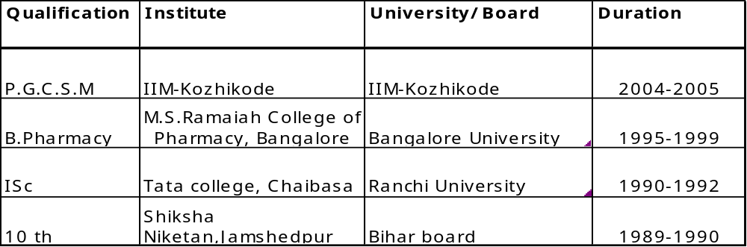

Professional Experience – 105 Months

Cadila Pharma May 2008 onwards
Asst. Product Manager

Micro Labs May 2007 – May 2008
Asst. Product Manager
(12 Months)

PROFESSIONAL ACHIEVEMENTS: -
Achieved highest productive brand in the division

Pharmed limited June 2006 –May 2007
Product Executive
(12 Months)

PROFESSIONAL ACHIEVEMENTS: -
Launched new products
Awarded as the best employee award in the company

Atrimed Pharma Pvt. Limited
Regional Sales Manager November ‘03- May ‘06 (30 Months)
Achievements:
- Consistently achieved number one position as a regional sales manager for 12 months.
- Developed strategies for new products in the company and identified new segment of promoting products.
- Stood first in the training program conducted by the company
Nicholas piramal India limited March ‘03- November ‘03
(9 Months)
Sales Officer
- Consistently achieved target for six month
- Awarded in detailing contest conducted in south zone
- Achieved the breakthrough in the major institution in the territory

USV Limited June ‘00 – February ‘03
(34 Months)
Marketing Officer

- Awarded as best performer in training programme conducted by USV limited
- Consistently achieved target for one year six months
- Launched various mega brands in company
- Consistently received award for best detailing in launch and strategy meeting.
- Conducted major CME in Bangalore.

Projects
- Study the existing distribution structure of Atrimed pharma and identify strengths and weakness in the system in comparison with the distribution of competing company. To assess alternative distribution strategies and develop one with a special emphasis on the rural markets.
- Study the selling methodology adopted by pharmaceutical companies. Sales force sizing and give recommendations for an appropriate methodology for the same. To examine the relative roles of branding vs. selling in the industry. To analyze the current product and promototion and brand promotion practices in the Indian pharmaceutical industry. The study is conducted in Nicholas piramal India limited.

Other Information
- Computer Proficiency: MS Word, MS Excel, MS Power Point, Cobol
- Languages: English , Hindi

