RESUME

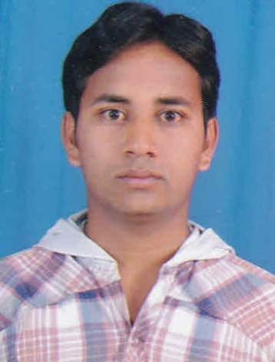
ANKIT D. Patel
Address: At-Post-Kasalpura,Ta-Mehsana;
Di-Mehsana
Mehsana-384421
Gujarat, India
Contact Number: 97225 80855 (M)
E-mail: ankitpatidar007@gmail.com ____________________________________________________________________________________________________________________________________
CAREER OBJECTIVE:
Seeking a challenging position in Electrical Power Engineering field, where my academic background and practical experience can be applied and further enhanced.

EDUCATION
  Degree | Board/  University | Year of  Passing | CPI/  Percentage | CGPA/  class
  B.E (Electrical)7th sem | GTU-Ahmedabad | 2012 | 5.97 | 6.63
  HSC | GSEB-Gandhinagar | 2009 | 58.00 % | 2nd
  SSC | GSEB-Gandhinagar | 2007 | 81 % | Dist.
PROJECT | Load based power grid monitoring & distribution usin microcontroller
PERSONAL DATA | Date of Birth: | 16-09-1991 |  |  | Marital Status: |  | Single
PERSONAL DATA | Gender: | Male |  |  | Religion: |  | Hindu
PERSONAL DATA | Nationality : | Indian |  |  | Language Known: |  | Gujarati, Hindi, English
FAMILY BACKGROUND | Father | Mr.Dahyabhai K. Patel  farmer
FAMILY BACKGROUND | Mother | Ms. Bhagavatiben D. Patel  Housewife
EXPERIENCE | Name of Organization |  |  | Position held |  | Period (from - to )
EXPERIENCE | Nil
RELEVANT SKILLS | Computer skills: |  | MS Word, Excel, PowerPoint, Internet use
RELEVANT SKILLS | Soft skills: |  | Leadership, Communication, Team-Building, Organizational, Management, etc…
RELEVANT SKILLS | Personal skills: |  | - Having the ability to work under stress.  - Self-motivated ,hard working, ambitious.
HOBBIES | Sports, reading
AREA OF JOB  INTERESTS | Maintenance, Marketing
REFERENCES | Mr. J.H.PATEL Head of Uma electicals,Ahmedabad.  Contact No: +919879730061
DECLARATION
I hereby declare that the above information is correct and true to the best of my knowledge and belief.
Place : Kasalpura Yours Sincerely,

Date : A.D.PATEL

