CURRICULUM VITAE

BHAVESH KAUSHIKBHAI PATEL 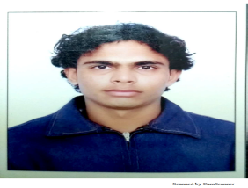
Contact details: - +91-7621086081
Email Id: - Bbhavesh286@gmail.com

➢ SUMMARY
- I am energetic, eager to bring administrative skills to a growing company in
need of top level support. I am hard working and looking for a Company in
which I can grow my skills as well as my future.

➢ EDUCATIONAL QUALIFICATION
- I have passed S.S.C from G.S.E.B with 52% marks.
- I have passed I.T.I from S.T.T.C with second class.
- Basic knowledge of Computer including MS Office, MS Excel..

➢ EXPERIENCE
⦁ I have worked as MST Supervisor in Kotak Mahindra Bank Limited on behalf of Shetty Infrastructures Pvt. Ltd. for one year.(2018-2019)
⦁ I have worked as MST in Thomson Reuters (MNC) on behalf of Shetty Infrastructures Pvt. Ltd. for two years.(2016-2018)
⦁ I have worked as MST in Shetty Infrastructures Pvt. Ltd. for one and a half years.(2014-2016)
⦁ I have worked Wireman in Nisharg Enterprise Ltd. (Nirma) for four years

➢ PERSONAL INFORMATION
⦁ ADRESS: - B-18, Vishamo Appt., Smruti Mandir, Ghodasar, Ahmedabad-380050.
⦁ DATE OF BIRTH: - 06th November’1986
⦁ MARITAL STATUS: - Married
⦁ RELEGION: - Hindu
⦁ NATIONALITY: - Indian
⦁ LANGUAGES KNOWN: - Hindi & Gujarati
⦁ HOBBIES: - Sports and Travelling

➢ DECLARATION
I hereby declare that the above stated information about me is true to the best
of my knowledge.

BHAVESH KAUSHIKBHAI PATEL

