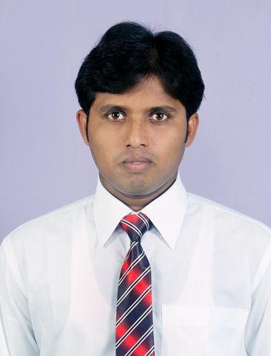
CURRICULUM VITAE

IMAM HUSSAIN
Village+Post- Dayal pur
P.S- Janta Bazar , Dist.-Chapra
Pin code- 841206 Bihar
Email id: rehanimam47@gmail.com
Phone No- +91-7677934794/8100245124

CAREER OBJECTIVE
.
- Looking for responsible and challenging career, where my skills can be effectively utilized and contributed for organization success.
Academic Qualification
- B.Tech (Mechanical Engineering): ACADEMY OF TECHNOLOGY, Hooghly
( Affiliated with WEST BENGAL UNIVERSITY OF
TECHNOLOGY)

- Senior Secondary Examination : Equivalent to grade 12 from Rajendra College, Chapra with 70% in 2009.
First Division with Distinction.
- Secondary Examination :Equivalent to grade10 from S.D.N.High School ,Lahlad Pur with 63% in 2006.
. First Division with Distinction.
Software Proficiency

  - Software known: Auto Cad, Solid Work,
  - Office suite: MS-office.
  - Power point
  - Operating system : Windows XP / Windows 7/8
Mini Project

  - Project Area : Manufacturing Technology
  - Project Title : “Planetary gear system”
  - Software used for Designing : Solid Works

Main Project

  - Project Area : Manufacturing Technology
  - Project Title : “Electro Chemical Drilling Machine”
  - Project Role : Completed and function.
  - Software used for Designing : AutoCAD

Industrial Visits
- Sail,Bokaro
  - Texmaco Rail & Engineering Works Ltd,Belgharia,Kolkata
  - Kolaghat Thermal Power plant ,Kolaghat

Training and Workshops undergone

Implant training:
  - Organization : Steel Authority of India limited.
  - Duration : 12 days
  - Knowledge Gained : Learnt about various machining processes.
  - Organization : Texmaco Rail & Engineering Works Ltd,Belgheria ,Kolkata,
Steel Foundry Division
  - Project Work : Casnub Boggie
  - Duration : 30 days
  - Organization : Kolaghat Thermal Power plant
  - Duration : 30 days
  - Knowledge Gained : Learnt about various machining processes.
Personal Trait
  - Self motivated & Quick learning abilities in new environment
  - Problem solving ability
  - Co-operative and keen observer

Working Experience

  - Organization : Sukhmani Engineering Pvt Ltd. , Silvasa
  - Duration : 15th June 2014 to 20th May 2015
  - Organization : Lahari Engineering Pvt Ltd ,Ahmedabad
  - Duration : 25th June 2015 to 15th November 2015

PASSPORT DETAILS
Name : IMAM HUSSAAIN
Passport No. : M0668675
Date of issue : 07/08/2014
Date of Expiry : 06/08/2024
Place of issue : Patna
PERSONAL PROFILE
Father’s Name : Maqusud Alam Ansari
Date of Birth : 11 Dec 1990
Nationality : Indian.
Marital Status : Unmarried.
Languages Known : English, Hindi & Urdu.
Hobbies : Internet surfing, watching movies, listening music.
Permanent Address : Village Post- Dayal pur
P.S- Janta Bazar, Dist.-Chapra
Pin code- 841206 Bihar.

I hereby declare that all the details furnished here are true to the best of my knowledge.

Your faithfully,
IMAM HUSSAIN

DATE:
PLACE: SIGNATURE: ____________________

