RESUME
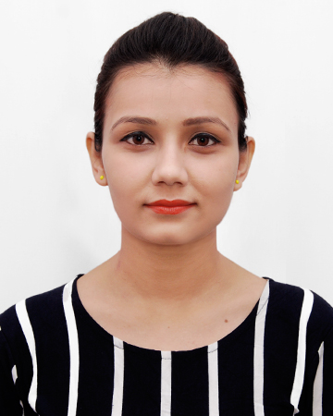
MAMTA HAZARIKA
Address:
D/o: Dilip Kr. Hazarika
House No. 45, Boloram Bora Road,
Happy Villa Uzan Bazar, Guwahati-03
Contact no-+91 9706912900
Email ID- mamzzhazarika1234@gmail.com

OBJECTIVE:

To work in an exciting and challenging environment in a position that has the potential for growth and innovation, where I can utilize and enhance my skills.
STRENGTH
- Ability to take up assignment and complete them with in time.
- Quick learner and open to new ideas.
- Passion for hard work, perfection and success.
- Easily mix-up with people.

EDUCATIONAL QUALIFICATION
EXAMINATION | BOARD / UNIVERSITY | EDUCATIONAL INSTITUTIONS | YEAR OF PASSING
B.Com | Dibrugarh university | Nerim Group of Institution | 2016
H.S. | CBSC | Kendriya Vidyalaya No. 1 Itanagar (A.P) | 2013
H.S.L.C | CBSC | Kendriya Vidyalaya No. 1 Itanagar (A.P) | 2011

EXTRA CURRICULAM ACTIVITIES

- Under going 3 months training in ICICI Academy for Skills.
(Highlight of the course)
- Life Skill
- Selling Skills
- Customer Service

HOBBIES

- Travelling
- Cooking

LANGUAGES KNOWN:

- English
- Hindi
- Assamese

PERSONAL PROFILE

Fathers Name : Dilip Kr. Hazarika
Date of Birth : 17th Sept. 1995
Religion : Hindu
Nationality : Indian
Gender : Female
Marital Status : Single
Caste : S.C
Permanent Address : D/o Dilip Kr.Hazarika
House No. 45, Boloram Bora Road,
Happy Villa Uzan Bazar, Guwahati-03

DECLARATION

I hereby declare that the above mentioned information is correct up to my knowledge and I bear the responsibility for the correctness of the above mentioned particulars.

Date:
Place: Signature

