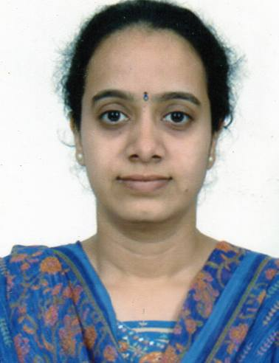 | Ms.VIBHUTI DINKERRAI TRIVEDI  B/22, Navkar Apartments,  Vejalpur Road,JIvraj Park,  Ahmedabad -380 051.  +919099148332  vibhuti_d_trivedi@yahoo.com

JOB OBJECTIVE

A responsible and challenging position which allows me to implement my abilities and knowledge, which acquired during my academic & professional career and also my dedication towards the duties with sole aim of the growth and to adapt the changing organizational needs with the global scenario.

EDUCATIONAL QUALIFICATION

QUALIFICATION | BOARD/UNIVERSITY | % | PASSING YEAR
M. Com | Gujarat University | 58% | May’ 1999
B. Com | Gujarat University | 69% | March’1997
H. S. C. | GSEB | 70% | March’1994
S. S. C. | GSEB | 78% | March’1992

OTHER QUALIFICATION :
Successfully completed Executive Programme of Company Secretary.-2013

COMPUTER EDUCATION :

Successfully completed my DCA (Diploma in Computer Application) from ACT- Computer in year April 1999.
COMPUTER SKILLS:-
- Thorough proficiency in Computer usage.
- Microsoft Office and Windows (XP/ Office2003,2007)
- Knowledge of Tally .
- Well versed with Internet skills viz., E-mail, Net and Website Surfing.

(Cont.2)

--- 2 ---

EXPERIENCE : 16 YEARS

Since September’99 I am working with “Acquitech Engineers Pvt.Ltd.” having Dealership for various Industrial Products . Results-oriented Commercial Assistant with 17 years of experience in providing effective and flawless support to Senior Executives. Possess the highest degree of integrity with a stellar record of maintaining confidentiality. Adaptable to change, superb customer service, organizational skills and excellent time management skills.
JOB PROFILE:

- Handling Correspondence including drafting, sending E-mails, Website surfing etc., Assisting Director in his day-to-day activities. Arranging his appointment & taking dictation for direct letters from his side.
- Calendar maintenance, meeting coordination and screening calls.
- Entire Back office responsibilities viz., Generating Inquiries, preparing offer, Quotation, Proforma Invoice, and Order Acceptance etc. Follow up with Various Principals located in different parts of India. Orders, Payment, C-Form collection, follow-up with customers and solving the problems pertaining to company’s Customer Care Department.
- Looking after Basic Account work like preparing bills, credit /debit note, reports like outstanding, managing creditors & debtors, preparing of Excise Invoice etc.
- Handling Petty-Cash, Banking activities & day to day interaction with Banking matters.
- I am involved in fund management activities of the entire company in able guidance of my employer.
CURRENT CTC: RS. 6,00,000/- P.A.

PERSONAL INFORMATION :

- Date of Birth : 7th December ’1976
- Marital Status : Unmarried
- Languages Known : English , Hindi , Gujarati

