Application for the post of Pediatrician
Dr. Nirav Patel (MBBS, D.C.H.), Reg. No: G-43907
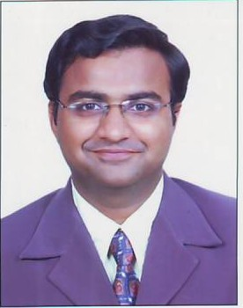
Mobile No. : +919727796878 E-Mail: dr.niravpatel87@gmail.com, vipatel8277@yahoo.co.in

CAREER OBJECTIVE:
- Serving human being with my worthy skill hand.
- Converting difficulties in to opportunities, learning continuously for the benefit of the organization and myself as well as the society where I live and I work for.
- Willing to accept any challenge to learn a something new for a brighter future which will be helpful for organization and career.
Personal Details:
Name:
Dr.Niravkumar V. Patel
Address:
18, Ganeshdwar Bunglowes Gate No: 2
Chenpur Road, New Ranip
AHMEDABAD
Contact No.:
+91-9727796878
Date of Birth:
21st Feb’1987
Languages Known:
Gujarati, Hindi, English.
Gender:
Male
Marital Status:
Single
Nationality:
Indian
Hobbies:
Reading

Professional Qualification:
- P.G. Diploma in Pediatrics (D.C.H.) at Jawaharlal Nehru Medical College- Belgaum affiliated by KLE University
- Completed MBBS from Pramukhswami Medical College-Karamsad affiliated by Sardar Patel University.
- Pediatric Advanced Life Support (PALS) course in 2012
Educational Qualifications:
- MBBS: 59.27% with First attempt in March’2009.
- Internship completed in March’2010
- H.S.C from GSEB with 80.15% in March’ 2004.
- S.S.C from GSEB with 87.14% in March’2002.
eXPRIENCE:
- Two years experience as PG Resident in 1340 bedded KLE’S Prabhakar Kore Hospital & Medical Research Centre, Belgaum having Pediatric Ward of 120 Beds, PICU with 14 Beds, NICU with 30 Beds, Well equipped OPD, 4 Separate OPD Clinics & Special Clinics:
- Worked under Neonatologist,Pediatrics Cardiologist, Pediatric Neurologist, Pediatric Nephrologists & Pediatric intensivist.
- Worked as Sub Inspector in Vaccine trial of GSK Pharmaceuticals

Presentation:
- Presented papers in International Conference at Ahmedabad during November’2012
Declaration:
Please consider my application positively; I have full confidence that I will shoulder all the responsibilities of the post. I will be thankful, if opportunity be given to me to serve your esteem organization.

Dr. Nirav Patel

