PANDYA MAYUR V.
Block No-134/3199,Guajarat Housing Board, Near Last Bus Stop,
Meghani Nagar ,Ahmedabad-380016.
:
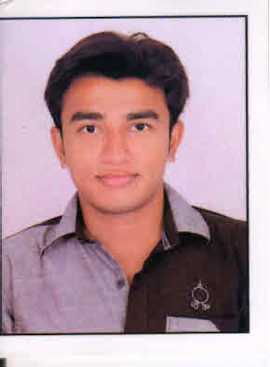
Personal Details:

Date of Birth : 21-04-1994
E-mail Address : mayurpandya2141994@gmail.com
Contact No. : 9687586334
Languages Known : English, Hindi and Gujarati.
Hobbies : Reading, Writing, Music, Cricket

CAREER OBJECTIVE:

Intend to build a remarkable career with leading corporate of hi-tech environment with committed & dedicated people, which will help me to explore myself fully and realize my potential. I am willing to work as a key player in challenging and creative environment.

Qualities:
Eagar to learn, enthusiastic to work, excellent verbal skills, comprehensive problem
Solving ability. Good team player to work with who is willing to get result for a common
Goal.

Interest:
Willing to learn new things and make it simpler way to learn the same.
like to meet people and help them to solve the queries of them
Project:

Modification in Fixed Crapper Blades of ATFD MACHINE.
The focus of this project is to reduce maintenance cost and increase efficiency and maintain a thickness of rotor cell and try to less consumption of time in transporting by improvement .

Modification in design of defensive trucks.
The focus of this project is to established inflancing system in ASHOK LAYLAND TRUCKS.also established winch and nbc system in ASHOK LAYLAND TRUCK.

Area of interests:

Production and manufacturing
Maintenance
Research and Development

Educational Background:

sr | Qualifying Examination | board/ university | year of passing | (%)
1 | S.S.C. | GSEB | March.2009 | 83
2 | H.S.C. | GHSEB | March.2011 | 73
3 | B.E.MECHANICAL | G.T.U | MAY 2015 | 6.22(C.G.P.A)

SKILL:

M.S. Office & Internet

Company Name | Courses Covered
Windsor | Injection Molding
Mazda Pvt Ltd | Heat Transfer
Sejasmi | Die Casting
Vkvc | Pipe Line and Polyurethane
Industrial Visit:

Declaration:

I hear by declare that all the information mention above is true and correct to the best of my knowledge.

