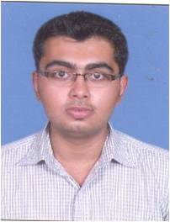
Personal Data:  Date of Birth : 4 June 1992  Father Name: Parbat D. KARANGIA  Sex : Male  Nationality : Indian  Marital Status : Single  Contact Information:  Permanent Address:  M.I.G-345 , K.K NAGAR,  Sector-4,Near.k.k.nagar cross road, Ghatlodia  AHMEDABAD-380061  E-mail:  Hardikkarangia345@gmail.com  Contact No.  Mobile 9429518321 ;  8128252925 ;  9409053468 | Hardik p. Karangia  SUBJECT  For the post of :  PROFESSIONAL QUALIFICATION  Pursued Bachelor of Commerce from Gujarat University, Ahmedabad in 2012.  Given exam of m.com (sem-4) from Gujarat University, Ahmedabad.  ACADEMIC QUALIFICATION  - Passed Senior Secondary Board Examination from Gujarat Board in 2009 with 52.86 %  - Passed B COM From Gujarat university in March 2013  COMPUTER SKILLS  - Basic knowledge of computer hardware.  - Knowledge of TALLY 9 and ERP  - Good typing speed.  HOBBIES  - Chess.  - Going for Long Drive.  - Collect information about Space & E.T.  LANGUAGES KNOWN  - English : Read, Write and Speak  - Hindi : Read, Write and Speak  - Gujarati : Read, Write and Speak  (Hardik p. Karangia)  Place: Ahmedabad, Gujarat

