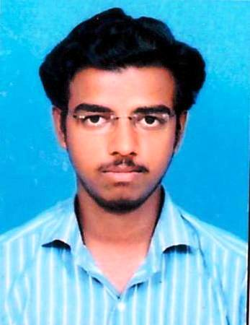
RESUME

MRUGESH S RAVAL  B.E (Electrical)  E-mail: MRUGESHRVL@Gmail.com  Mobile No: +919537794238/ 8690087051 | - Address Block:  6/A,HARKORNAGAR,  NEAR MODI’S HOSPITAL,ADARSH HIGH SCHOOL ROAD,  PATAN(NORTH GUJARAT)  PIN-384265

CAREER OBJECTIVE:

- Seeking a position to utilize my skills and abilities in the power industry that offers professional growth while being resourceful, innovative and flexible.

ACADEMIC QUALIFICATION:
- Aggregate C.G.P.A=6.72

DEGREE | INSTITUTE | UNIVERSITY /  BOARD | S.P.I
8th SEM  JULY-2014 | GOVERNMENT ENGINEERING COLLEDGE,PATAN | G.T.U | 7.27
7th SEM  DEC-2013 | GOVERNMENT ENGINEERING COLLEDGE,PATAN | G.T.U | 7.38
6th SEM  MAY-2013 | GOVERNMENT ENGINEERING COLLEDGE,PATAN | G.T.U | 6.08
5th SEM  DEC-2012 | GOVERNMENT ENGINEERING COLLEDGE,PATAN | G.T.U | 6.50
4th SEM  JUNE-2012 | GOVERNMENT ENGINEERING COLLEDGE,PATAN | G.T.U | 6.47
3th SEM  DEC-2011 | GOVERNMENT ENGINEERING COLLEDGE,PATAN | G.T.U | 5.00
1st YEAR  JUNE-2011 | GOVERNMENT ENGINEERING COLLEDGE,PATAN | G.T.U | 5.13
H.S.C  MARCH-2010 | P.P.G EXPERIMENTAL,PATAN | G.S.H.S.E.B | 72.66%
S.S.C  MARCH-2008 | ADARSH HIGH SCHOOL,,PATAN | G.S.H.S.E.B | 84.31%

TECHNICAL SKILLS:

Prog. Languages | C,C++
Operating Systems | Windows XP/Vista/7
Assembly Languages | 8085,8086, 8051 Microcontroller
Design Software | MATLAB,portius,multisim,kail,ODIN
Office Automation Tools | MS-Word, PowerPoint, Excel

PERSONAL DETAILS:

Date of Birth | 12TH JANUARY 1993
Father’s name | Suresh kumar Raval
Marital status | Single
Nationality | Indian
Blood Group | B+
Hobbies | Making new Contacts, Travelling, Reading, and Internet Surfing.
Languages known | English, Hindi, Gujarati.
Strengths | Comprehensive problem solving abilities, excellent verbal and written communication skills, ability to deal with people diplomatically, willingness to learn, team facilitator hard worker.

EXPERIENCE DETAILS:
I HAVE 6 MONTHS OF EXPERIENCE IN ANGEL BROKING PVT LTD.I AM WORKING AS A TECHNICAL ANALYST….WHILE I AM USING MSCD,RSI,BOLLINGER BAND,CCL ETC….

REFERANCES:

RAKESH MODI
Signature
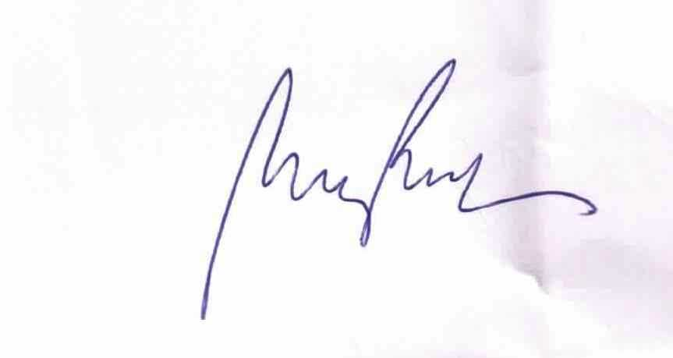

MRUGESH RAVAL

