RESUME 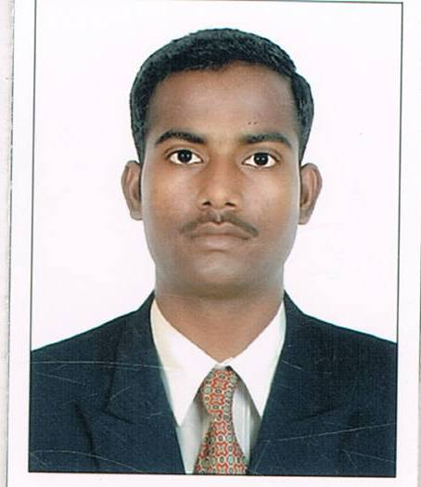

SAMIR J. TIWARI (M) 9662772042, 8347827118
E-mail ID- samir_8838@yahoo.com

PERSONAL INFORMATION –

NAME - SAMIR J. TIWARI

ADDRESS - 83, PANDITJI HOME, GHAR VIHONA PLOT,
OPP. JAGDISH BUS-STOP, SAGAR R. HOUSE,
CADILA ROAD, NEW GHODASAR,
AHMEDABAD- 380050.

DATE OF BIRTH - 14th March, 1988.
SEX - Male
NATIONALITY - Indian

MARRITAL STATUS - Unmarried

LANGUAGES KNOWN -
Mother tongue – Hindi
Working language – English
Other Language – Gujarati.

HOBBY - Reading, Writing, Drawing …

EDUCATIONAL QUALIFICATION –

- Recently, pursuing for PGDCA – Computer Application Diploma from C-DAC Govt. Recog. Institute.
- I have completed B.A. from Gujarat University, in 2008, and obtained 68 %. (University Topper)

- I have completed H.S.C. from Gujarat HSEB in 2005, and obtained 77%.
- I have completed S.S.C. from Gujarat SEB in 2003, and obtained 82 %.
(School Topper)

COMPUTER & OTHER QUALIFICATION –

- I have completed the Certificate Course of M.S. Office from ITCT in 2007 and obtained A Grade. (Recent My Typing Speed is 45 wpm approx.)

- I have completed the Certificate Course of Drawing Conducted by Intermediate level Gujarat Drawing Board, and obtained A++ Grade.

- I was selected in top Five Candidates’ List in the event of Teacher’s Day during College life.

- I have completed the Civil Defence Basic Training conducted by Senior Police Inspector – Under Supervision of IPS Sanjiv Bhatt , Ahmedabad City Unit, Government of Gujarat and obtained Ist Grade.

- I was the Member of Gujarat Geographical Association, Dept. of Geography, Gujarat University, Ahmedabad for a Year and attended the seminar of 14th Biannual Meet – 2007.

WORK EXPERIENCE –

(1) Infibeam.com – a E-Commerce Pvt. Ltd. Company – from the Group of the NSI Infinium
Global Pvt. Ltd. – for approx 1.4 years and still working -- my working Profile in this
company as per given below details….

My Responsibilities were … As a Data Analyst (EDP) --2012 Feb to 2013 Jun and running

- Overall working on MS Office – Excel , Word, Outlook and Internet with Web Searching and surfing
- Manage all relevant data in MS Excel using various formulas and after confirming and validating – upload on CMS – company’s Data Management System
- To validate data given by vendors – publishers
- To manage all coming data from various source in MS Excel
- To verify and justify the data as per requirement of the company software / ERP / Website
- To confirm the details of the given data with various department (relevant department if required)
- To manage all gathered data in MS Excel using MS Word and various excel formulas
- At last to upload all managed data by using MS Excel .csv format – on company’s software – data management system
- Then, verify it and to take overlook how it reflecting on company’s Website
- To call vendors to confirm given/ provided data if required
- To consult with IT Team for the issue of data management system if requied
- To provide training New Joiner if required

(2) I have 3 Months Job as a Computer Operator ( Data Management Executive) In Metro Telworks Wireless Engineering India Pvt. Ltd., Ahmedabad. -- 2012

My Responsibilities were –

- To Adjust Data in MS Excel
- Data Validation in MS Excel
- To Communicate Through Telephone and MS Outlook Express with Engineers, working on Field
- To Import Data in ERP ( Microsoft Navision) after Validating in MS Excel
- To co-ordinate with Technical Team for Data Collection
- Data verification as per required format
- Site Data Validation before Import into ERP
- Collect data within timeline from various circles ( All Over India )

- I have 3 Months Job as a Computer Operator ( Data Entry Operator ) in Just Dial Pvt Ltd, Ahmedabad. – 2011 -2012

My Responsibilities were –

- To Work on Software and Website, Designed by Company
- To Work on Excel for Reporting – Daily Basis
- To Verify Data from Different Sources – Telephonic Verification, Website Search, and other Hardcopies provided by Company
- To Confirmed All Contact Details with Customers and Edit if Required.

(4). I have 5 Months Job as Office Assistant (IT Department) in Unitedworld School of Business ( A MBA College) – Gurukul Road, Ahmedabad… 2010 to 2011 .Details as below…

My Responsibilities were …

- Filing Works
- Data Entry on MS Word & Excel
- Mailing Through Outlook & Internet
- Data Evaluation on Excel
- Maintaining updates on college’s ERP Software – IIMS
- Searching by Google Search Engine
- To go out of Station with Professor, for college Marketing purpose –Visited- Kutchcha, Mahesana’s Colleges of BBA and BCA
- To Make project works on MS Word & Excel / Powerpoint as guided by the Professor of College
- To assist Admin & Receptionist
- To Assist IT Head and Work as guided by him.
- To Assist Admin and work guided by him/her.
- To Give Proper Responses on Call when it comes my Responsibility.
- Accepting all works as guided above I have to assist the Head of Marketing.

(5). I have 1 Year Job as Computer Operator (Office Assistant) in Zenith Infomedia,
Ahmedabad…Details as below…

My Responsibilities were…

- to convert Data Files of jpg. And other format files in Word/ Excel/ PowerPoint and to send it at guided destinations.
- Accepting it, my work field was to assist my colleagues to complete their works.

(6) Including all above work experiences I have total 3.5+ Years’ Experience in Computer Operating—Data Analysis (EDP) Field.

EXPECTED SALARY –
Expected Salary – 18,500/- INR

Last ( Current ) Salary – 12,210/- INR (monthly)

I hope I will be selected. I will work hard to complete the works as guided by you. It’s clear that you will like my work and work-style.

Thanking you in anticipation…

Place: Ahmedabad

Date: / / 2013.

(SAMIR J. TIWARI)

