M.SELVAKUMAR
(M.E in Mechanical Engineering)
Mobile : 08149988884
Email id : mselvakumarpgt@gmail.com

Objective
Seeking Managerial Assignments in the domain of maintaining Bill of Materials (BOM) for Production, Engineering Change Release, Material planning & controlling, New Product Launch and implementing Engineering Changes for Product Life Cycle Management.

PROFILE:

- 12 years of Experience in Release and Change Management and Leading the Team of Software and Hardware (Team Size :8)
- Thorough Knowledge of Passenger Car Parts Details (BOM)
- Currently associated with Mercedes-Benz Research and Development India as a Senior Technical Lead in Product Data management.(PLM/PDM)

Details of Professional History:
Mercedes-Benz Research and Development India (Dec 2014 to Till Now)
Roles & Responsibilities:

- Creation of the BOM & Engineering changes in SMARAGED (EC) for Telematics Component and adhering with Release Plan.
- Creation of PIN configuration in EPDM for Antenna and Loud Speaker Components
- Checking the Engineering Drawing as per MBN Standards and archiving in engineering Client
- Part positioning and Packaging check by using NX tool for telematics components in order to avoid the Collusion in DMU
- Creation of Engineering Changes in Proto parts and regular running Parts by using ACM and regular follow-up with CFT
- Attending the Change Management Meeting(Änderungsmanagement) and Explained the Part Changes and get the approval from management to support the innovative changes and Cost Reduction Changes

TATA Motors Limited (Nov 2012 to Dec 2014)
Responsibilities: Engineering Change Management& BOM Management:

- Analyzing the DML (Design Modification List) Changes and then Call for a Cross Function Meeting to discuss the EO Change matters with the Related Departments (P&SC, Procurement, Mfg-Planning, etc) and then Fixing EPA (Effective Point of Adoption).
- Interact with R&D , to resolve the EBOM Errors

Renault Nissan Technology Business Centre India (Mar 2011 to Nov 2012)
Responsibilities: Engineering Change Release, BOM Preparation
- Creation of Pre-production & Production Engineering Changes and Released to Global Nissan Plants and Maintaining 100 % accurate for all E.BOM & M.BOM

Hyundai Motor India limited (Apr 2007 to Feb 2011)
Responsibilities: Engineering Change Release, BOM Preparation
- Analyzing the Engineering Changes and then Call for a meeting to discuss the EO Change matters with the Related Departments and then Fixing EPI
- IQS and Field Compliant Oriented Engineering changes will be discussed and followed with Special attention.

OVERSEAS ASSIGNMNET

- Onsite Job Supporting and Process Establishment of Group Global BOM (G2B) in “Nissan Technical Center”, Japan. (Duration: 45 days)

- Onsite job Supporting and Process Establishment of RD/USF (Telematics) Teams in “Daimler AG” Germany (Duration : One year)

ACADEME

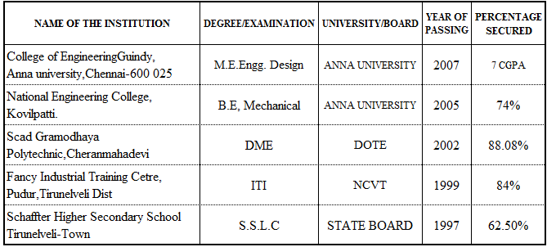

PERSONAL MINUTIAE
Date of Birth : 10.02.1982
Father’s Name : Mr. S.Murugan
Languages Known : English, Tamil, Malayalam
Nationality : Indian
Passport No : G9033980
Address for Communication : 59, Vinayaka Layout,6th Cross,4th Street
Whitefield, Bangalore, India-560066
Declaration
I hereby declare that the above statements are true to the best of my knowledge

Place : Bangalore M.SELVAKUMAR

