Satishkumar Rajnath. Ravat

Add. :- Ahmedabad : - 95, Society’s Chawl, Nr. Jantanagar, A.E.C.Road,
Amraiwadi, Ahmedabad – 38 0026.
Mobile No. :- + 91- 9925391146 Email: satishravat@gmail.com,
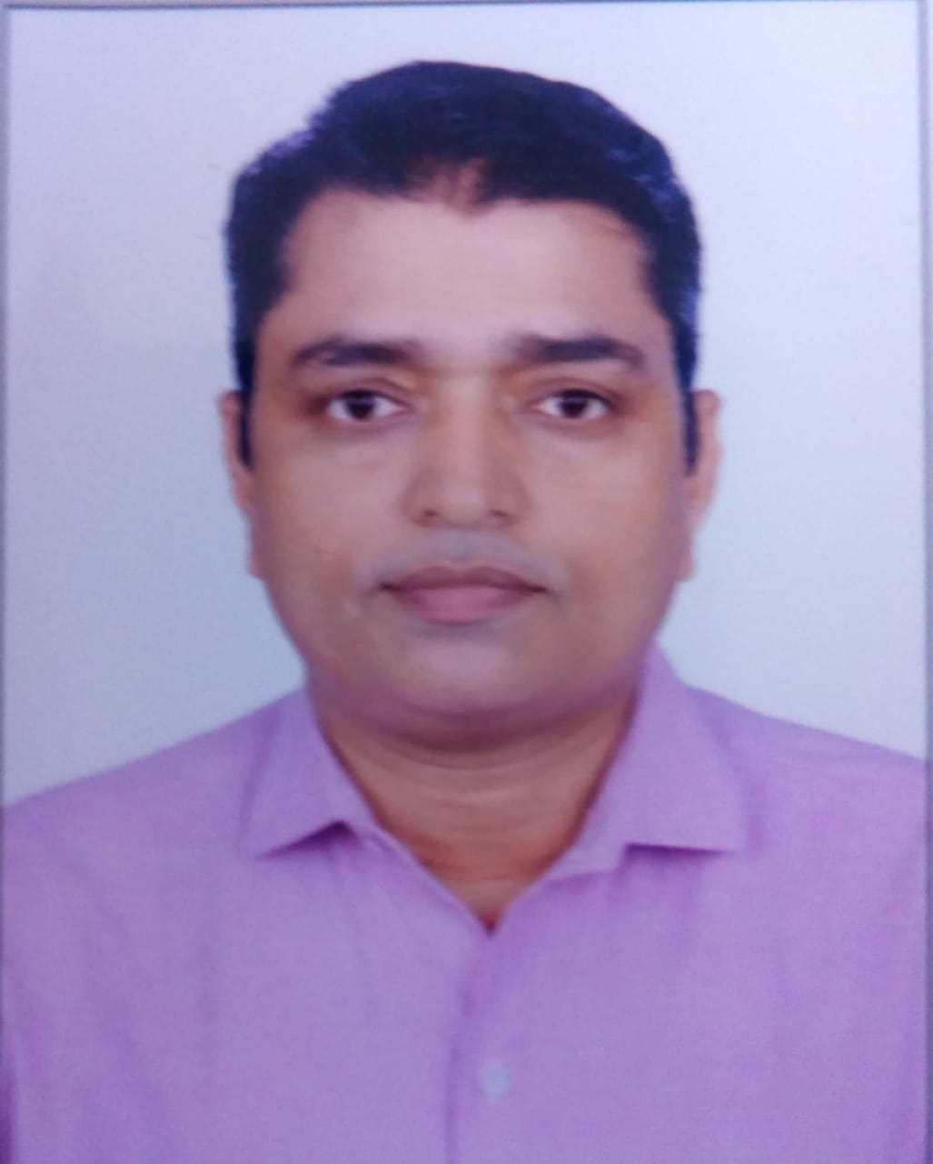
Objective:
A responsible and challenging position which allows me to implement my abilities, knowledge and my dedication towards the duties with a sole aim of the progress, and to adapt the changing organization needs with global scenario.

PERSONAL DETAIL :-

- Name :- Ravat Satishkumar R.
- Father’s Name :- Ravat Rajnath M.
- Mother’s Name :- Ravat Chandravatidevi R.
- Nationality :- Indian.
- Date of birth :- 21st April 1978.
- Sex :- Male.
- Marital Status :- Married.
- Height :- 5 feet 6 inches
- Weight :- 70 kg.
- Language known :- English, Hindi & Gujarati

Qualification :-

Sr. | Degree | University/Board | Passing Year | Result
1 | B.Sc. (Statistics) | GUJARAT Uni. | 2001 | Pass
2 | PGDCA | IGNOU | 2012 | 59%
3 | MCA | IGNOU | 2012 | 57.36%
4 | MA-Economics | Madurai Kamraj University | 2016 | 55%

COMPUTER LITERACY :-

Sr. | Cource | University/Board | Passing Year | Result
1 | CIC | IGNOU | 2000 | 64.30%
2 | HDCS | LCC | 1997 | A
3 | ITI (Client Ser. Tech. Using Oracle) | ITI | 2000 | A

Work Experience:-
Sr. | Organization | Post | Duration
1 | Govt. Of India Ministry Of Labour & Employment, Labour Bureau (WR) Ahmedabad | Junior Consultant | 20/10/2014 to 31/07/2018
2 | Govt. Of India Ministry Of Labour & Employment, Labour Bureau (WR) Ahmedabad | Investigators (Statistics) | Dec-2013 to Jul-2014
3 | Govt. Of India Ministry Of Labour & Employment, Labour Bureau (WR) Ahmedabad | Supervisor (Statistics) | Oct-2012 to Jun-2013
4 | GMC Pvt. Ltd.(Guj.)  (An Idea Cellular Data Preservation Agency Guj. Reason) | Admin Manager | Aug-2011 to Sep.-2012
5 | Nelson's English School, Maninagar, Ahmedabad | Office Assist. (Clerk) | Aug-2008 to July-2011
6 | Convent English School, Amraiwadi, Ahmedabad | Computer Teacher Cum Clerk | June-2001 to July 2008

Current Salary:- 36000.00 Per Month + TA/DA
[ TA DA travel inside the country in connection with the official work equivalent to the 5400 Grade pay as per 6th CPC ]

Refrance :-

- Shri P. D.Karu , S.S.O, Govt. of India, Ministry of Labour & Employment, Labour Bureau (WR), Ahmedabad.
Contact No. :- +91 – 9904416609.
- Shri S. H. Nagbhidkar , S.S.O, Govt. of India, Ministry of Labour & Employment, Labour Bureau (WR), Ahmedabad.
Contact No. :- +91 – 9904416609.
- Shri D. M. Shah, Ex-Head of office / Ex-Assistant Director, Govt. of India, Ministry of Labour & Employment, Labour Bureau (WR), Ahmedabad.
Contact No. :- +91 – 99247 81163.
- Shri G. P. Meena, Head of office, Govt. of India, Ministry of Labour & Employment, Labour Bureau (WR), Ahmedabad.
Contact No. :- +91 – 85910 03440.

Thanks & Regards,

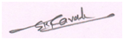
( Satish Ravat )
Mo. No. 9925391146.
satishravat@gmail.com

Work Profile:-
Organization :- Government Of India, Ministry Of Labour & Employment,
Labour Bureau (WR) Ahmedabad
Designation :- Junior Consultant (Statistics). Period:- 20/10/2014 to 31/07/2018
Job Profile :-
- Administration responsibility :-
- Planning and coordinating administrative procedures and system & devising ways to streamline processes.
- Administration responsibility of Labour Bureau (WR) Ahmedabad and Labour Bureau (SWR) Chembur(E), Mumbai Office.
- Total Technical Support & IT Solution of Labour Bureau (WR), Ahmedabad and Labour Bureau (SWR), Chembur(E), Mumbai Office.
- Recruiting Price Collectors & Price Supervisors under NFLS & CPI-IW Scheme and training personnel and allocate responsibilities of their allocated Centres.
- Project completion responsibility during the time period.
- Maintaining & preparing all MIS, Progress Report Weekly & Monthly.
- Staff performance and provide coaching and guidance maximum efficiency.
- Assessing Ensure the smooth and adequate flow of information within the Regional office to facilitate Head Quarters Shimla & Chandigarh.
- Manage schedules and deadlines of running all schemes.
- Monitoring the CPI-IW Base year 2001=100 & NFLS CPI-IW Proposed base 2016=100 Scheme of 7 States/UT’s (Maharashtra, Gujarat, Rajasthan, Madhyapradesh, Chhattisgarh, GOA and Dadara & Nagar Haweli)
- Monitoring the Scheme of 5th & 6th EUS all over Maharashtra, Gujarat & Rajasthan State.
- Maintaining & preparing all MIS, Progress Report Weekly & Monthly.
- Supervisions the Investigators fields, collecting the DATA, scrutinize and analyze the filled schedule & Data.
- Allocate the EUS Schedule to all Maharashtra Investigators and providing schedule, UFS map and other thing.
- Monitor inventory of office supplies and the purchasing of new material with attention to budgetary constraints.
- Monitor costs and expenses to assist in budget preparation.
- Oversee facilities services, maintenance activities and tradespersons (e.g Printers Cartilage refilling)
- Organize and supervise our office activities (renovations, event planning etc.)
- Ensure operations adhere to policies and regulations.
- Keep abreast with all projects & schemes work developments.
- Arrangement of RO meeting (Regional Meeting) at RO Ahmedabad of SRO Mumbai.
- Liaising & communication :-
- The Head Quarter ( LABOUR BUREAU, Govt. of India) Chandigarh for NFLS New CPI-IW Proposed Base 2016=100, 5th & 6th EUS (employment and Unemployment Survey )
- The Head Quarter ( LABOUR BUREAU, Govt. of India) Shimla for old CPI-IW Base 2001=100,
- All DSO (District Statics Officer) of Maharashtra, Gujarat, Rajasthan & DNH’s DSO (District Statics Officer) for EUS.
- The PAO office, Chandigarh for PFMS (Public Finance Management System, Ministry of Finance, Government of India), CDDO, Budget & Grant, Salary, Pension and Payment, Accounts & etc.
- Head office & Branch Managers of Nationalize and Private Banks, NBFC etc. MUDRA Loan Data regarding.
- Selected Centre’s Price Collectors, Price Supervisor, State Coordinator and concern authority (working under States DES & Labour Commissioners office) for NFLS New CPI-IW Proposed Base 2016=100 & old CPI-IW Base 2001=100 for Weekly, Monthly, Clothing and Offtake Data.
- All Maharashtra, Gujarat, Rajasthan & DNH’s States/UT’s NSSO ( National Sample Survey Office) Govt. of India Office for UFS Map and Collecting its.
- Data Research & Analysis :-
- Primary Data Collection, Tabulation, Compilation, Analysis and Report generation.
- Maintaining & preparing all MIS, Progress Report Weekly & Monthly & Complete IT Solution.
- Supervisions the Investigators fields, collecting the DATA, scrutinize and analyze the filled schedule & Data.
- Inspection Report Preparing under NFLS New CPI-IW Proposed Base 2016=100, and old CPI-IW Base 2001=100.
- Taking review meeting of all Investigators taking their feedback and solve their problems & grievances.
- Allocate the EUS Schedule to all Maharashtra Investigators and providing schedule, UFS map and other thing.
- CPI –IW Rates of Petrol & Gas Letter preparing & Sending to Shimla.
- Pendency Clearing of Off-take Data and Weekly, Monthly and Clothing Returns.
- HR Responsibility :-
- Preparing the Salary Sheet of all Maharashtra Investigators and Gujarat Supervisors & Investigators working Under NFLS New CPI-IW Proposed Base 2016=100, 5th and 6th EUS. QES (Quarterly Employment Survey) and OWS (Occupation Wage Survey).
- Checking & Preparing the TA & DA Bill Sheet of all Maharashtra Investigators and Gujarat Supervisors & Investigators working Under NFLS New CPI-IW Proposed Base 2016=100, 5th and 6th EUS. QES (Quarterly Employment Survey) and OWS (Occupation Wage Survey).
- Tour Program preparation, Centre Allocation of all Scheme.
- Salary Bill and advance bill and etc. Preparation of all Permanent and Contractual Employee,
- PFMS (Public Finance Management System, Ministry of Finance, Government of India), CDDO, Budget & Grant, Salary, Pension and Payment, Accounts & etc.
- NPS (National Pension Scheme) Generation and submission work handling etc.
Organization : - Government Of India, Ministry Of Labour & Employment,
Labour Bureau (WR) Ahmedabad
Designation :- Investigators (Statistics). Period:- Dec-2013 to Jul-2014
Job Profile:-
- Administration responsibility :-
- Planning and coordinating administrative procedures and system & devising ways to streamline processes.
- Administration responsibility of Labour Bureau (SWR) Chembur(E), Mumbai Office.
- Total Technical Support & IT Solution of Labour Bureau (SWR), Chembur(E), Mumbai Office.
- Monitoring the all over Maharashtra State EUS
- Handling the SWR(Sub Western Region Office)Chembur, Mumbai-71.
- Project completion responsibility during the time period.
- Maintaining & preparing all MIS, Progress Report Weekly & Monthly.
- Staff performance and provide coaching and guidance maximum efficiency.
- Assessing Ensure the smooth and adequate flow of information within the Regional office to facilitate Head Quarters Shimla & Chandigarh.
- Manage schedules and deadlines of running all schemes.
- Monitoring the Scheme of 4th EUS all over Maharashtra State.
- Maintaining & preparing all MIS, Progress Report Weekly & Monthly.
- Supervisions the Investigators fields, collecting the DATA, scrutinize and analyze the filled schedule & Data.
- Allocate the EUS Schedule to all Maharashtra Investigators and providing schedule, UFS map and other thing.
- Oversee facilities services, maintenance activities and tradespersons (e.g Printers Cartilage refilling)
- Organize and supervise our office activities (renovations, event planning etc.)
- Ensure operations adhere to policies and regulations.
- Keep abreast with all projects & schemes work developments.
- Arrangement of RO meeting (Regional Meeting) and Index User’s Meeting at RO Ahmedabad of SRO Mumbai.
- Liaising & communication :-
- The Head Quarter ( LABOUR BUREAU, Govt. of India) Chandigarh 4th EUS (employment and Unemployment Survey )
- The Head Quarter ( LABOUR BUREAU, Govt. of India) Shimla for old CPI-IW Base 2001=100,
- All DSO (District Statics Officer) of Maharashtra, Gujarat, Rajasthan & DNH’s DSO (District Statics Officer) for EUS.
- All Maharashtra State NSSO ( National Sample Survey Office) Govt. of India Office for UFS Map and Collecting its.
- Data Research & Analysis :-
- Primary Data Collection, Tabulation, Compilation, Analysis and Report generation.
- Maintaining & preparing all MIS, Progress Report Weekly & Monthly.
- Supervisions the Investigators fields, collecting the DATA, scrutinize and analyze the filled schedule & Data.
- Complete IT Solution.
- Taking review meeting of all Investigators taking their feedback and solve their problems & grievances.
- Allocate the EUS Schedule to all Maharashtra Investigators and providing schedule, UFS map and other thing.
- CPI –IW Rates of Petrol & Gas Letter preparing & Sending to Shimla.
- Pendency Clearing of Off-take Data and Weekly, Monthly and Clothing Returns.
- HR Responsibility :-
- Preparing the Salary Sheet of all Maharashtra Investigators working Under 4th EUS.
- Preparing the TA & DA Bill Sheet of all Maharashtra Investigators and working Under 4th
- Tour Program preparation, Centre Allocation of all Scheme.
- Checking & Preparing the TA & DA Bill Sheet of all Maharashtra Investigators and Gujarat Supervisors & Investigators.
Organization : - Government Of India, Ministry Of Labour & Employment,
Labour Bureau (WR) Ahmedabad
Designation :- Supervisor (Statistics). Period:- Oct.-2012 to Jun.-2013
Job Profile:-
- Administration responsibility :-
- Planning and coordinating administrative procedures and system & devising ways to streamline processes.
- Administration responsibility of Labour Bureau (SWR) Chembur (E), Mumbai Office.
- Total Technical Support & IT Solution of Labour Bureau (SWR), Chembur (E), Mumbai Office.
- Monitoring the all over Maharashtra State 3rd (Employment & Unemployment Survey – 2012) EUS-2012.
- Handling the SWR(Sub Western Region Office) Chembur, Mumbai-71.
- Project completion responsibility during the time period.
- Maintaining & preparing all MIS, Progress Report Weekly & Monthly.
- Staff performance and provide coaching and guidance maximum efficiency.
- Assessing Ensure the smooth and adequate flow of information within the Regional office to facilitate Head Quarters Shimla & Chandigarh.
- Manage schedules and deadlines of running all schemes.
- Monitoring the Scheme of 4th EUS all over Maharashtra State.
- Maintaining & preparing all MIS, Progress Report Weekly & Monthly.
- Supervisions the Investigators fields, collecting the DATA, scrutinize and analyze the filled schedule & Data.
- Allocate the EUS Schedule to all Maharashtra Investigators and providing schedule, UFS map and other thing.
- Oversee facilities services, maintenance activities and tradespersons (e.g Printers Cartilage refilling)
- Organize and supervise our office activities (renovations, event planning etc.)
- Ensure operations adhere to policies and regulations.
- Keep abreast with all projects & schemes work developments.
- Arrangement of RO meeting (Regional Meeting) and Index User’s Meeting at RO Ahmedabad of SRO Mumbai.
- Liaising & communication :-
- The Head Quarter (LABOUR BUREAU,Govt. of India) Chandigarh 3rd EUS (employment and Unemployment Survey)
- The Head Quarter ( LABOUR BUREAU, Govt. of India) Shimla for old CPI-IW Base 2001=100,
- All DSO (District Statics Officer) of Maharashtra, Gujarat, Rajasthan & DNH’s DSO (District Statics Officer) for EUS.
- All Maharashtra State NSSO (National Sample Survey Office) Govt. of India Office for UFS Map and Collecting its.
- Data Research & Analysis :-
- Primary Data Collection, Tabulation, Compilation, Analysis and Report generation.
- Maintaining & preparing all MIS, Progress Report Weekly & Monthly.
- Supervisions the Investigators fields, collecting the DATA, scrutinize and analyze the filled schedule & Data.
- Complete IT Solution.
- Taking review meeting of all Investigators taking their feedback and solve their problems & grievances.
- Allocate the EUS Schedule to all Maharashtra Investigators and providing schedule, UFS map and other thing.
- CPI –IW Rates of Petrol & Gas Letter preparing & Sending to Shimla.
- Pendency Clearing of Off-take Data and Weekly, Monthly and Clothing Returns.
- HR Responsibility :-
- Preparing the Salary Sheet of all Maharashtra Investigators working Under 3rd EUS.
- Preparing the TA & DA Bill Sheet of all Maharashtra Investigators and working Under 3rd EUS-2012.
- Tour Program preparation, Centre Allocation of all Scheme.
- Checking & Preparing the TA & DA Bill Sheet of all Maharashtra Investigators and Gujarat Supervisors & Investigators.
Organization :- GMC Pvt. Ltd.(Guj.)
(An Idea Cellular Data Preservation Agency Guj. Reason)
Designation :- Admin Manager Period:- Aug-2011 to Sep.-2012
Company Profile: It is a leading Data Managements & Data Preservation Company, CAF Management in Idea cellular Pvt. Ltd.
Job Profile:-
- Administration responsibility :-
- Planning and coordinating administrative procedures and systems and devise ways to streamline processes.
- Recruiting and training personnel and allocate responsibilities and office space.
- Assessing staff performance and provide coaching and guidance to ensure maximum efficiency.
- Ensuring the smooth and adequate flow of information within the company to facilitate other business operations.
- Managing schedules and deadlines.
- Monitoring inventory of office supplies and the purchasing of new material with attention to budgetary constraints.
- Monitoring costs and expenses to assist in budget preparation.
- Oversee facilities services, maintenance activities and tradespersons (e.g Computer Hardware Er. electricians).
- Organizing and supervising other office activities (recycling, renovations, event planning etc.)
- Ensuring operations adhere to policies and regulations.
- Keeping abreast with all organizational changes and business developments.
- Look after the H.O. Gujarat office premises and its management.
- Watch the whole work of contractors and it men power.
- Deal whole required Items & Billing to its.
- To reduce the cost-cutting as much as possible.
- Inter departmental and zone coordination
- DATA & MIS Management Responsibility:-
- Maintaining Whole MIS. Data analysis & Management.
- Tracking and daily updation of MIS on business data of advisors, agency manager’s wise and sent to Boss and H.O. regularly.
- Meta Data Preparing and uploading responsibility. Check & Revert the whole mail of our Company and Client E-mails.
- Taking all type of reporting with all responsible persons and All Gujarat Location’s (SURAT, BARODA, NAVSARI, VAPI, HIMMATNAGAR, SURANDRANAGAR, AHMEDANAD, …..)
- To encourage our Data-Entry Team, Gunning Tem, MIS Team, Audit Team and other teams by keeping various activities.
- Solve the pendency of data and Maintaining QC Data Sheets.
- Watch the whole process of Data Preservation & Data managements. Start to End.
( Caf Receiving, Gunning, Form Generating, Data Entry, 2nd Level Audit, Activation Date, De-Pining, Scan, Re-Pining & Dispatch the Caf Boxes in ware house.
- Responsibility of Term Data (AHM, ROG, VTM).
- Daily Updating of Policy MIS with relevant details and also in the system. Follow is done in pending cases with H.O, B.O. and Location Heads. Handling Clients ( Idea’s Officers) / walk-in Queries relating to their policies,
- As an Human Resource Responsibilities:-
- Processing the Joining Kit of New Employees.
- Generating their employee codes and activation of their Payroll systems.
- Taking care of their Salary Payouts. Maintaining Men Power in Office.
- Processing of Exits, Absconding & Termination letters of employees.
- Coordinating with the Consultant for new recruitment and their consultant fees.
- Full fill the whole required requirement of the men power.
- As H.O. Branch Operation Responsibilities:-
- Daily Updating of Policy MIS with relevant details and also in the system. Follow is done in pending cases with H.O, B.O. and Location Heads.
- Handling Clients ( Idea’s Officers) / walk-in Queries relating to their policies,
- Tracking and daily updation of MIS on business data of advisors, agency manager’s wise and sent to Boss and H.O. regularly.
- Taking all type of reporting with all responsible persons and All Gujarat Location’s (SURAT, BARODA, NAVSARI, VAPI, HIMMATNAGAR, SURANDRANAGAR, AHMEDANAD, …..)
- Watch the whole process of Data Preservation & Data managements. Start to End.
- ( Caf Receiving, Gunning, Form Generating, Data Entry, 2nd Level Audit, Activation Date, De-Pining, Scan, Re-Pining & Dispatch the Caf Boxes in ware house. Handel the all out-side Work.
- Responsibility of Term Data (AHM, ROG, VTM).
- Ware house responsibility. Quality Control (QC) maintain. Daily Phoenix Data Reporting.
- Damage SIM & Recharge Voucher Coupon (All Gujarat) Reporting . Meta Data Submission.
Organizetion :- Nelson's English School, Maninagar, Ahmedabad.
Designation : - Office Assist. (Clerk) Period :- Aug-2008 to July-2011
Job Profile:-
Responsibilities As A Human Resource, ;-
- Processing the Joining Kit of New Employees.
- Generating their employee codes and activation of their Payroll systems.
- Taking care of their Salary Payouts, EPF, PT, etc….
- Processing of Exits, Absconding & Termination letters of employees. Tr.
Responsibilities As an Admin Cashier ;
- Receiving all type of fees,
- Maintaining Daily Account Sheet, ledger & General ,
- Daily Fees Collection as a Cashier, Daily Banking.
- Audit & All Account Sheet, Balance Sheet making in Computer.
- Liaising with EPFO, SVS and DEO office. MIS Preparing and maintaining.
Organization :- Convent English School, Amraiwadi, Ahmedabad
Designation:- Computer Teacher Cum Clerk Period:- June-2001 to July 2008
Responsibilities As A Human Resource, ;-
- Processing the Joining Kit of New Employees.
- Generating their employee codes and activation of their Payroll systems.
- Taking care of their Salary Payouts.
- Processing of Exits, Absconding & Termination letters of employees. Tr.
- Taking Interview of Tr.’s, Students & Parents,
Responsibilities As an Admin Cashier ;
- Receiving all type of fees,
- Maintaining Daily Account Sheet, ledger & General
- Audit & All Account Sheet, Balance Sheet making in Computer
- Liaising with SVS and DEO office.
Responsibilities As A Computer Faculty:-
- Taking Computer Subjects classes up to 12th Sci.
- Making & Checking Papers of Computer, Maths & Science.
- Total IT Solution of Schools. MIS Preparing and maintaining.
Thanks & Regards,
( Satish Ravat )
Mo. No. 9925391146.
satishravat@gmail.com

