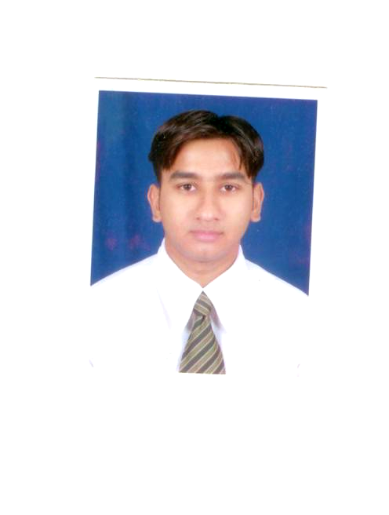

UJJAWAL SARGIYA
204 Panchvilla Tower
Nr. Bhuyangdev Cross Road
Memnagar,
Ahmedabad
+91 9974911290 E-mail ID sargiyaujjawal@gmail.com
Human Resource Manager,

______________________
Dear Sir(s),

Sub: Prospecting for a suitable position in your organization.

As you are aware that the corporate world gives great importance to the profession of MBA in Banking Finance and Marketing. It is hence, a matter of pride for me to become a part of this multi-faceted profession.

I am looking forward to pursue a suitable career opening in your esteemed organisation. A copy my C.V. is enclosed herewith for your kind perusal.

What my C.V. does not tell about me is that I am a sincere and hard working individual with a quick learning ability. I assure you that given the opportunity. I shall be able to live up to the expectations of your esteemed organization and believe that my potential can be most effectively utilized by your organization for mutual benefit and would be most happy to meet and discuss my career prospects with you, at your earliest convenience.

Looking forward to hear from you and in anticipation of positive response.

Thanking you,
Sincerely yours,

UJJAWAL SARGIYA

UJJAWAL M. SARGIYA
204 Panchvilla Tower
Nr. Bhuyangdev Cross Road
Memnagar,
Ahmedabad
+91 9974911290 E-mail ID sargiyaujjawal@gmail.com

Career Objective:

Seeking a position that will help in utilizing my competencies and opportunity for growth.

Academic Qualification:
Completed MBA in Banking Finance (Credit) & Marketing
Examination | Institution | Year of passing
MBA in Banking Finance (Credit) & Marketing | ICFAI, Ahmedabad  (Full Time) | April. 2007 with 5.53 CGPA
B. Com. | Gujarat University | June 2004 with 56%
Sr. Secondary | Rajasthan Board | April 2001 with 66%
Secondary | Rajasthan Board | April 1999 with 62%

EXPERIENCE:

A. Presently with Pinal Shah & Associates Ahmedabad as a Credit Appraisal and Project Finance Executive associated with Citi Bank, Citi Finance and India Bulls Since April 2008.

B. Worked with Galaxy Concab (I) Pvt. Ltd. Jaipur as an Executive Finance handling Accounts & Finance, managing Director Portfolio as well as managing Company Clients since September 2007 to March 2008.

C. Completed four months Summer Internship Program as well as working on commission basis for two month with Sharekhan Ltd. Ahmedabad. (Total 6 Months)
- Target to open 40 D-mat accounts, was able to open 30 D-mat accounts.

D. Worked as a audit trainee with M/s J. Vageriya & Associate from August 2004 to January 2005 in Ahmedabad.
During the tenure I got the following exposure:-
- Monthly scrutiny of Ledger & Journal Voucher.

E. Worked as an Accountant in Kodiya Garments, Ahmedabad from May 2003 to June 2004.
Projects Undertaken:-

- Finance project Report on “Inventory management technique” of Riviera Polymers Pvt. Ltd Ahmedabad.
- To know the “Market potential of High Net worth Individual Segment for Sharekhan Ltd. Ahmedabad.”
- Finance project Report on Process Account of Shah Alloys Ltd Ahmedabad.
- Service Marketing project Report on “Strength Targets Position of a Career Consultancy Ahmedabad.”
Computer Literacy:

Proficiency in Ms-Office, Tally 6.3, 7.2 and 9 etc. and quite conversant with Internet & E-Mail.

PERSONAL DETAILS:

Date of Birth : 13th May, 1983
Martial Status : Single
Permanent Address : 25, Oswal Wara,
Azad Chowk, Banswara,
(Rajasthan) – 327001
Ph. 02962-240961
Language Known : English, Hindi, Gujarati
E-mail ID : sargiyaujjawal@yahoo.co.in

Reference:-
CA HEMANT S. SARIYA CA PINAL M. SHAH
903, Akik, 410, Vraj Plaza,
Opp. Rajpath Club, Bhatta Paldi,
SG Highway, Ahmedabad. Ahmedabad,
+91 9898 17 9776 +91 9898 48 6852

CA JITENDRA R. VAGERIYA
B/6, 4th Floor, Shalimar complex,
Mahalaxmi five roads,
Paldi, Ahmedabad.
+91 9824 25 0131.

