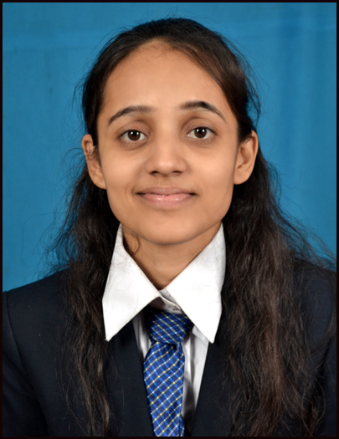
AASHAL HARIHAR VYAS
B-11, Shantinath App, opp Vejalpur Bus-Stop, Vejalpur ,Ahmedabad-51
Residence : (079) 26825683
Mobile: +91 8980055065
Specialization: Human Resource Management
E-mail: aashal109@gmail.com
aashal.anjali@yahoo.co.in

Career Objective

To work in such organization that offers career opportunities for growth & stimulates competition by which intellectual & analytical skills could be further improved

Experience
.
- Worked as a Biomedical Engineer , at Civil Hospital , Nadiad for six Months
- Currently Working as a Biomedical Engineer at Bodyline Hospital ,Paldi

Professional Qualification

- Currently pursuing M.B.A. with specialization in Human Resource Management (IVth Semester) from Shri Chimanbhai Patel Institute Of Management And Research, Ahmedabad.
- Have completed B.Tech. in Biomedical Engineering from Ganpat University with 63.07% in 2009.

Educational Qualification

Qualification | Institution | Board/  University | Percentage/CPI | Year of Passing
Master of Business Administration (Human Resource Management) | Shri Chimanbhai Patel Institute Of Management And Research | Gujarat Technological University | 7.58/10 | Pursuing  (2011-2013)
B.Tech. Biomedical & Instrumentation Engineering | U. V. Patel College of Engineering, Mahesana | Ganpat University | 63.07% | May-2009
H.S.C | R.R. Dwivedi High School | G.S.H.S.E.B | 64.88% | Mar-2005
S.S.C | R.R. Dwivedi High School | G.S.H.S.E.B | 85.43% | Mar-2003

Semester Project (Engineering)

- Measurement of Foot Pressure(VIIth SEMESTER)
- Speech Recognition(VIIIth SEMESTER)

Grand Project (Post Graduation)

- Title : “Efficiency of Recruitment Practices & its Impact on Talent Retention”

Brief Description: this research basically focus how an effective recruitment
Leads to retention of the talent in IT Sector.

Summer Internship Details

- Graduation: Worked as a Trainee at Civil Hospital , Gandhinagar in department of BIOMEDICAL Engineering
- Post Graduation: Summer Internship Project on “Study of Employee Safety & its Impact on Employee Satisfaction” at Bodyline Hospital, Paldi, Ahmedabad.

Extra Curricular Activates
- Participated in a Poster Presentation in National Level Technical Symposium-CONVERGENCE’07 organized by U.V. Patel College of Engineering, Ganpat University.
- Participated in management quiz “Devine Raga”
- Participated in the event Corporate Meet-“Tathya’ at B.K. School of Management

Computer Proficiency
- Working Knowledge of Windows Operating System
- M.S.Office

Personal Profile

- Name: Vyas Aashal Harihar

- Date of Birth: 10th September, 1987

- Languages Known: English, Hindi, Gujrati.

- Personal Skills: Positive Attitude , Well-organized, confident and self-motivated individual with ability to rapidly learn new tasks.

- Hobbies: Reading , Listening to music, Watching movies, Playing Badminton

- E-mail: aashal109@gmail.com,aashal.anjali@yahoo.co.in

- Address:B-11, Shantinath App, Opp Vejalpur Bus-stop, Vejalpur,
Ahmedabad-380051
.
(Aashal Vyas)

