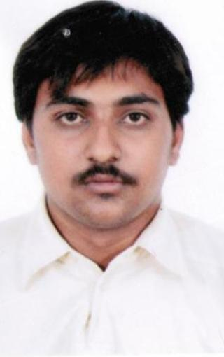
RESUME

DEVANG R. DAVE

CONTACT NO: +91-9998875533, +91-9426725572, 079-27433336

079-27479922
E Mail ID: devang8292@gmail.com , kvdave06@yahoo.co.in
------------------------------------------------------------------------------------------
Name : Devang Rajendrakumar Dave
Date of Birth: 8TH February, 1992
Permanent Address: M-6/42 Swatantra Senani Nagar, Pragatinager, Naranpura ,Ahmedabad-380013
Marital Status: Unmarried
Nationality: Indian
Languages Known: Gujarati, Hindi and English
Computer Knowledge: medium

Objective
Looking forward to associate myself with an organization where there is an Opportunity to share, contribute and upgrade my knowledge for development of self and organization.

Education Qualification:

Exam Passed | Name of University | Result | Year of Passing
S.S.C | G.S.E.B | 55.69 % | March 2007
I.T.I (Mechanical maintenance of chemical plant) | ITI Kubernagar | 73% | March 2009/10
Diploma in mechatronics | Gujarat Technical  University | Diploma 6thsemester 81.30% | July 2014

Academic project: segway (two wheel balancing scooter)
Microcontroller base completed
Technical Skill Set: C++, Micro Controller, PLC Database

Interested field: O/C, Production and Maintenance

Achievement & activities:
*Attended SMSCP mechatronics level -1course conducted by TSP Christian Sharp line Pvt Ltd, Navi Mumbai full time from 04/08/2014 to 11/09/2014 (Siemens certified mechatronic system assistant)
* Attended Construction Workers Training Program
* Participate ITI annual sport Volleyball competition in 2008-09
* Participate Combined Annual Training Camp NCC in 2004

SPECIAL HOBBY: Play Volleyball ,Play Computer game, Drawing

I hereby state that the information provided by me in my Resume is true and authentic to the best of my knowledge.

Thank you
Yours faithfully

DEVANG R. DAVE

