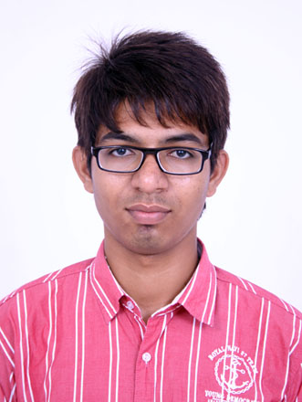
Present Address:
A19, Saytaym Shivam,
Akhasrdham Township,
Near, Sahjand English Medium School,Mahesana Cross road
Visnagar.
Ahmedabad-382424
Rushi Bipinkumar Patel
B.E. Electrical Engineering
Contact No. : - 8155841846

E-mail:- rushipatel285@Gmail.Com

CAREER OBJECTIVE
To work in a firm with a professional work driven environment where I can utilize and apply my knowledge, skills which would enable me as a fresh graduate to grow while fulfilling organizational goals.
BASIC ACADEMIC CREDENTIALS

Qualifications | Board/University | Year | Percentage
B.E (Electrical  Engineering) | Merchant Engineering college,  Basna,Visnagar.  Gujarat Technological University | 2010-2014 | C.G.P.A: 7.74 (72.4%)
12th Board  (sciences stream) | H.S.S.C Board  G.D.High School | 2009-10 | 47.40%
10th Board | S.S.C Board  A.G.P High School | 2007-08 | 81.83%

Certificate Of Achievements | State Of Organization | Stream | Medal/Rank/Mark | Year
Gujarat Energy Transmission Corporation | Government of Gujarat | Training | Successfully  completed | 2013
Gujarat Energy Development Agency | Government of Gujarat, | Workshop | Successfully  completed | 2013
EXPERIENTIAL LEARNING (SUMMER INTERNSHIP PROGRAM)

    - Company Name :- 220 KV SS GETCO Kheralu.
    - Project Title :- Protection of Transformer using various Devices.
    - Duration :- 8 days (18th june2013 to 25th june’2013).

PROJECTS REPORT

- Protection of transformer using various devices

- Protection of Temperature,Overload,Overcurrent,oillevel

IT PROFICIENCY

- Microsoft Software: Microsoft Office Word, Microsoft Office Excel, Microsoft Office Power Point.
- Language: Little Knowledge about C++ & C.
- Electrical Base Software: Keil , Proteus 8 ,Power Word Simulations.

INTERPERSONAL SKILL
- Good Skill:
- Ability to rapidly build relationship and set up trust.
- Confident and Determined.
- Ability to cope up with different situations.
- I like Work In Social Activities.
- Bad Skill:
- Silence in Nature.

INDUSTRIAL VISIT
- Thermal Power House, Mundra.
- T & R ,Changodar.
- Substation at Kheralu.

PERSONAL DETAILS

- Father’s Name : - BipinKumar V. Patel.
- Date of Birth : - 16th January1993.
- Language Known : - Gujarati, English & Hindi .
- Marital Status : - Single.
- Nationality/Religion : - Indian /Hindu .
- Interest & Hobbies : - Internet browsing, Reading, Cricket.
- Passport : - Yes

DECLARATION

I do hereby declare that the above information is true to the best of my knowledge.

You’re Faithfully

Rushi B. Patel

